PART1

# 1. Set up AWS/GCP/Azure VPC with subnets, NAT gateways, and security groups.

AWS Console

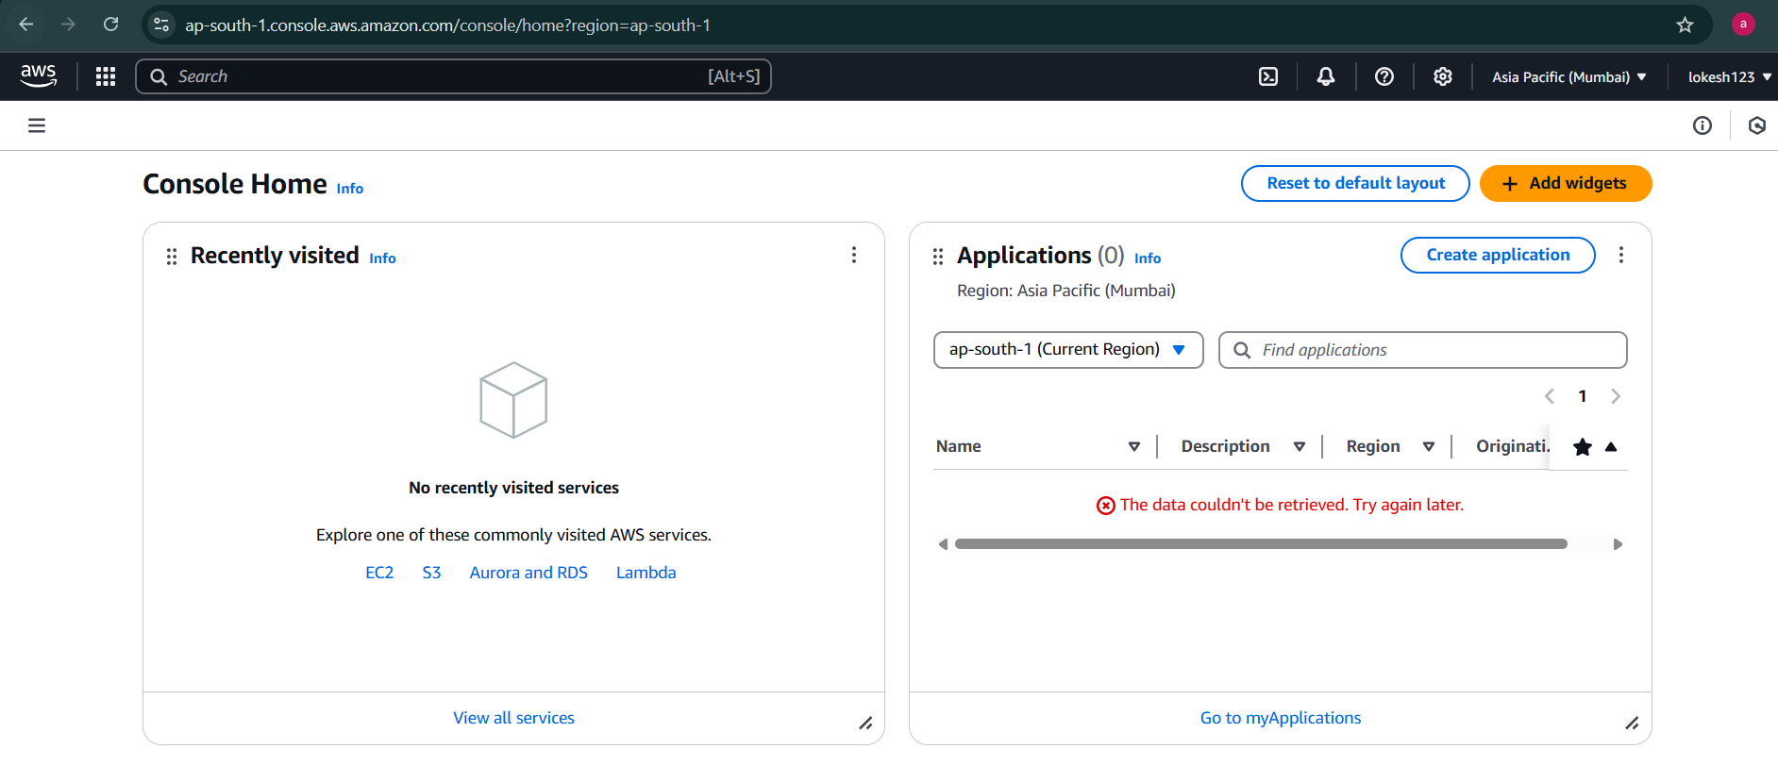

Make sure region should be same for entire project you do

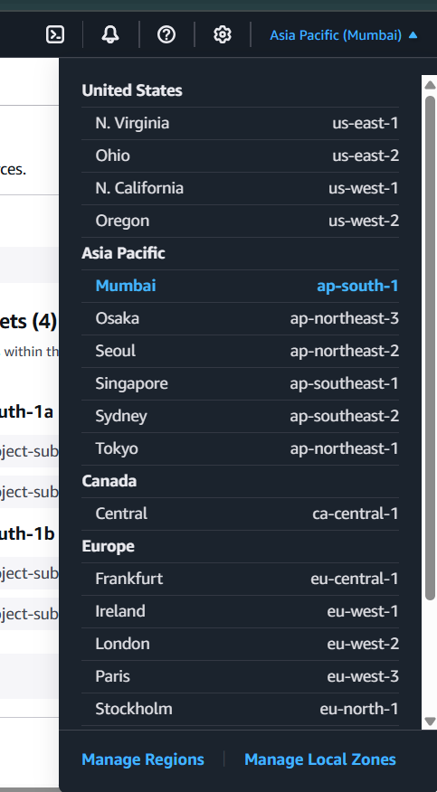

## VPC

Service that lets you launch your AWS resources in a logically isolated virtual network. By default, you can have a maximum of 5 VPC per region (soft limit) and 5 CIDR per VPC.

Default vpc is created when you create an account in aws for every region , default vpc comes with Subnets , route table , internet gateway.

Creating Custom VPC

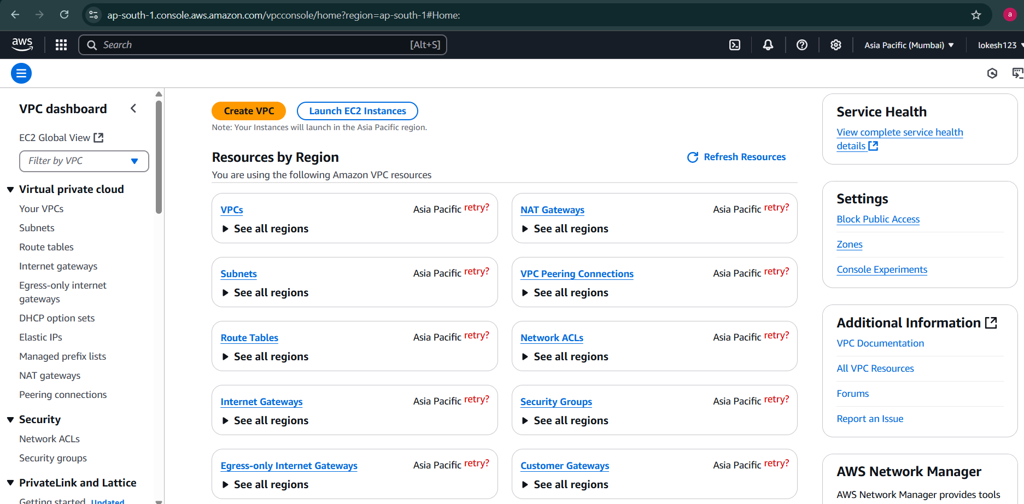

Give custom name for VPC

/16 is maximum CIDR notation for VPC

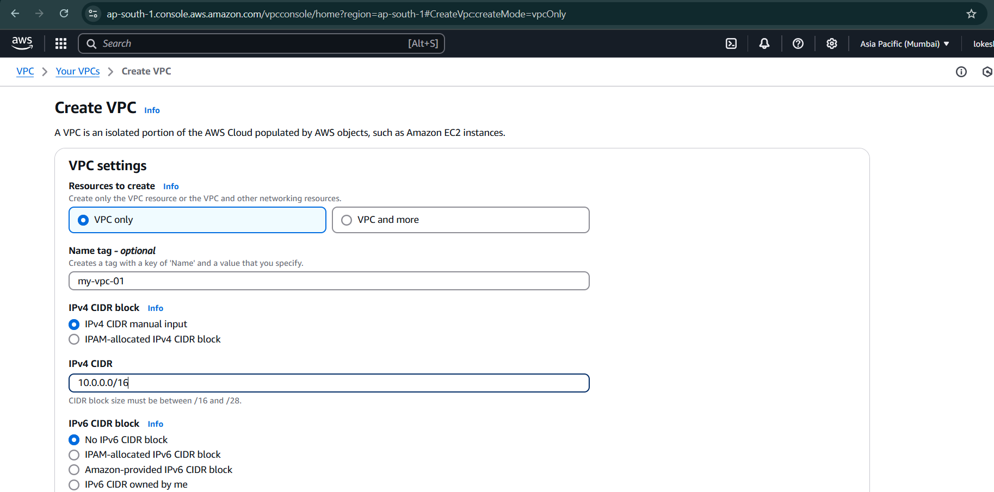

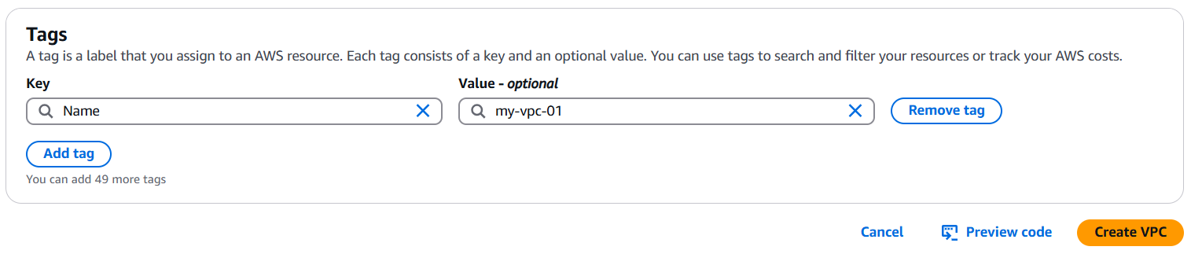

Created custom vpc with no other component (like subnets , Internet GateWay, route table)

Make sure you to enable DNS hostname & DNS resolution so that any instance that running in VPC can connect to public internet

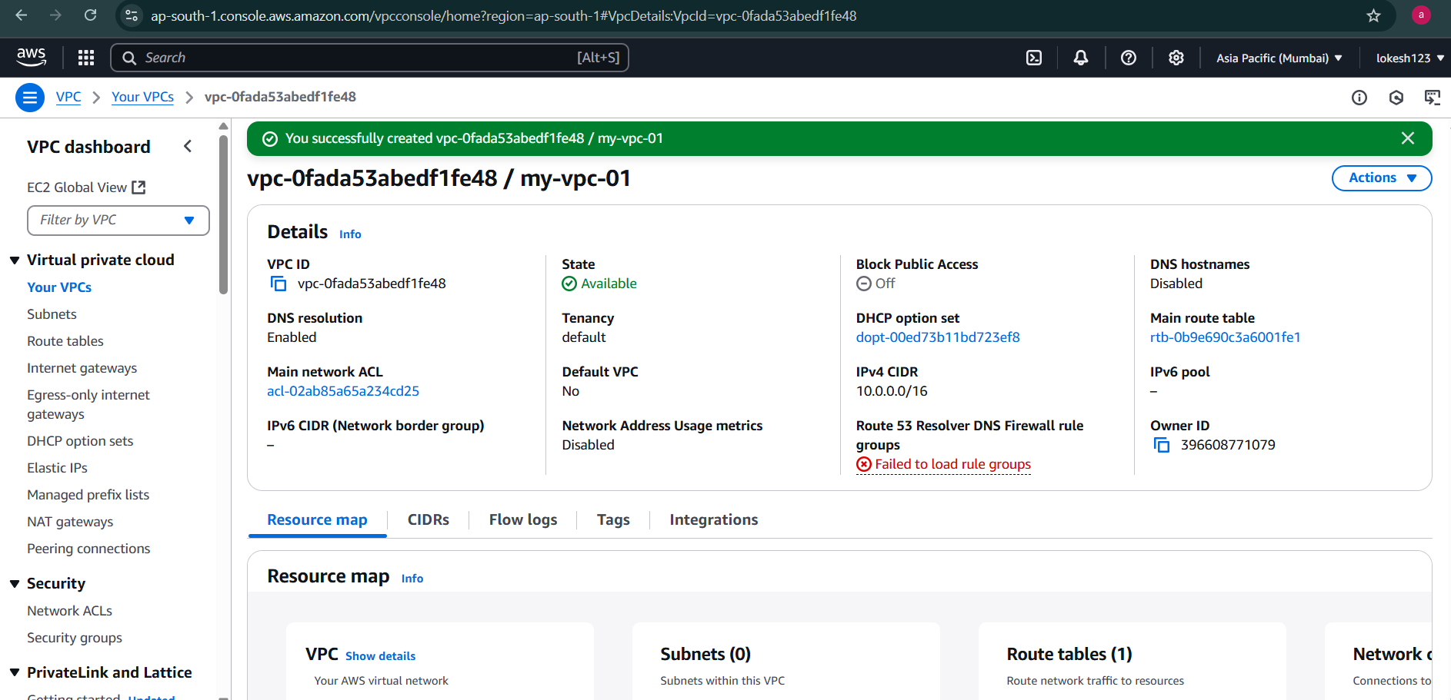

Edit VPC Settings -> Enable DNS hostnames

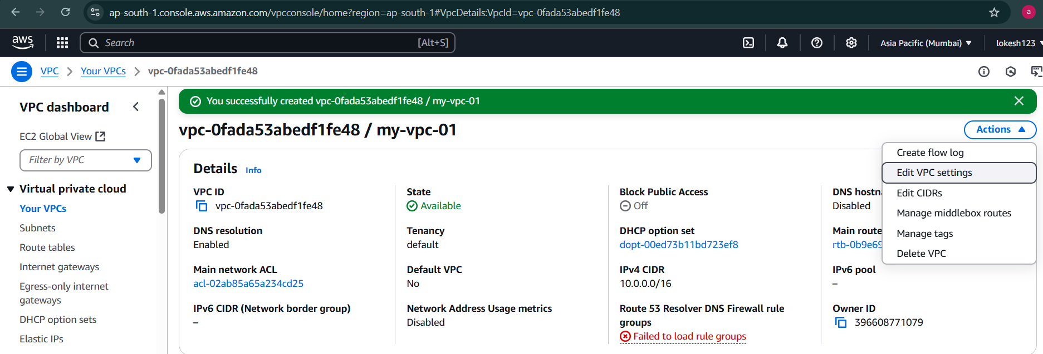

Click on save

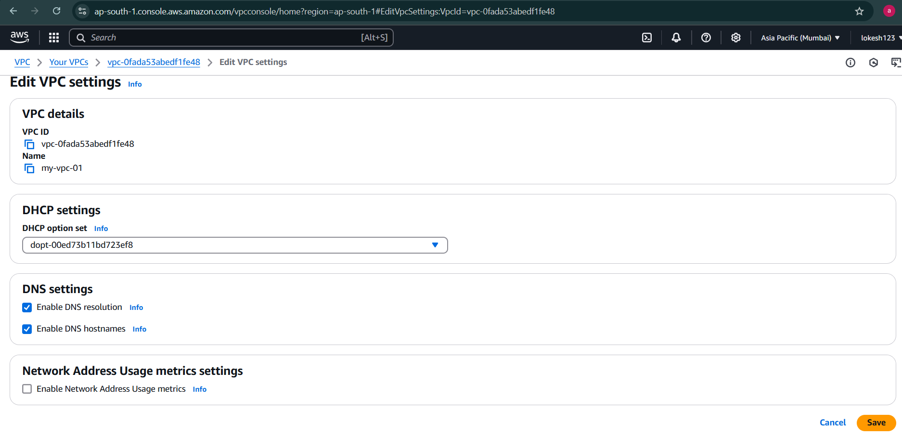

Now you can see

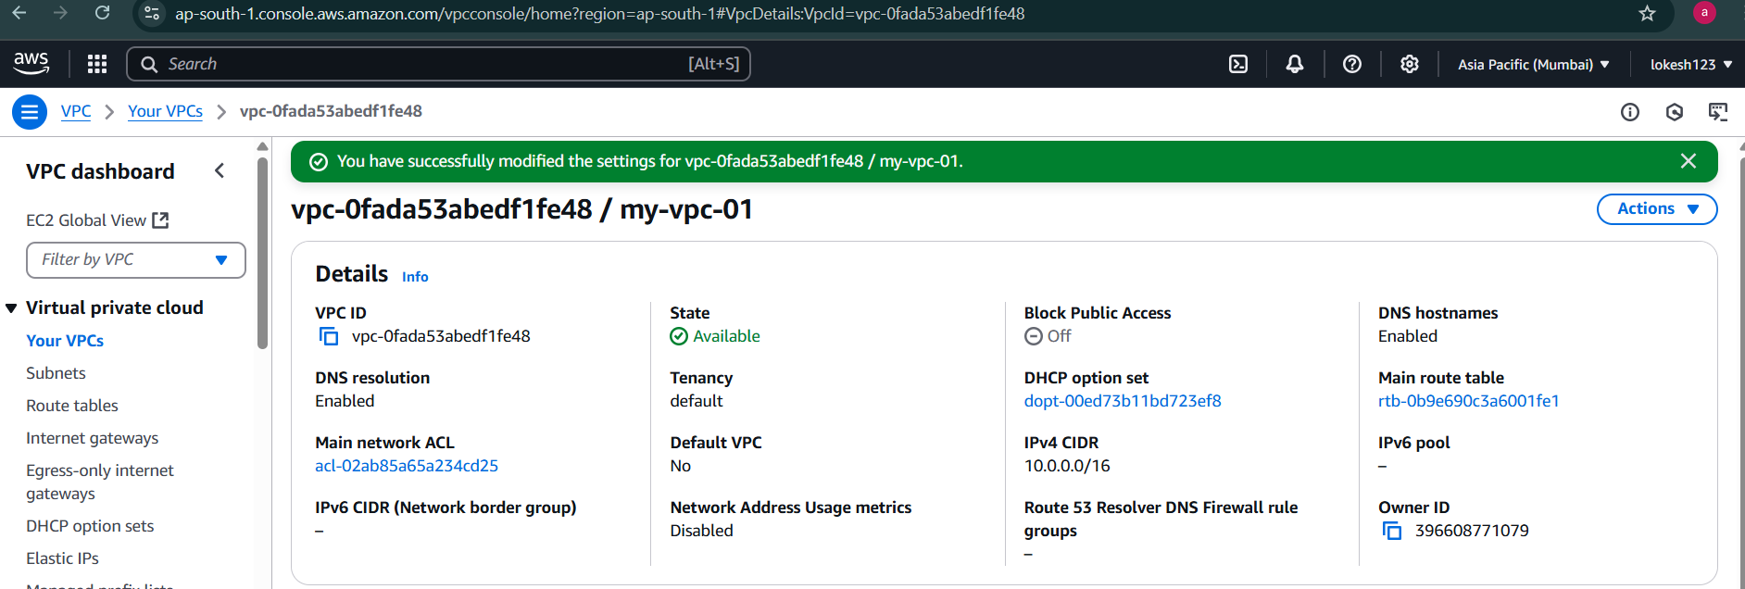

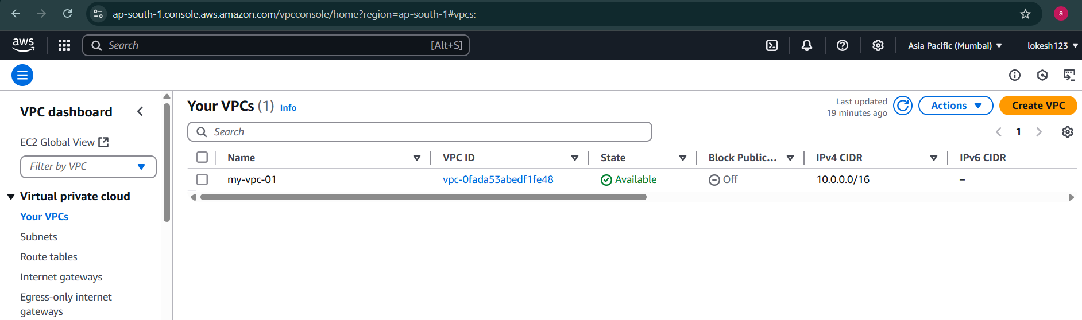

## Subnets

In console these all subnet are default subnet of that particular region

Click on Create Subnet

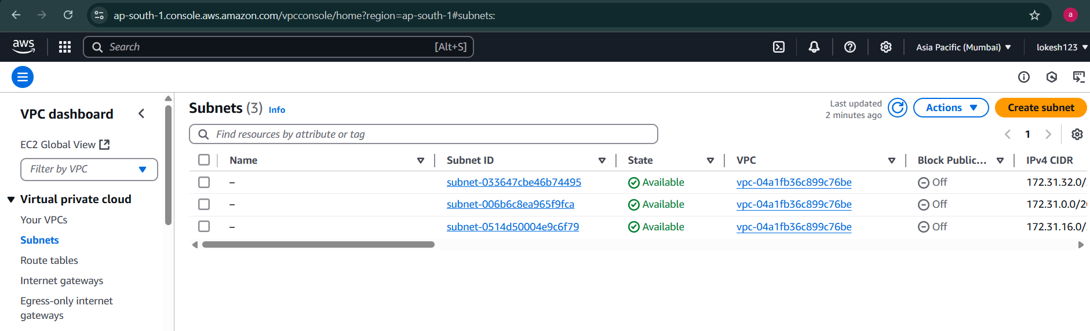

Creating 2 public subnets for zone A and zone B

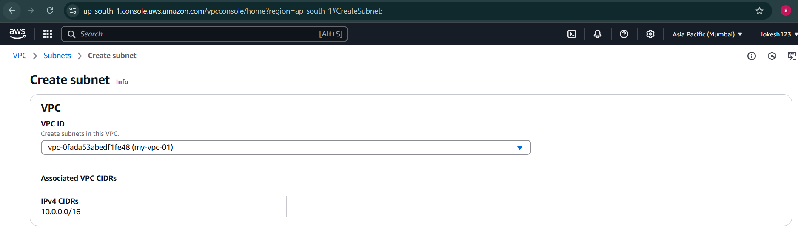

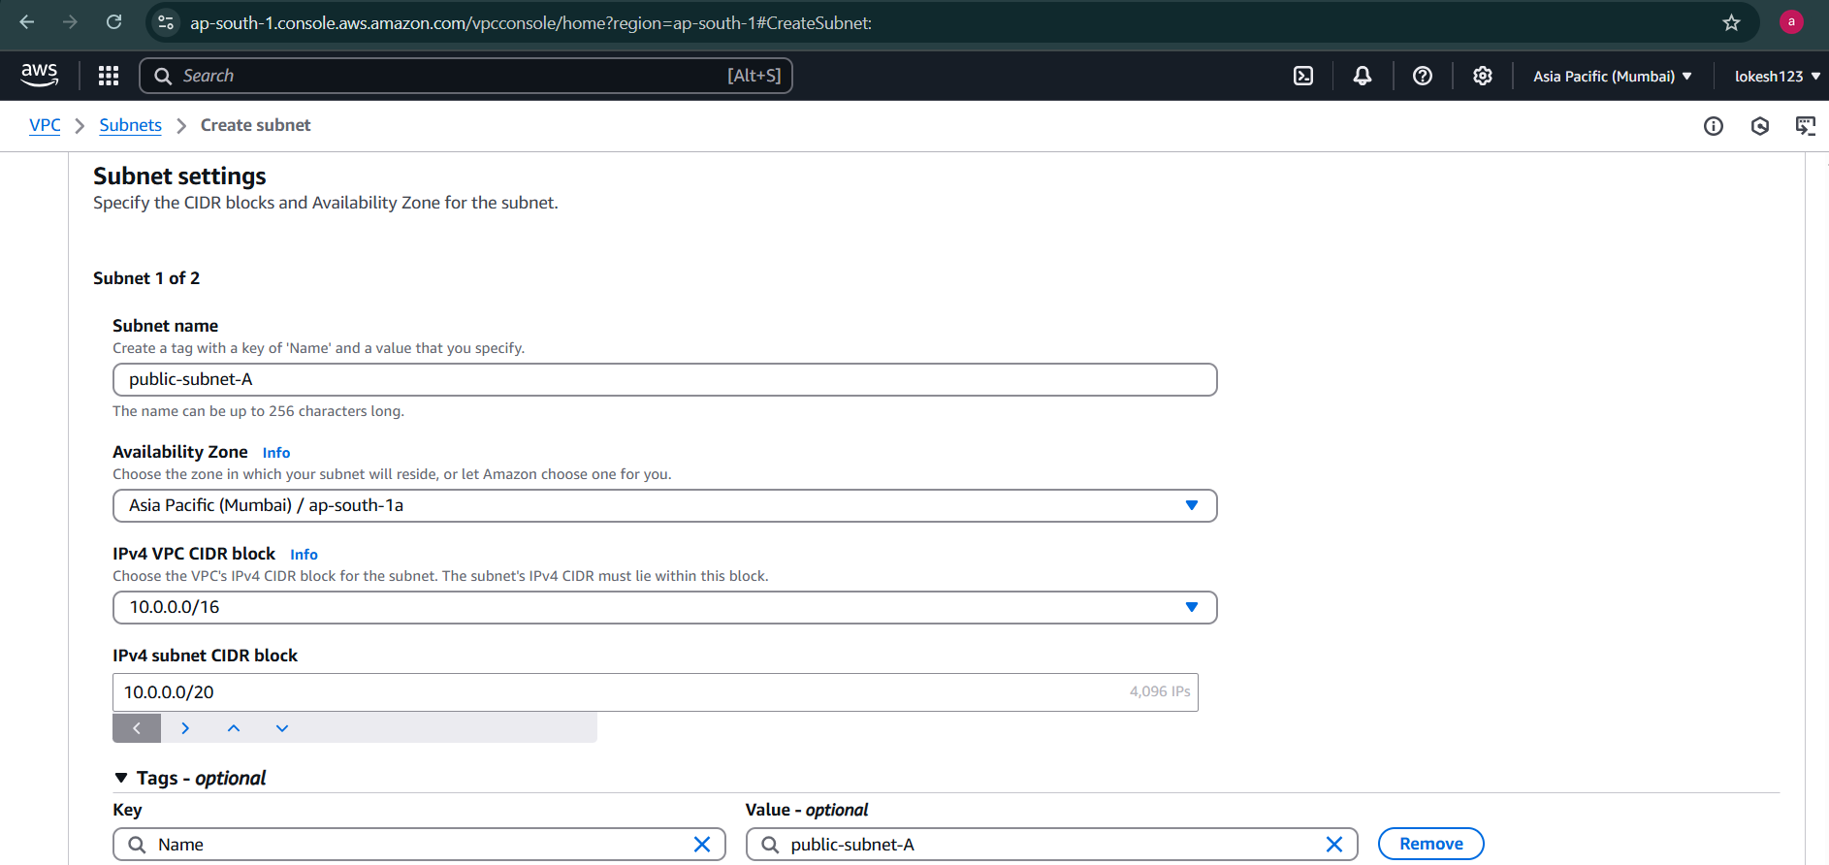

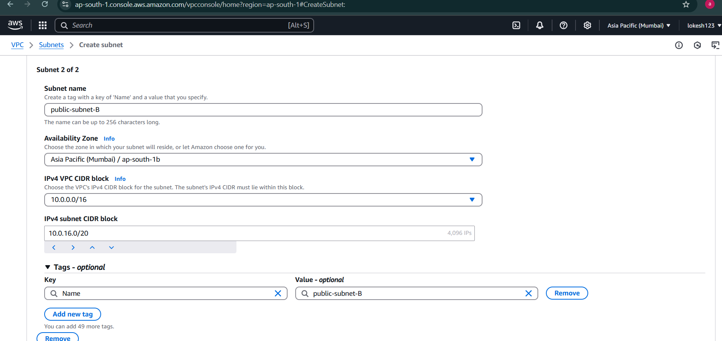

Creating 2 private subnets for zone A and zone B

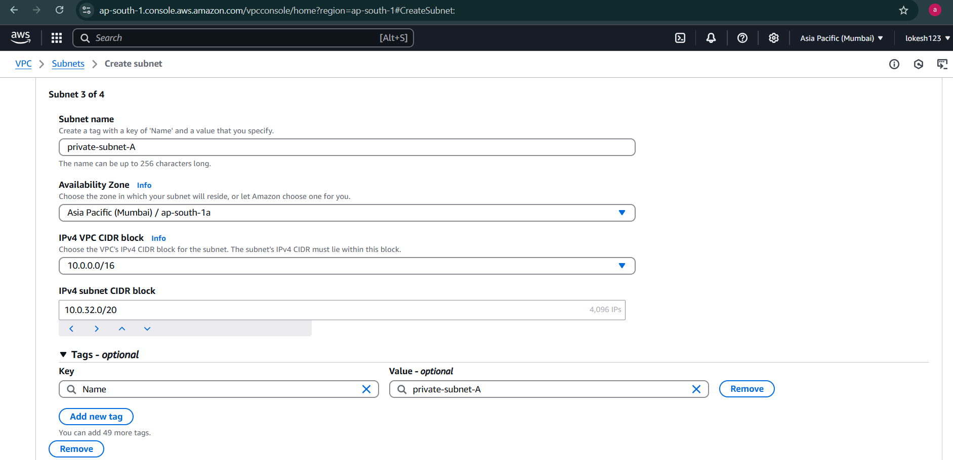

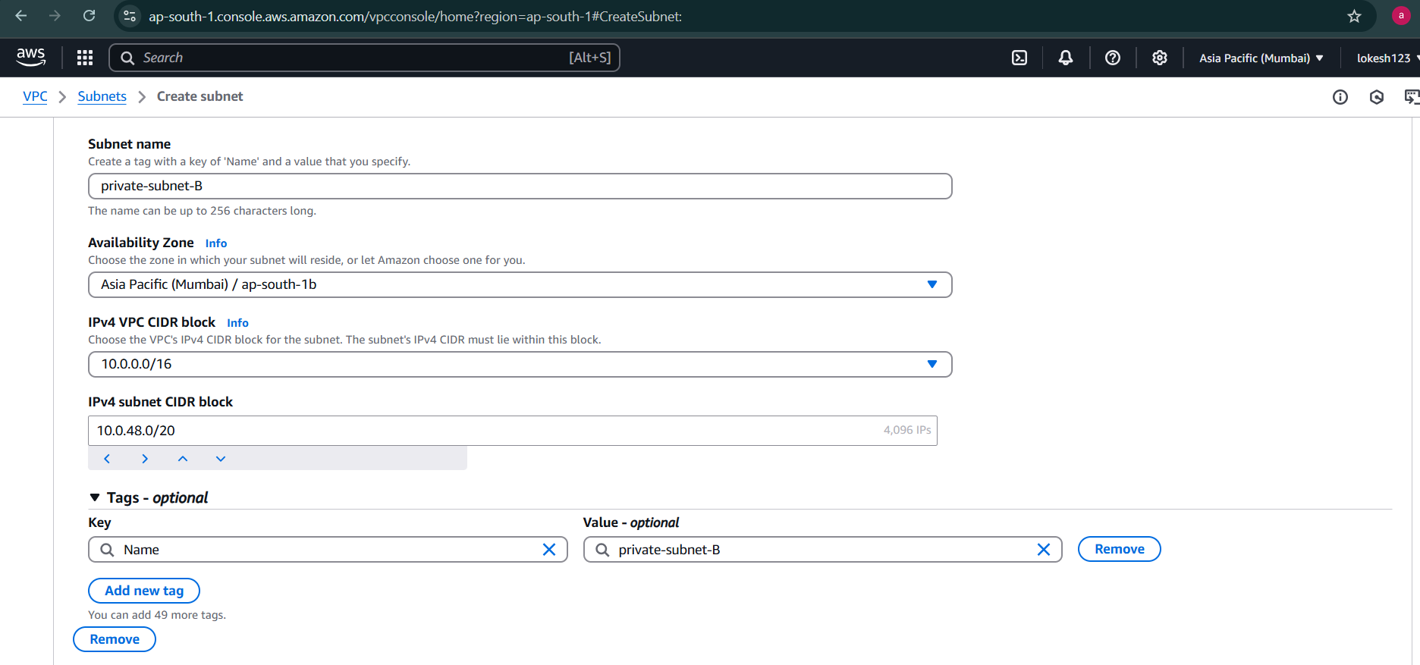

Click on create subnets



Newly created Subnets

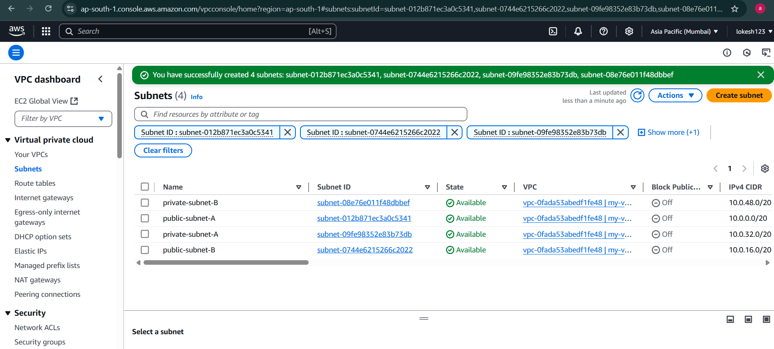

## Internet Gateway

Create Internet Gateway

Internet Gate way -> create internet gateway

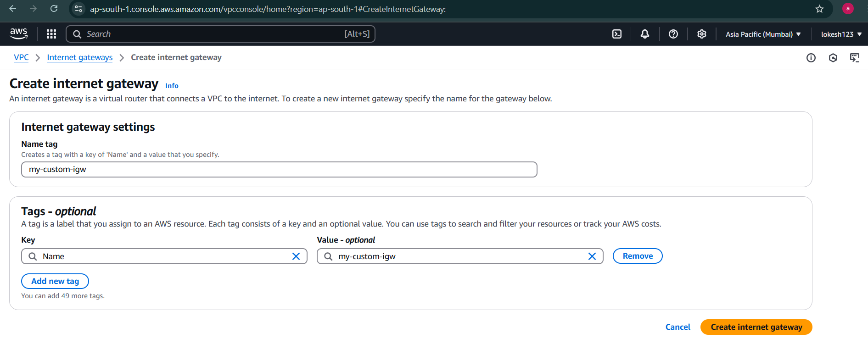

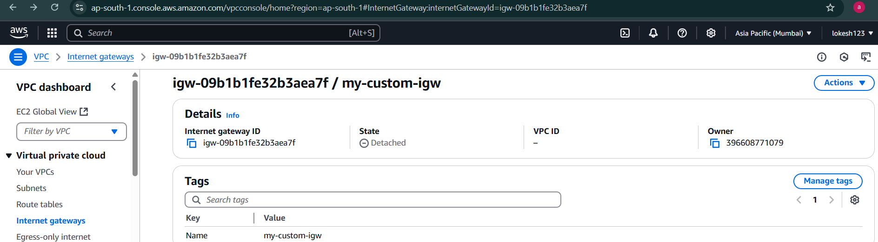

2 internet gateways listed

One is default internet gateway

Other is which is custom gateway which I created

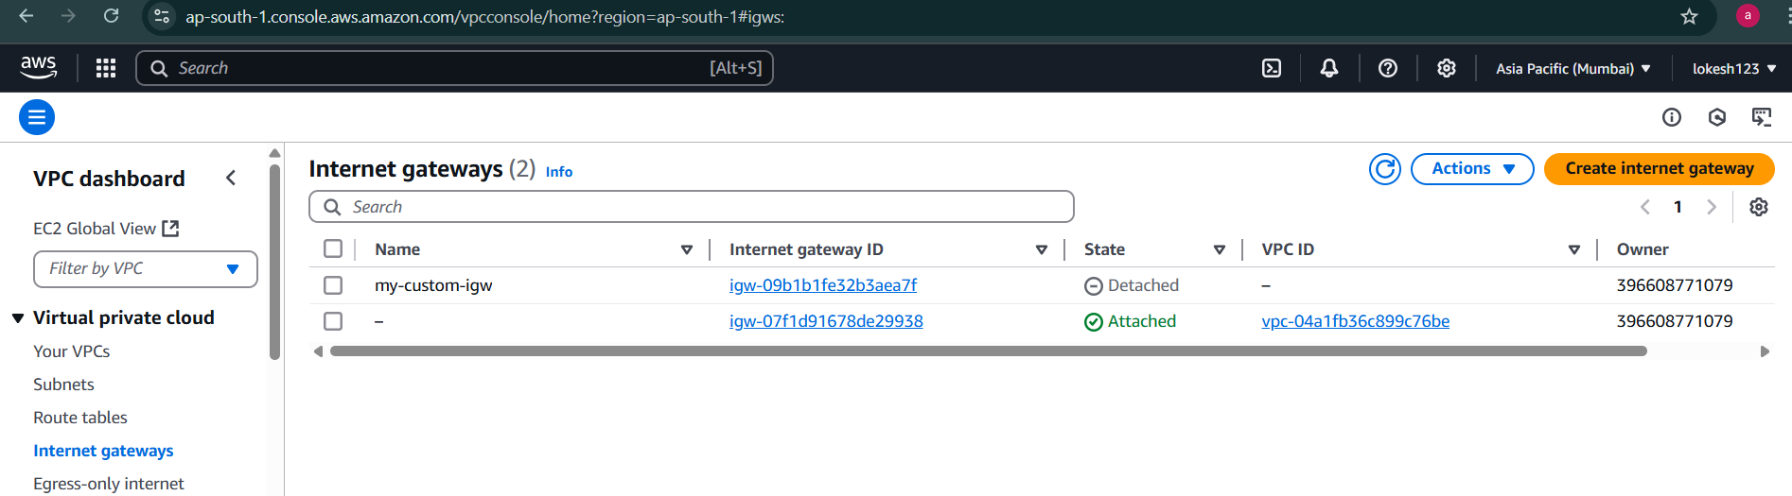

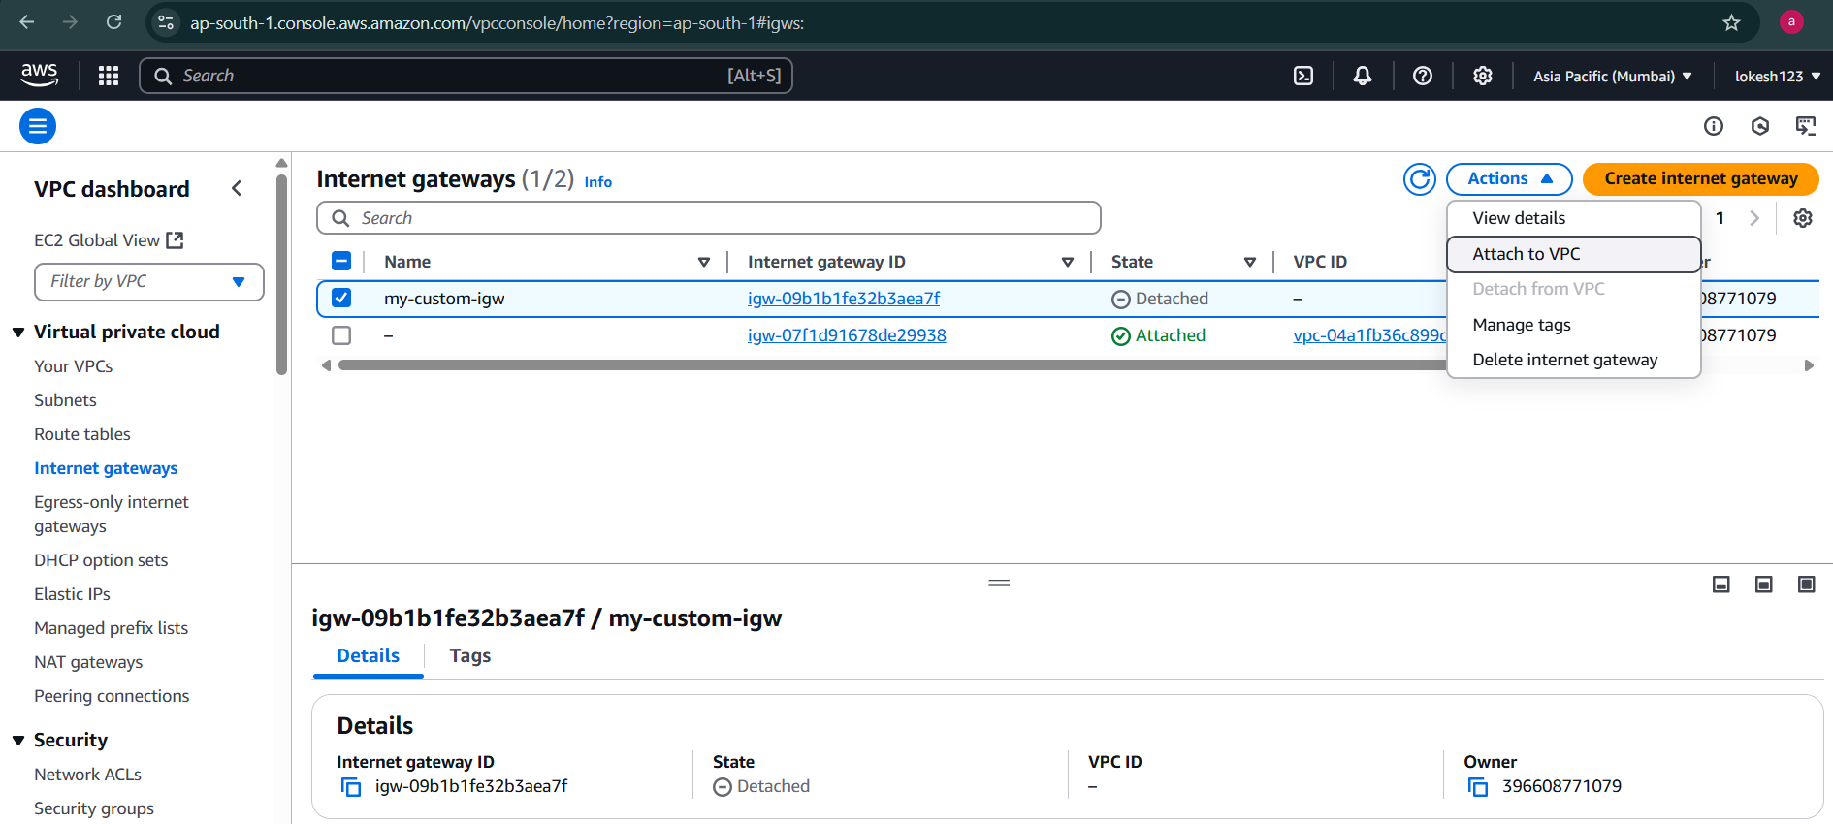

Only 1 internet gateway is attached to 1 VPC

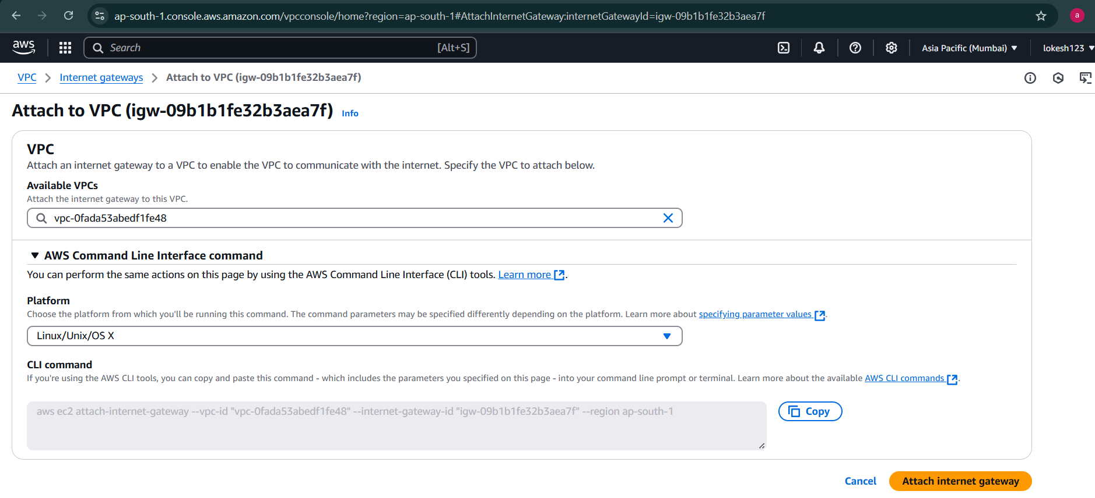

## Route Table

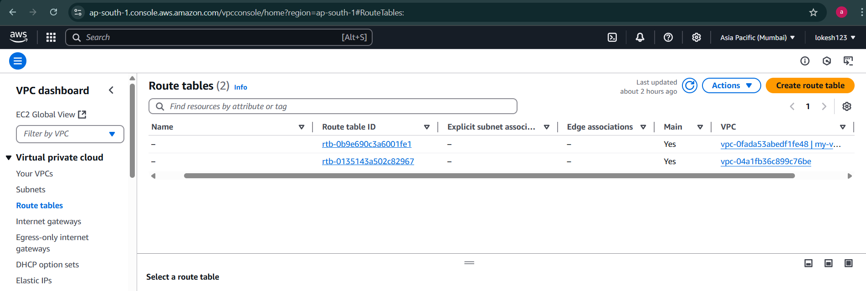

Routable created with vpc, it has all the subnets which we created in vpc

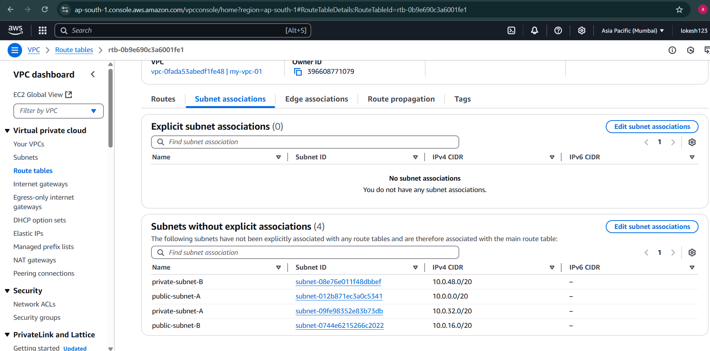

The route table with the custom internet gateway does not have access to internet

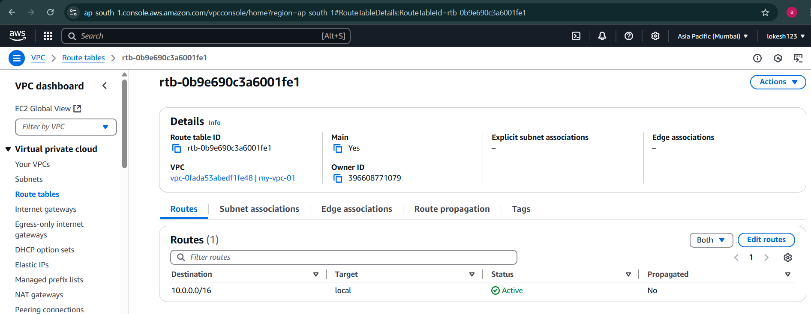

Click on create route table

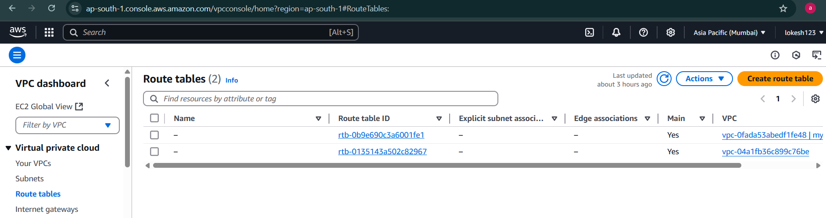

Give name and select VPC that I have created then click on create route table

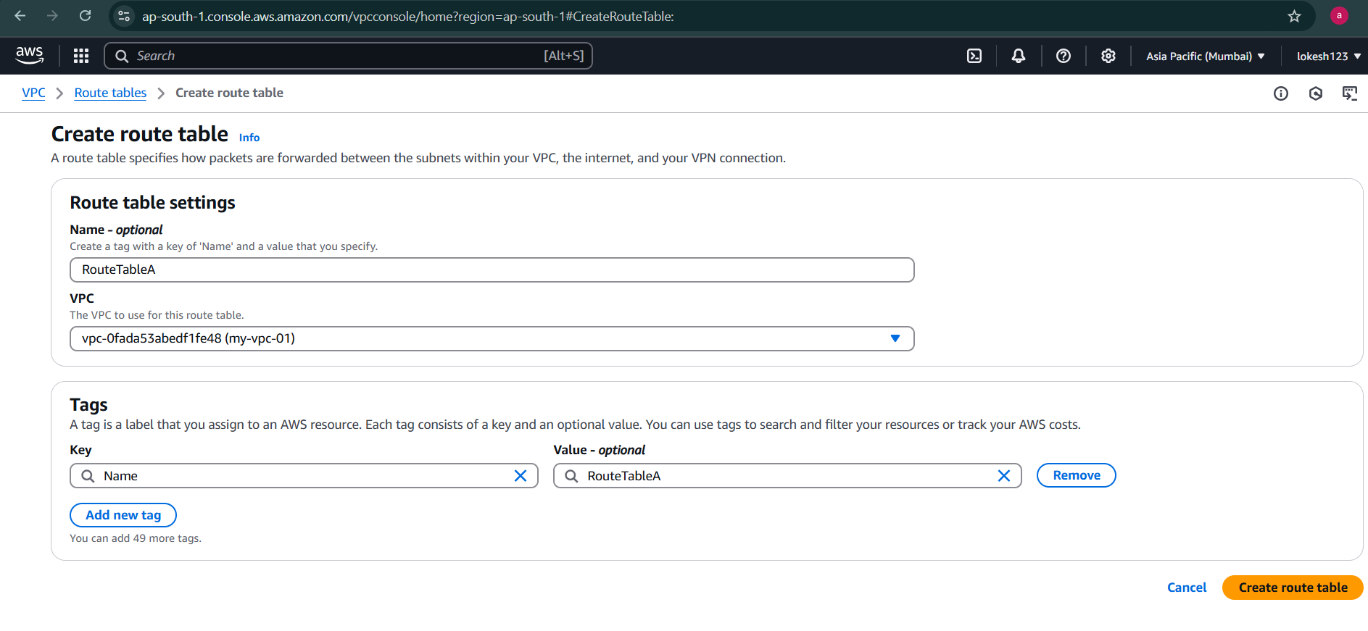

Now its created New Route Tabe named as RouteTableA

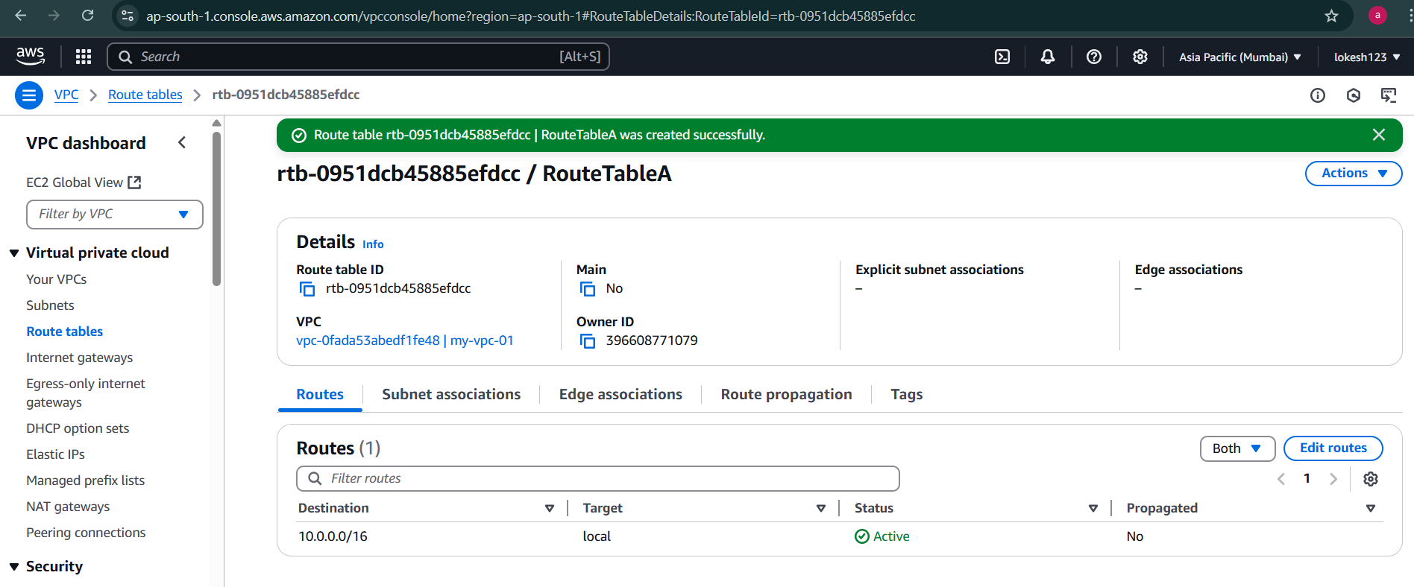

Create another routetable for private subnet

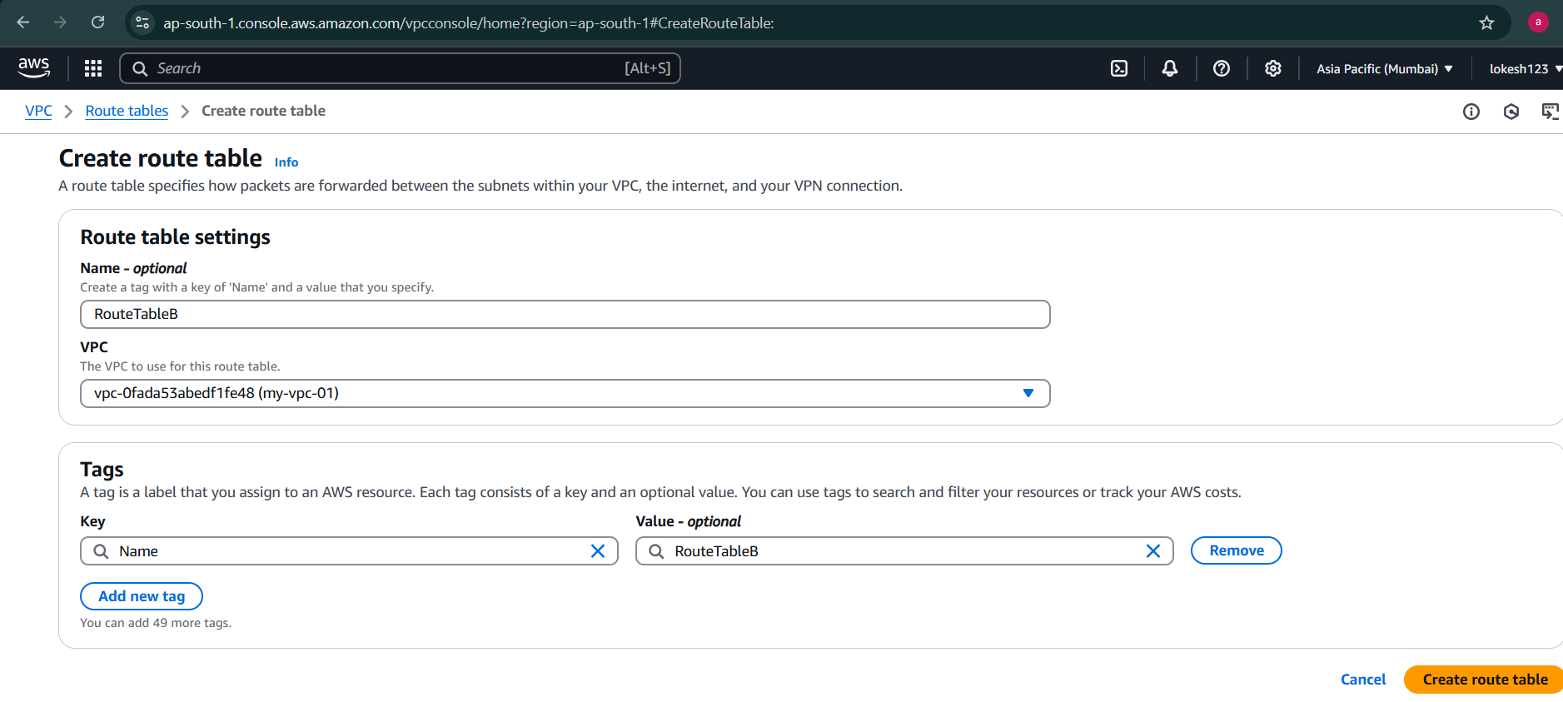

Now its created New Route Tabe named as RouteTableB

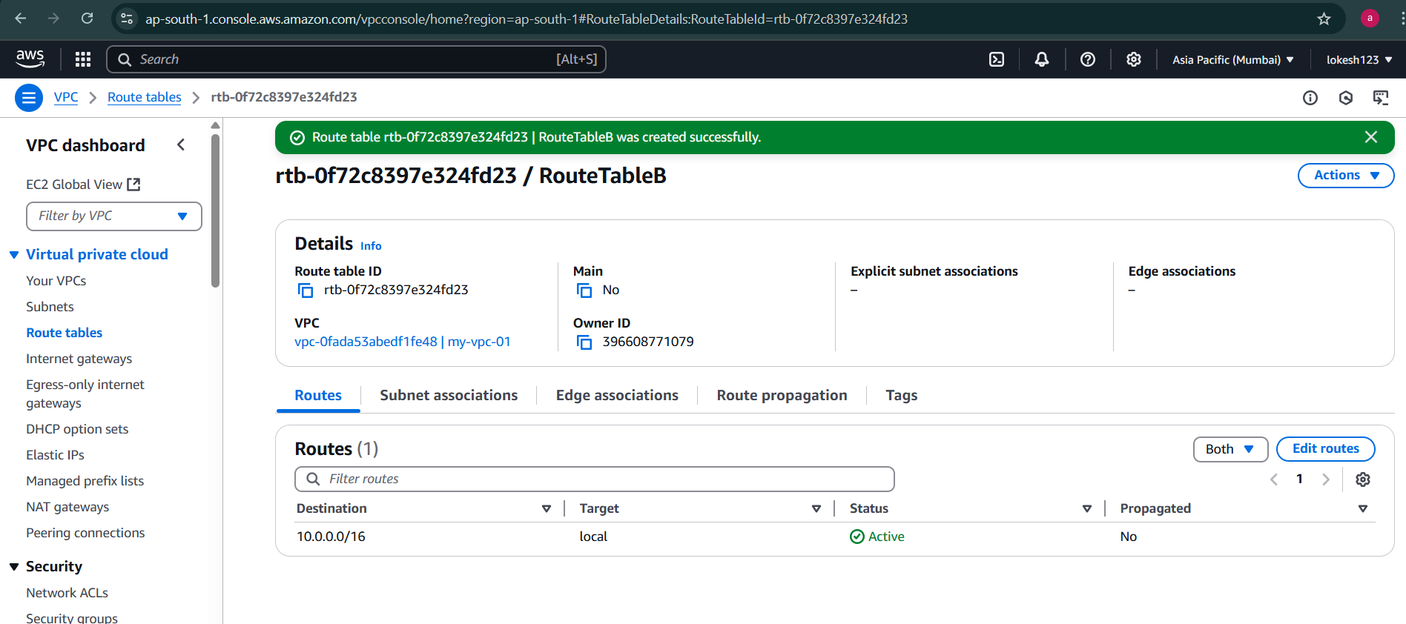

Click on RouteTable1

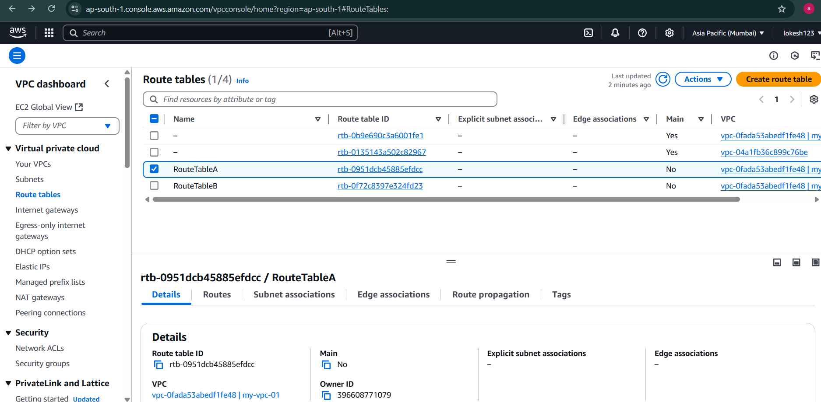

There are no Subnets in RouteTableA as of newly created

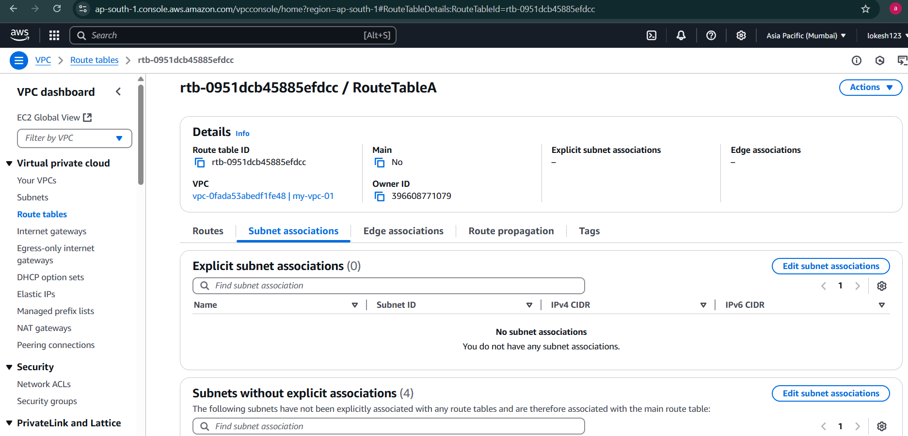

Add public subnet A and public subnet B to the RouteTableA

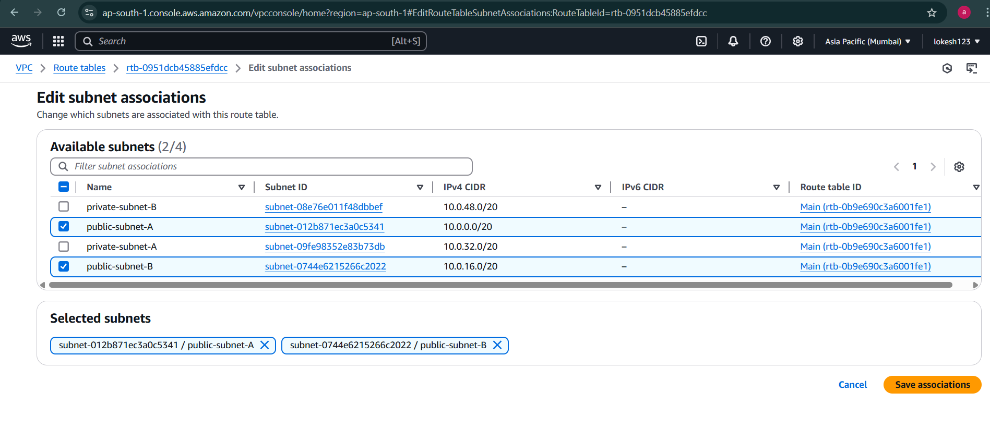

Now public-subnet-A and public-subnet-B will detach with main route and attach with RouteTableA

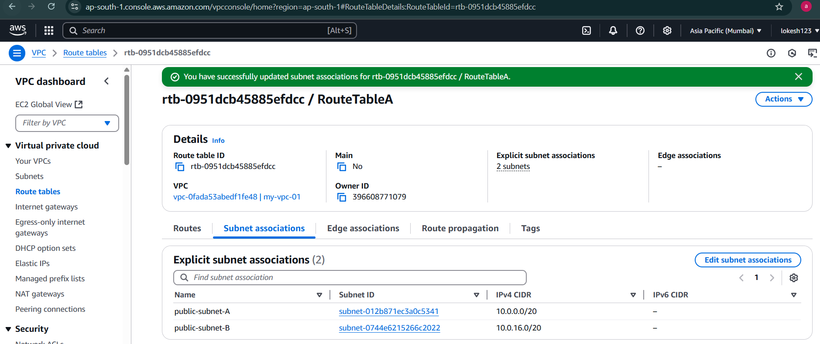

Similarly RouteTableB

Now priavte-subnet-A and private-subnet-B will detach with main route and attach with RouteTableB

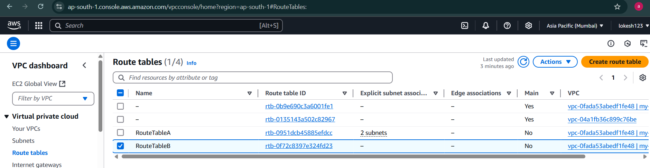

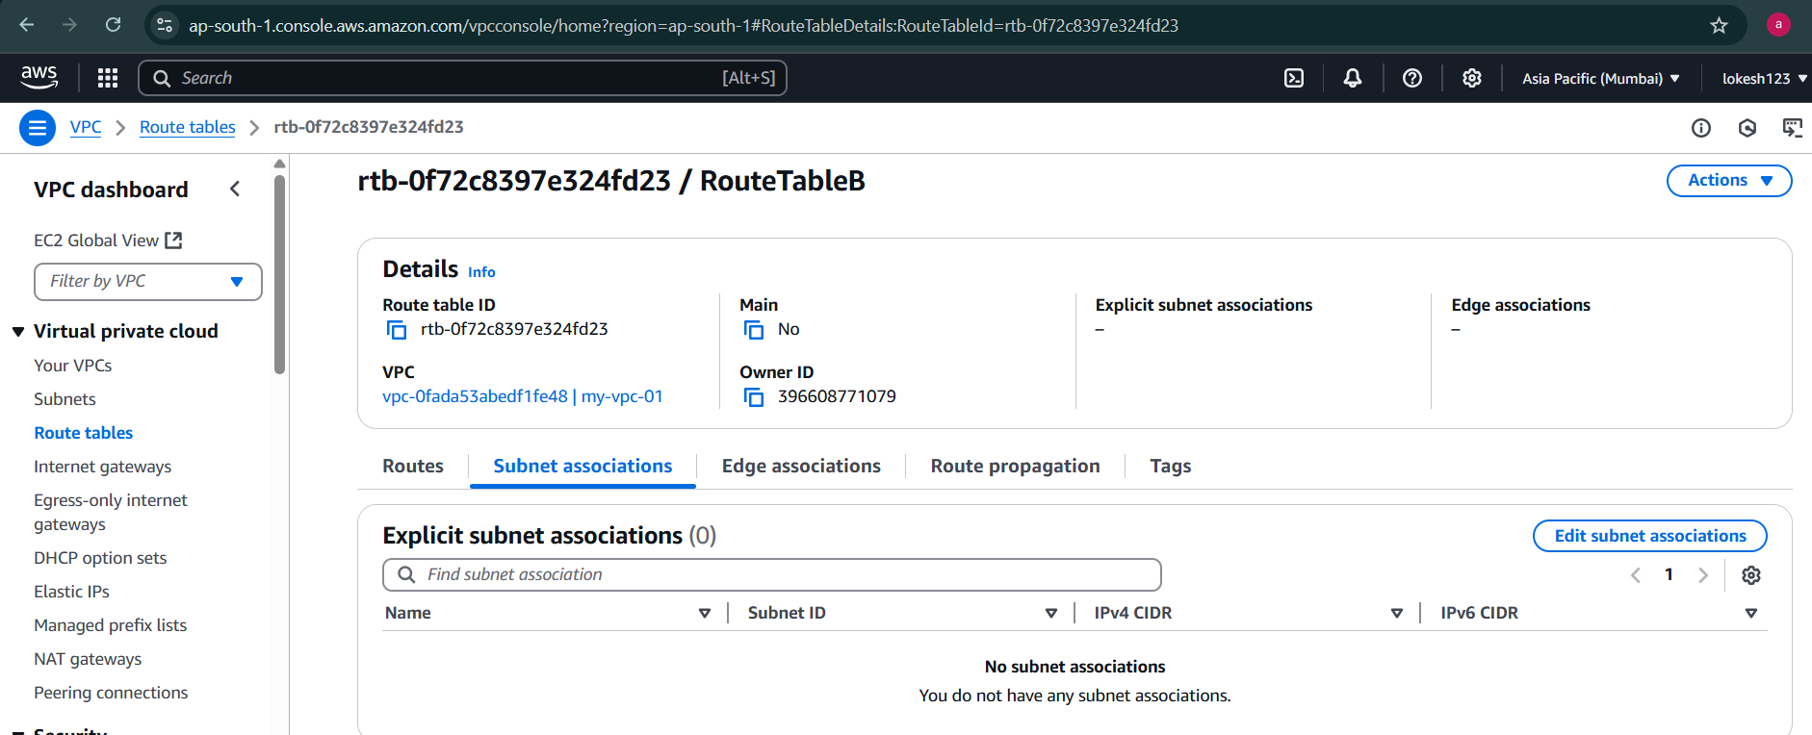

Now add private-subnet-B, private-subnet-A to the RouteTableB

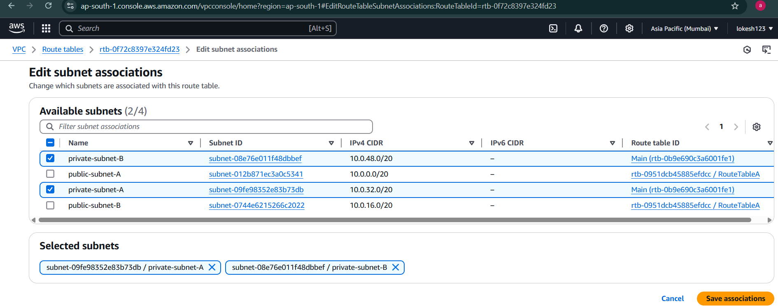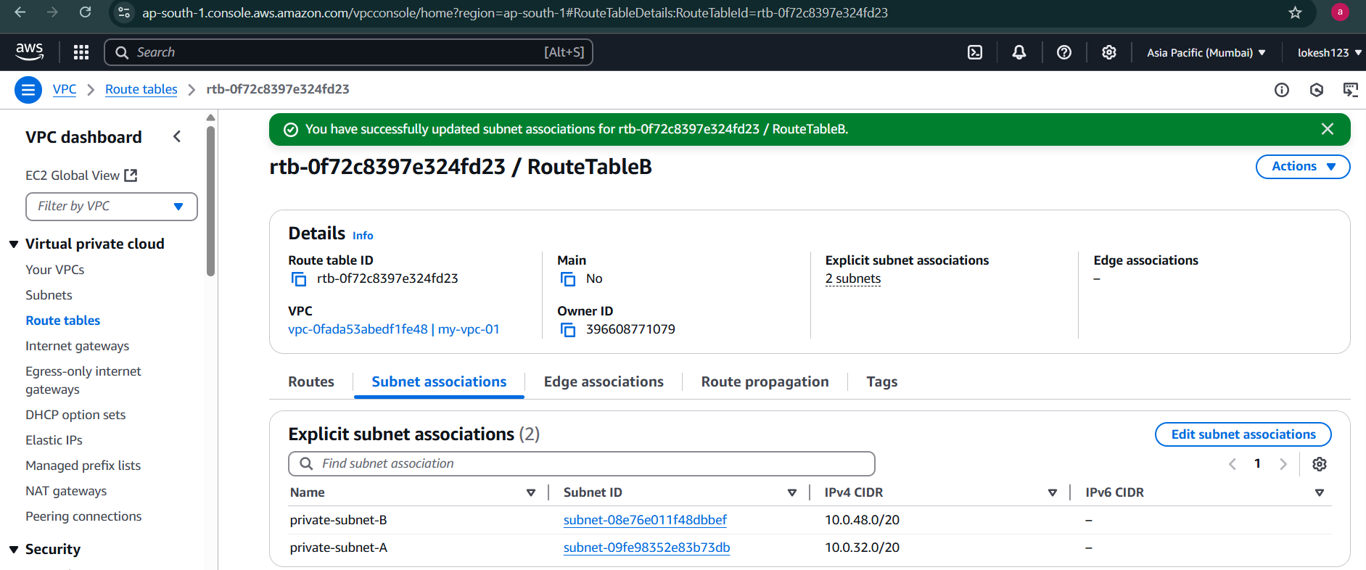

When we create route table and associate with the custom vpc bu default it doesn't have access to the internet unless we add route to the internet gateway

Go to RouteTableA

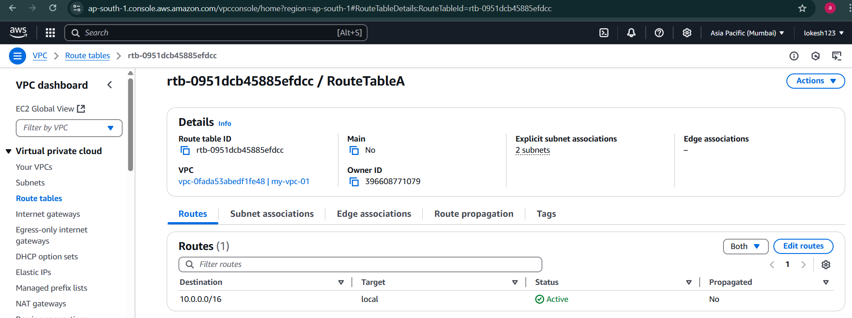

Choose 0.0.0.0/0 means all the ips applicable at destination and choose target as Internet Gateway and then click on save changes

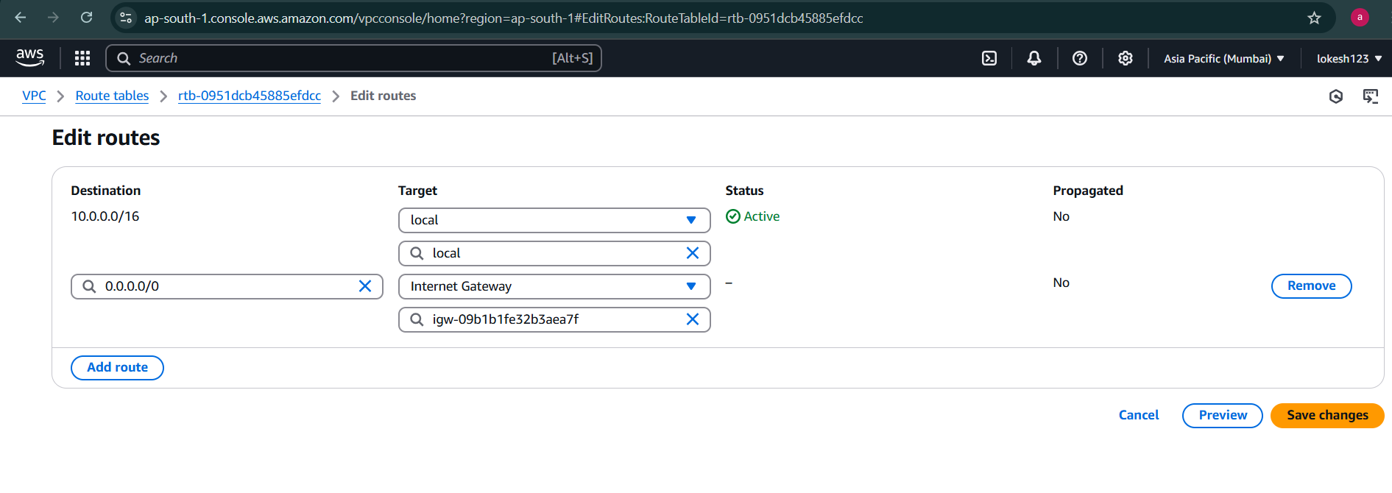

Now RouteTableA has internet gateway has route to internet via internet gateway

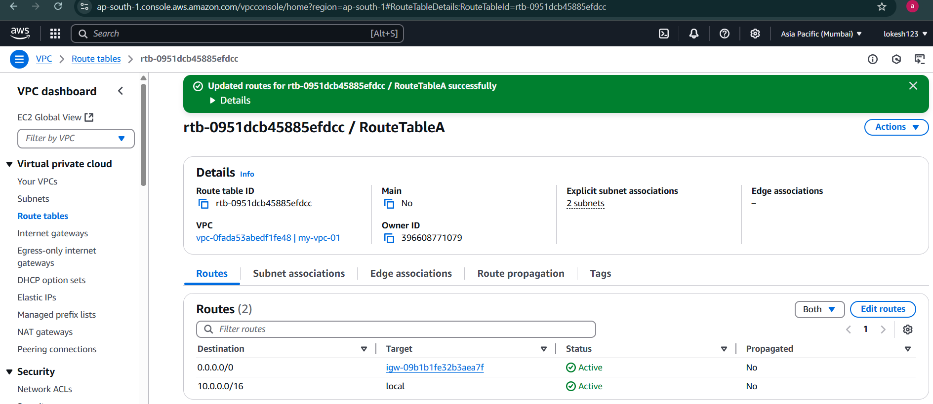

## Security Groups

* A security group acts as a virtual firewall for your EC2 instances to control incoming and outgoing traffic.
* Inbound rules control the incoming traffic to your instance, and outbound rules control the outgoing traffic from your instance.
* If you don't specify a security group, Amazon EC2 uses the default security group.
* By default, security groups allow all outbound traffic.
* Security groups are stateful-if you send a request from your instance, the response traffic for that request is allowed to flow in regardless of inbound security group rules.
* You can associate more than one security group with an instance.

Security group - Rules

Amazon EC2 blocks traffic on port 25 by default.

Security group rules are always permissive; you can't create rules that deny access.

You can add and remove rules at any time. Your changes are automatically applied to the instances that are associated with the security group.

Specify below at the time of rule creation:

Name

Protocol

Port Range

Type

Source: Custom/AnyWhere/MyIP

Source Value: CIDR Block, Security Group

EC2 one for public subnet -> for webserver

EC2 one for private subnet -> for database server

Go to EC2 instance

Launch Instance

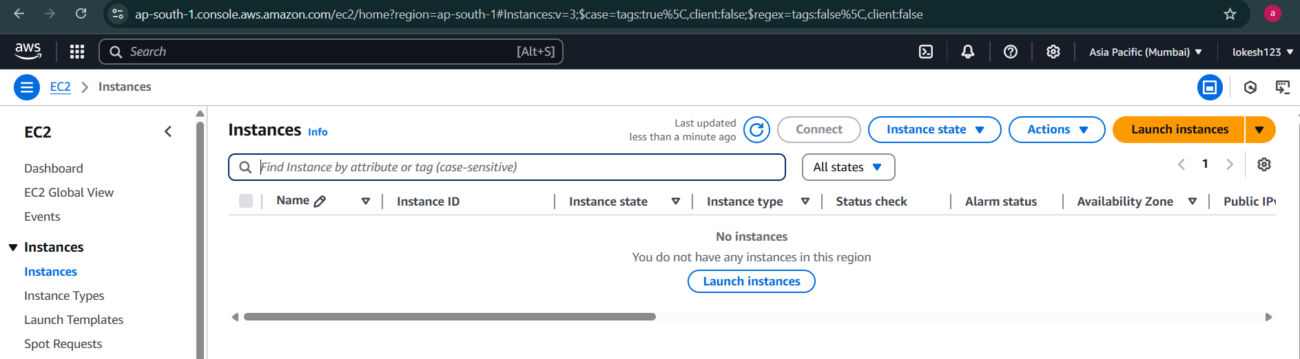

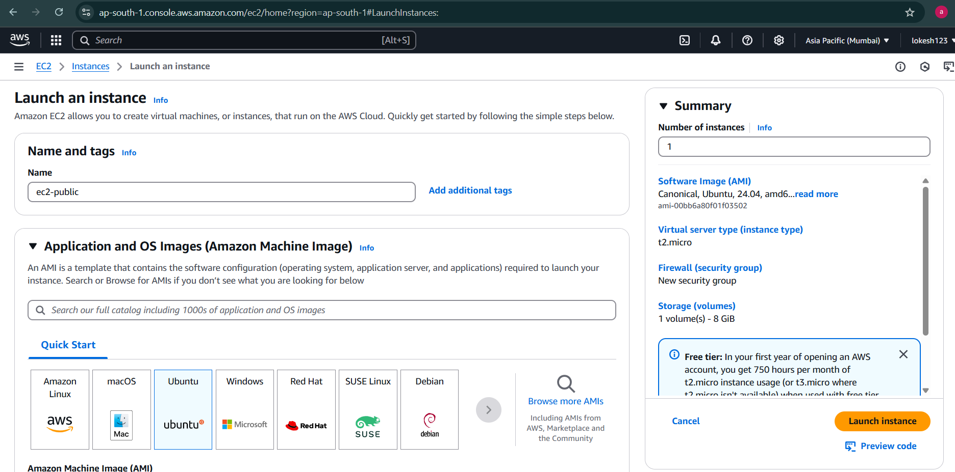

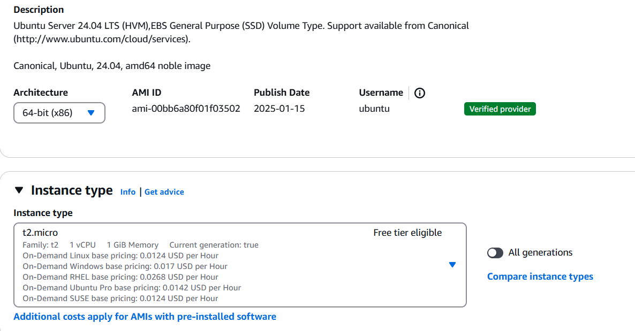

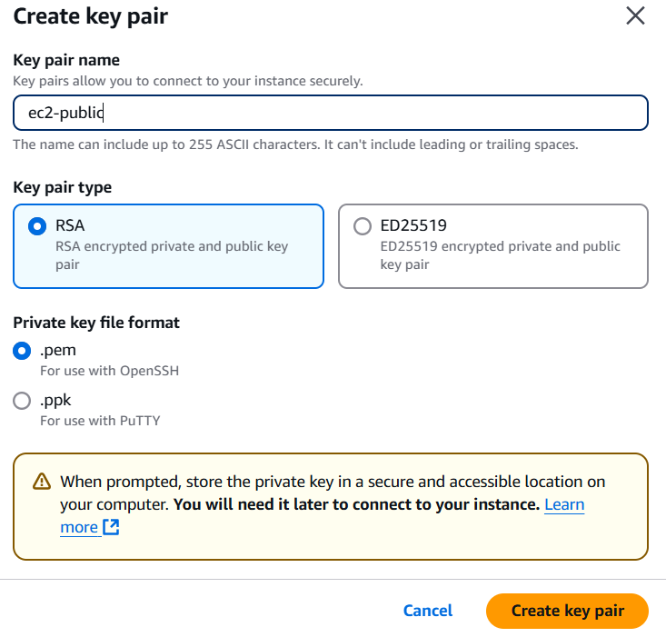

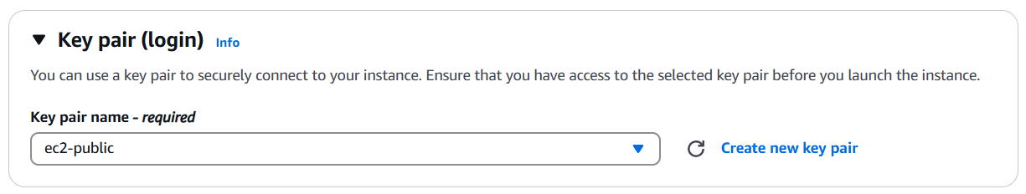

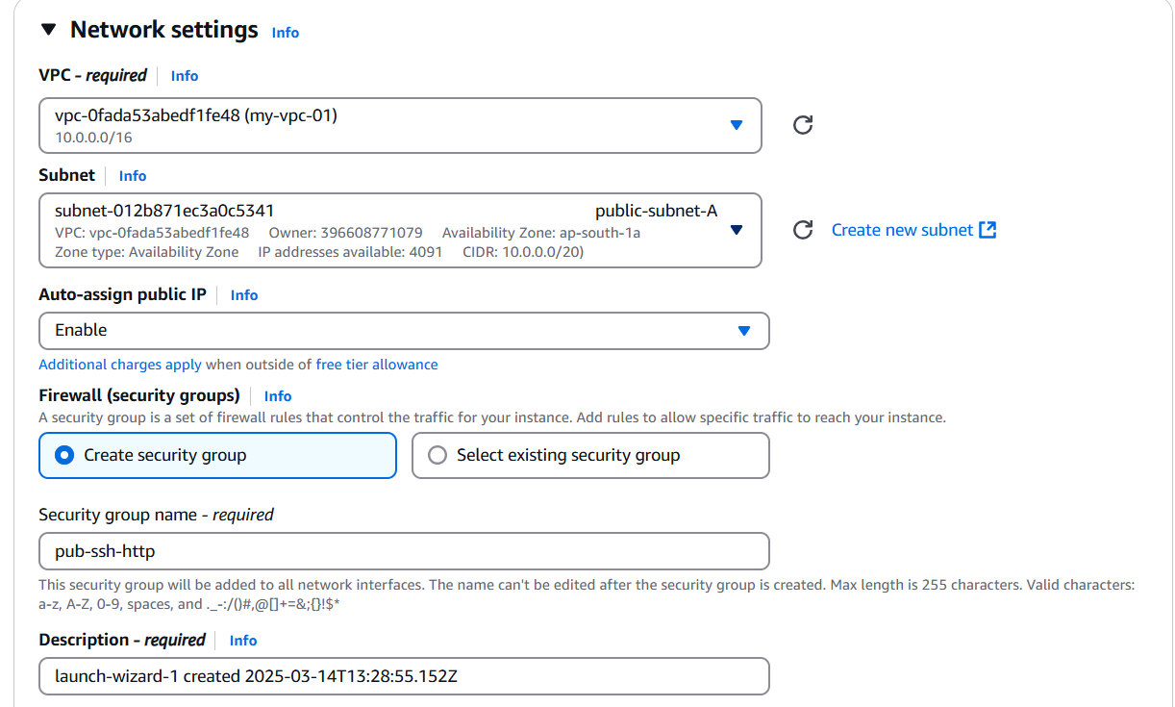

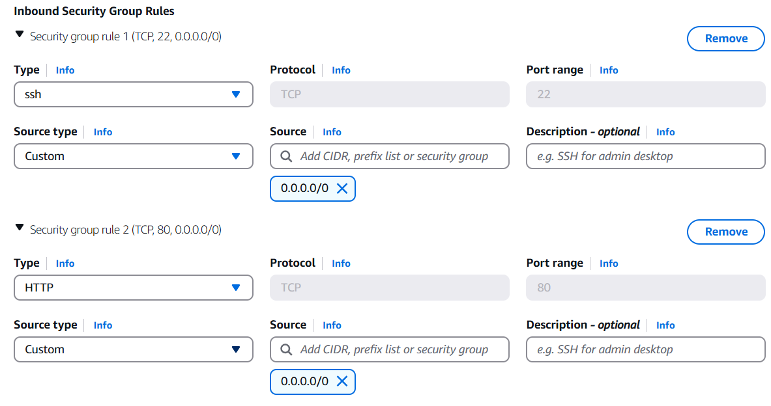

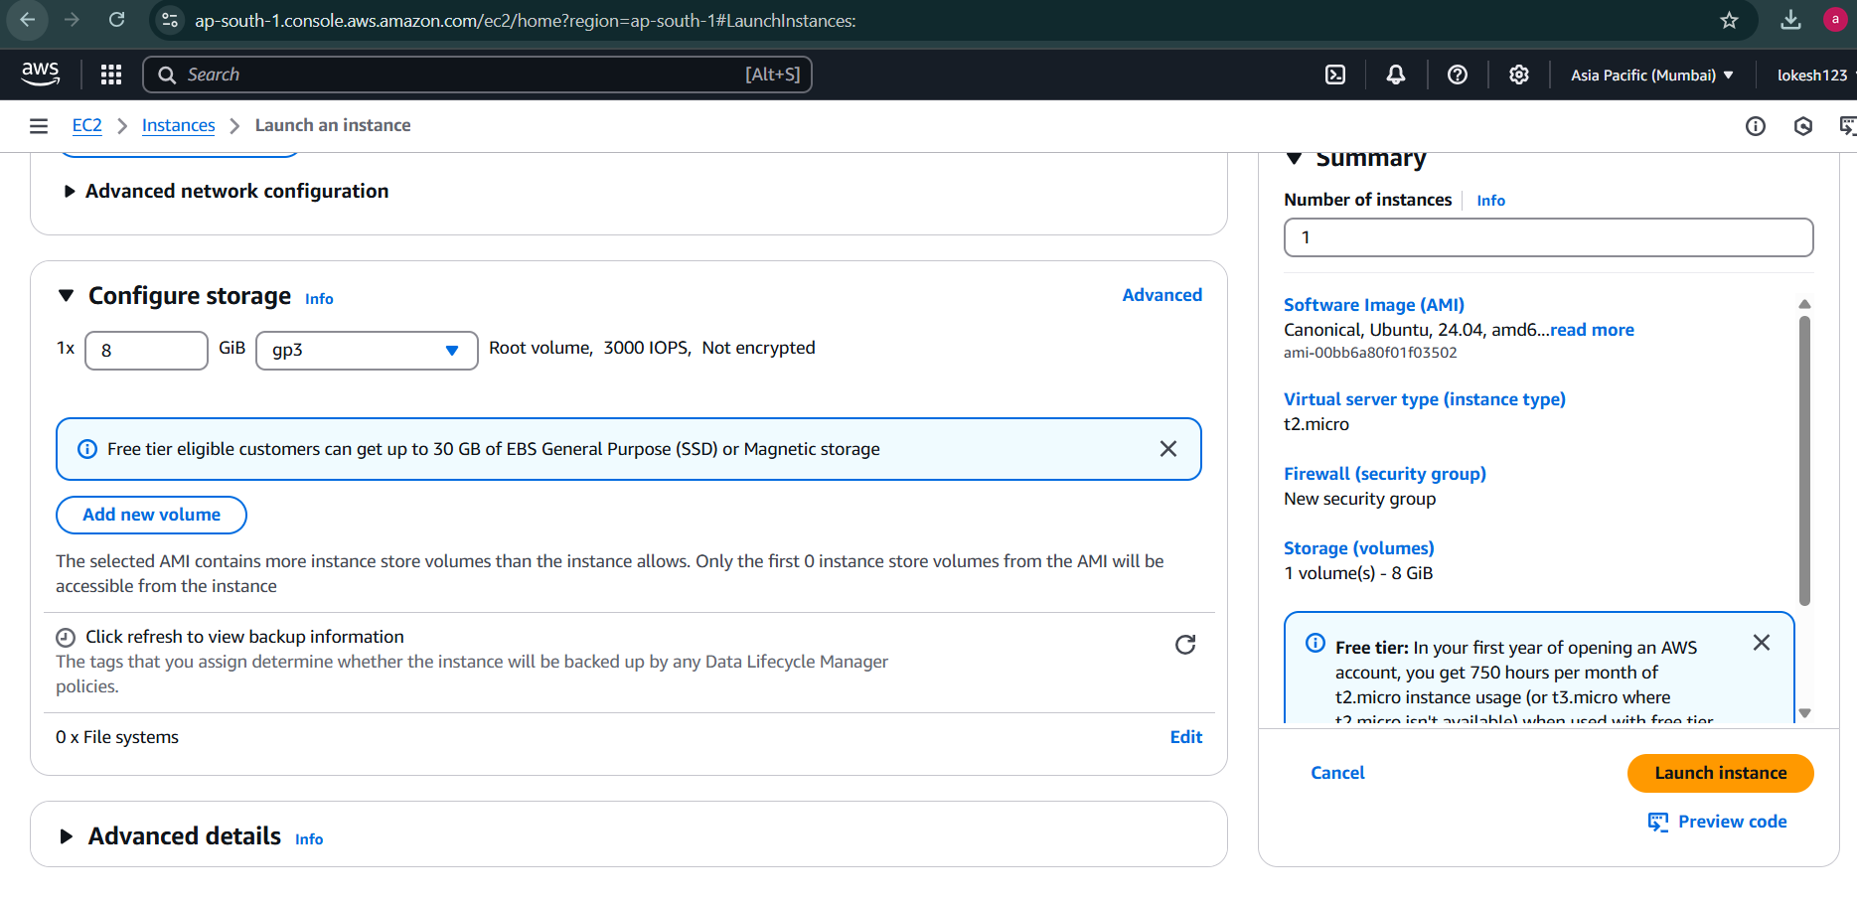

Launch 2nd ec2 instance as database server

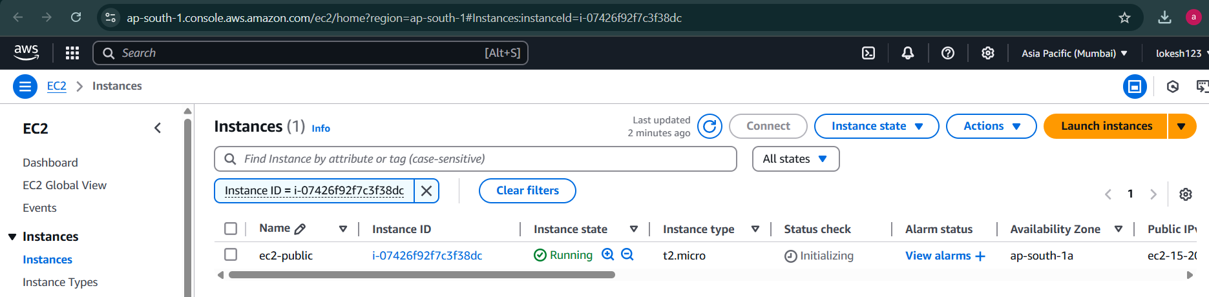

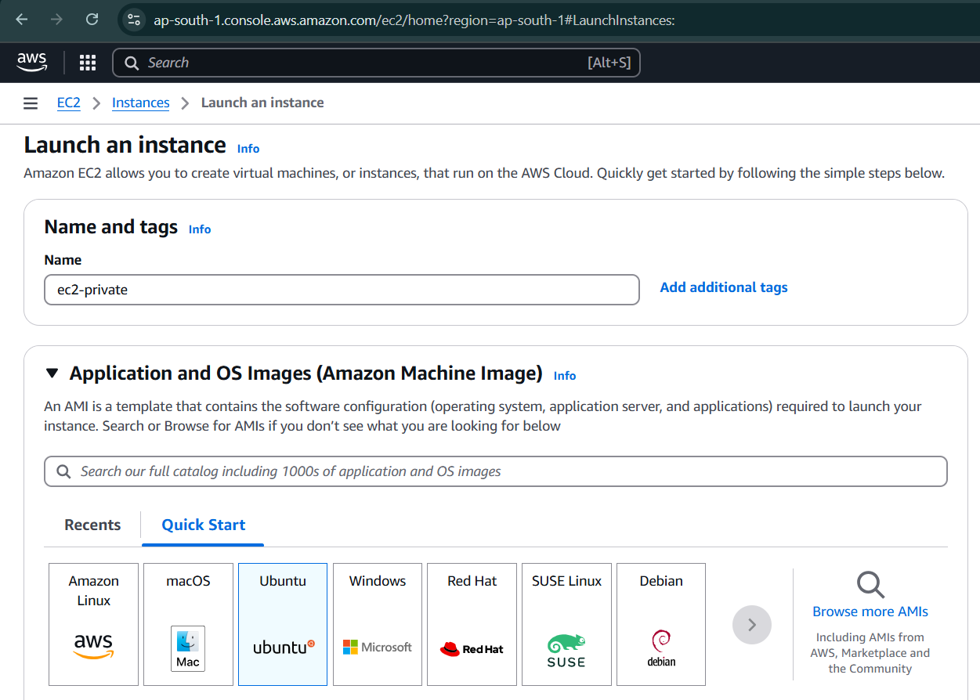

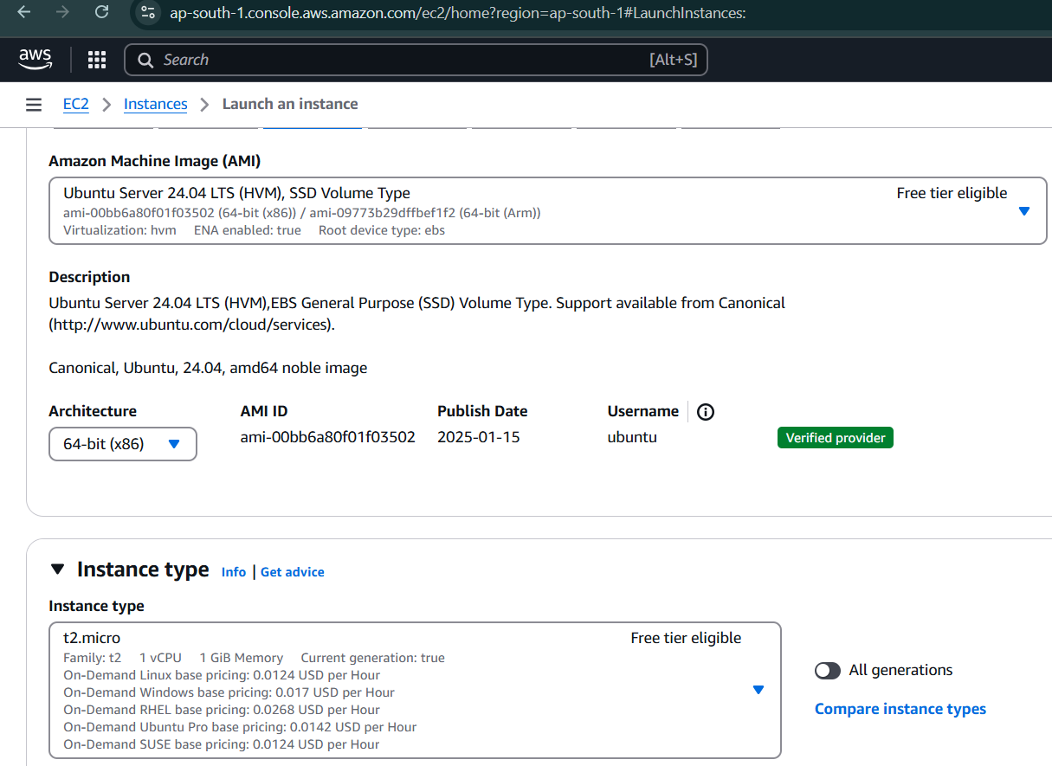

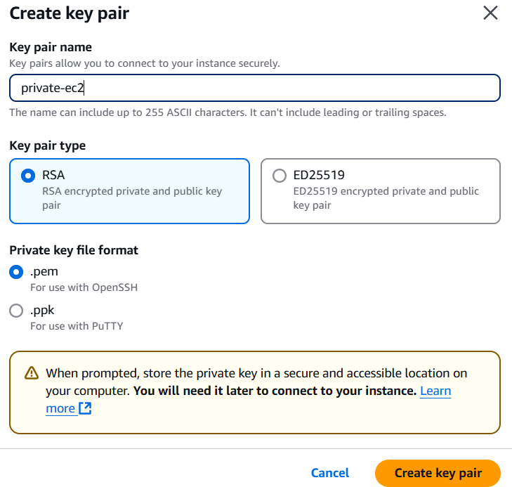

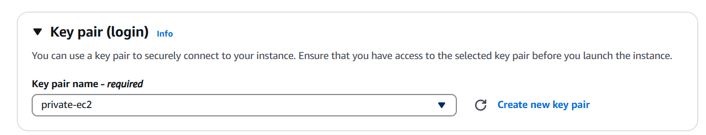

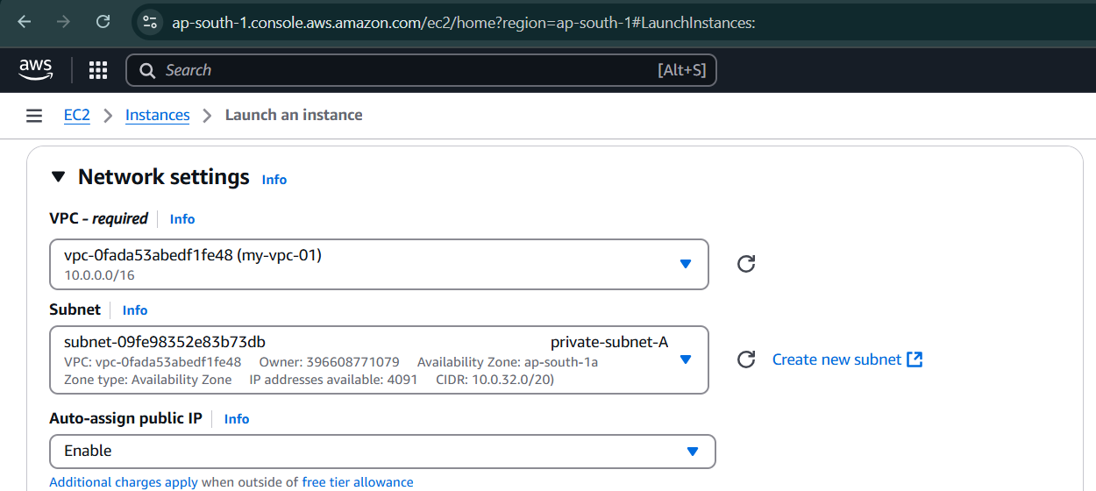

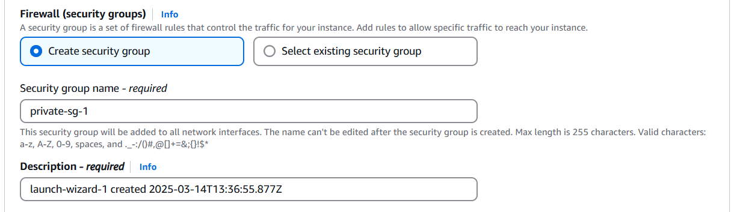

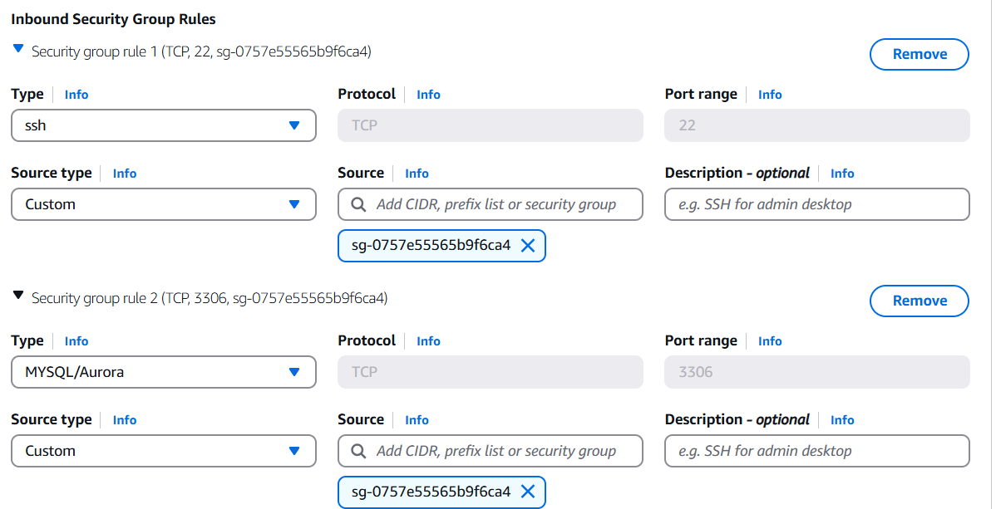

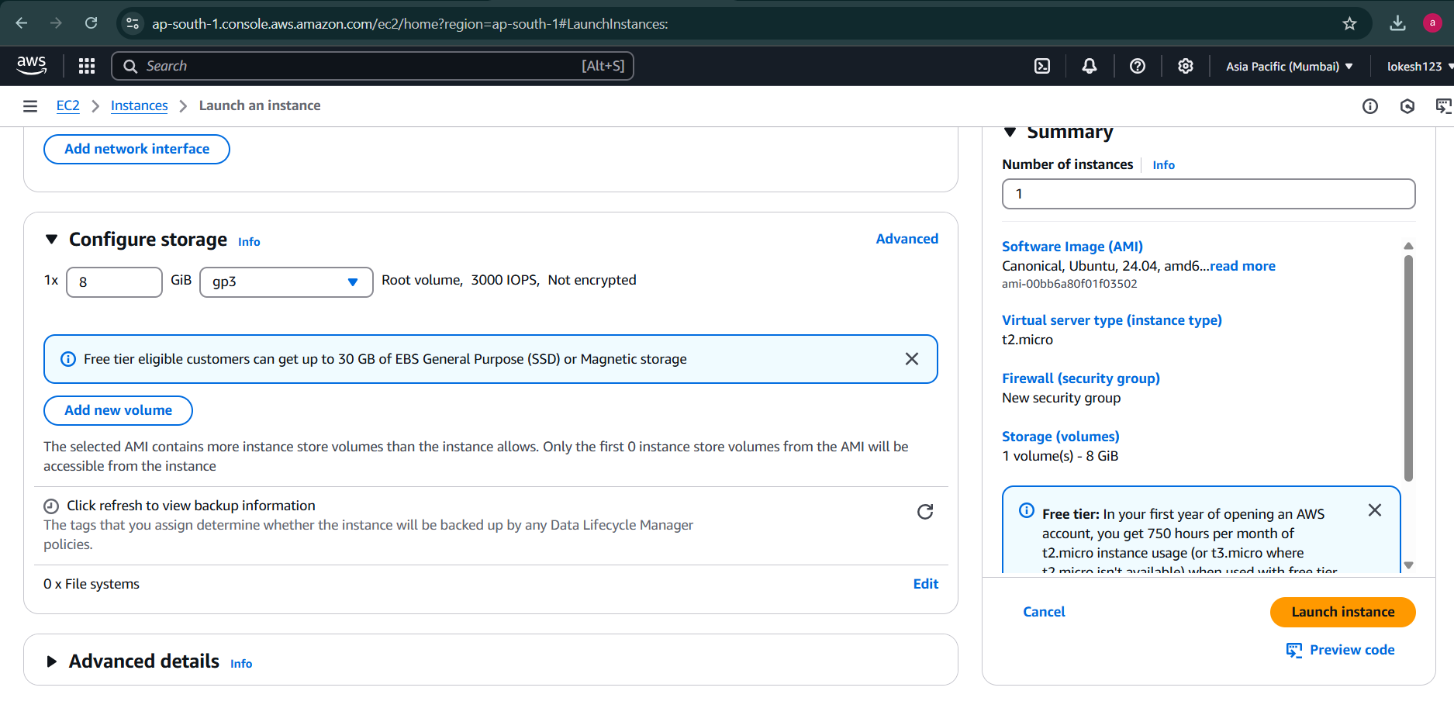

Go to ec2-public and copy Public IPv4 take it as host , give user name as ubuntu and also take key pair past in path give it inthe MobaXtrem

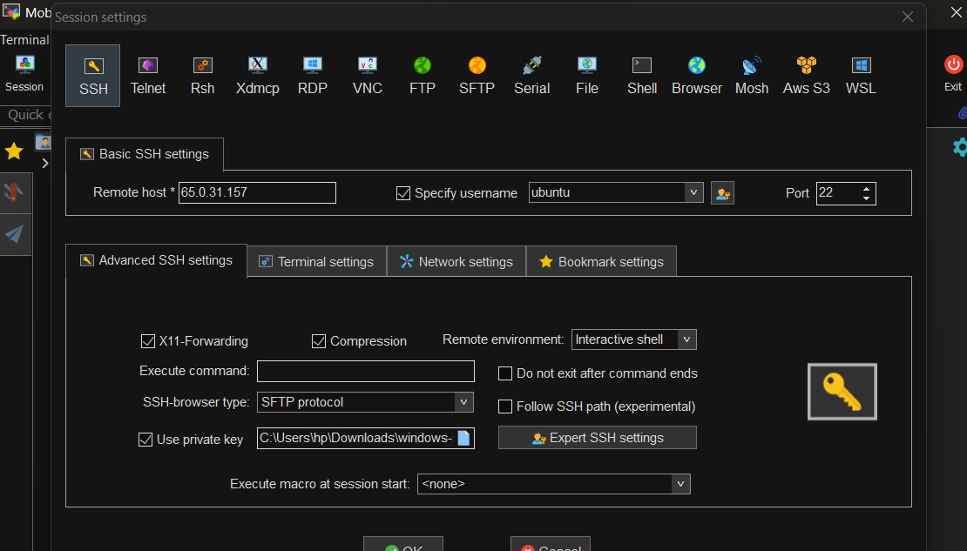

Now you can access the ec2 instance of webserver in MobaXtrem

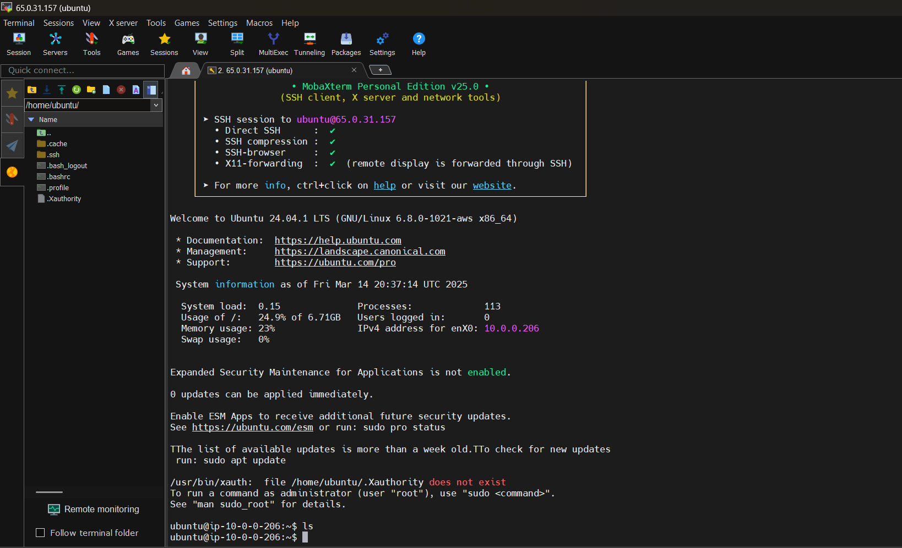

Go to ec2-private and copy Public IPv4 take it as host , give user name as ubuntu and also take key pair past in path give it in MobaXtrem

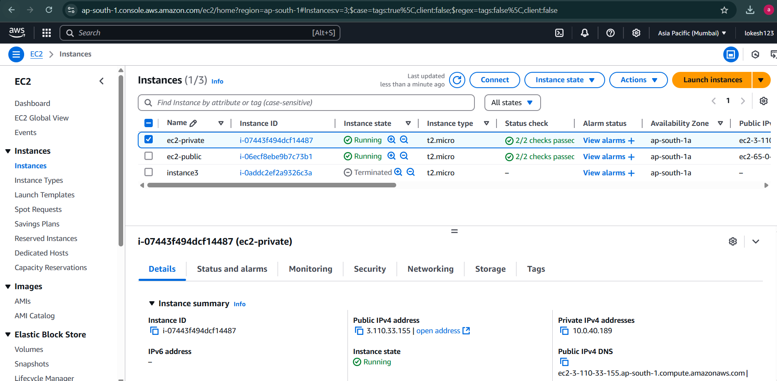

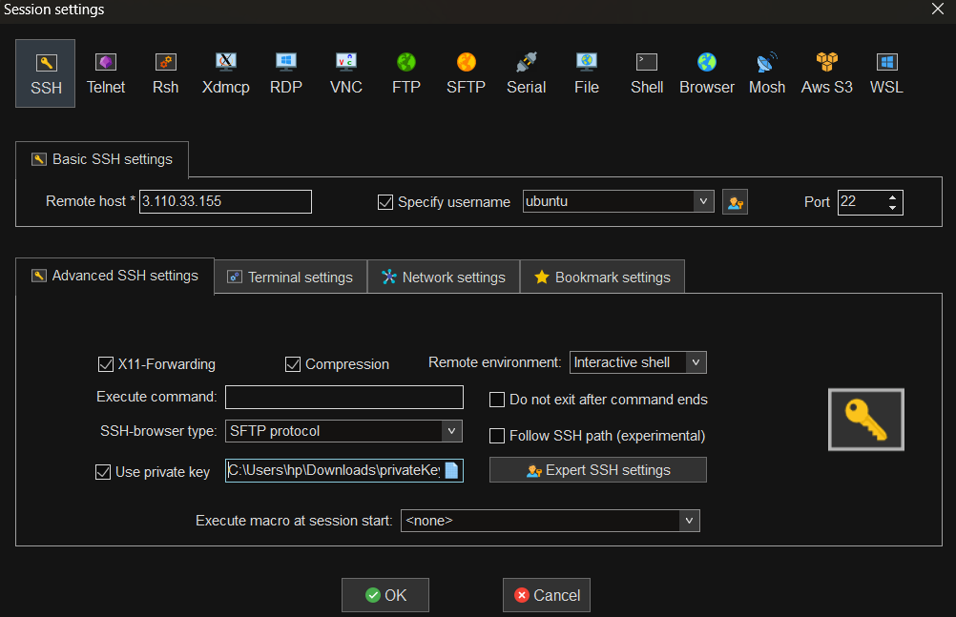

It cant connect as its private network and didnt initiate ssh access to this server

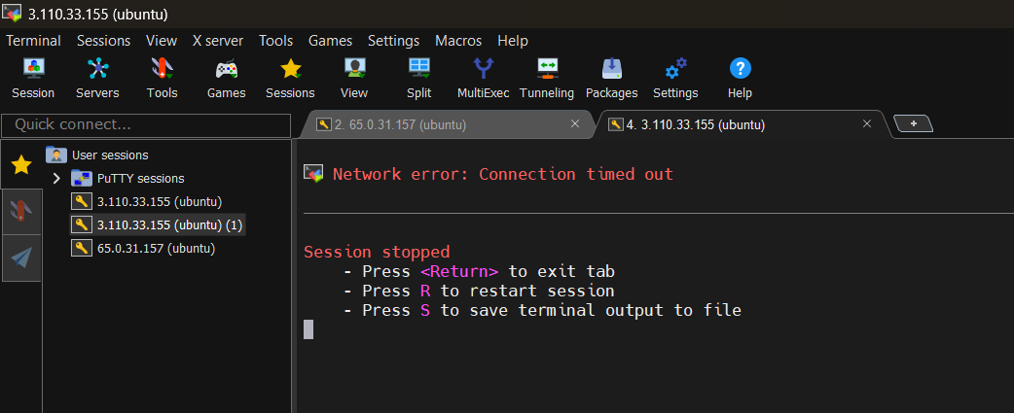

Note :

In Security Groups we can have inbound and outbound rules for the allowed traffic and we dont have have any inbound and outbound rule that denies traffic ,whereas NACL have inbound and outbound rules for the allowed and denies traffic

## NAT GATEWAY

Gateway is a better alternative of Nat instance

Managed service by AWS, high availability, higher bandwidth, auto-scaling

No security groups to manage

No infra management/server patching is required

1 NAT Gateway can span over 1 AZ for auto-failover

Click on create Nat Gatway

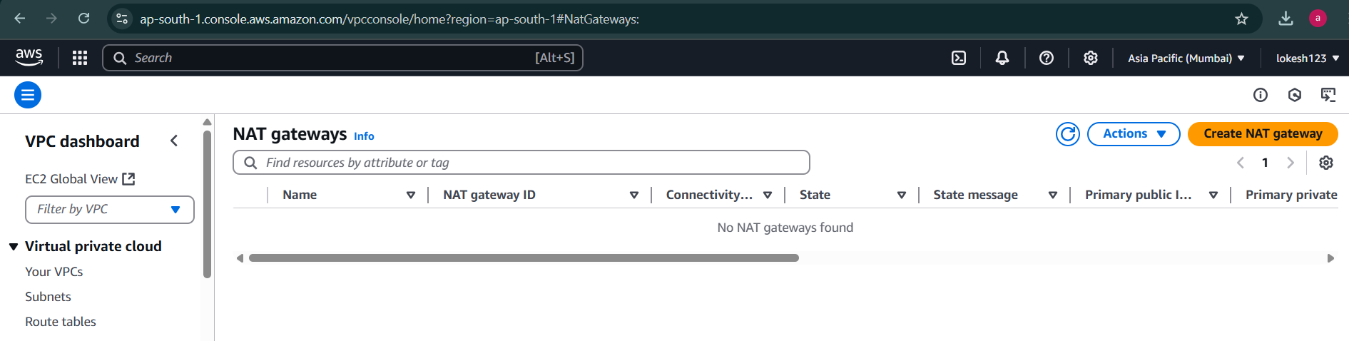

Give name, choose public subnet, Allocate Elastic IP and then click on create NAT gateway

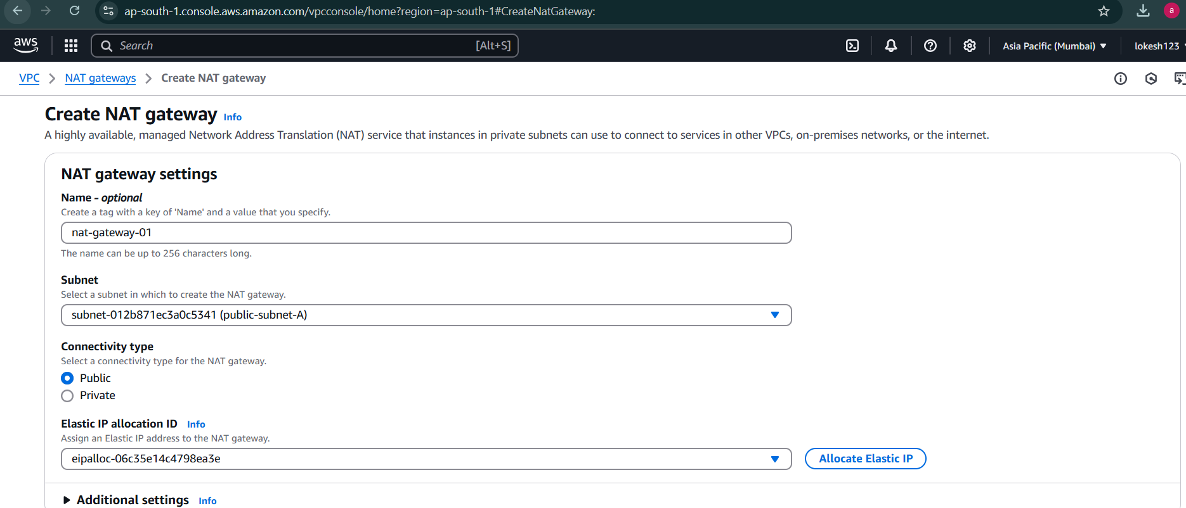

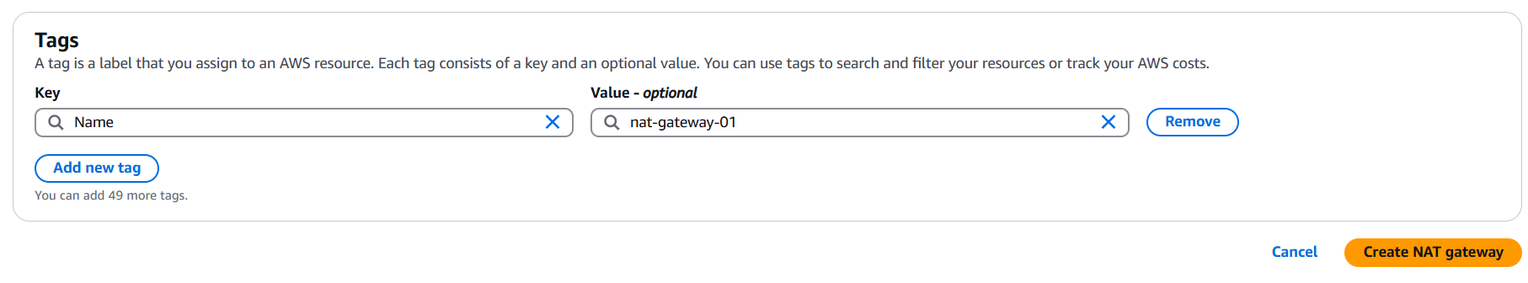

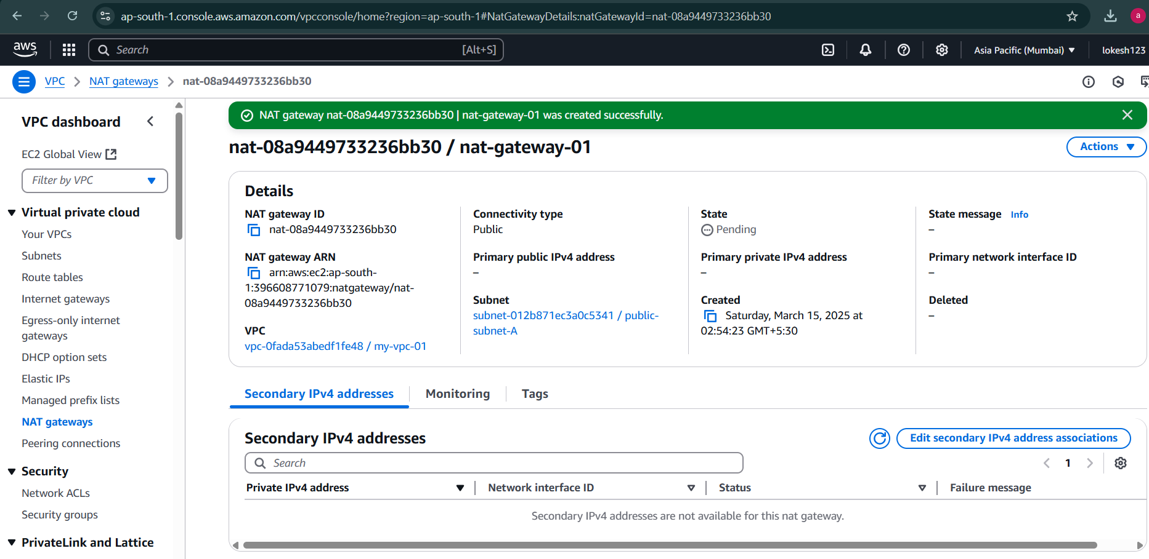

**PART 3**

**Automated Intrusion Detection & Response (IDR)**:

# 1. Deploy **Suricata or Snort for network traffic anomaly detection**.

## Snort Installation and setup

### Update all the apt packages

lokesh@agent1:~$ sudo apt-get update

[sudo] password for lokesh:

Hit:1 http://security.ubuntu.com/ubuntu jammy-security InRelease

Hit:2 http://in.archive.ubuntu.com/ubuntu jammy InRelease

Hit:3 http://in.archive.ubuntu.com/ubuntu jammy-updates InRelease

Hit:4 http://in.archive.ubuntu.com/ubuntu jammy-backports InRelease

Reading package lists... Done

### Install Snort

lokesh@agent1:~$ sudo apt-get install snort -y

Reading package lists... Done

Building dependency tree... Done

Reading state information... Done

The following additional packages will be installed:

libauthen-sasl-perl libclone-perl libdaq2 libdata-dump-perl libdumbnet1

libencode-locale-perl libfile-listing-perl libfont-afm-perl

.

'

.

.

### Choose Interface as eth0 for LXD

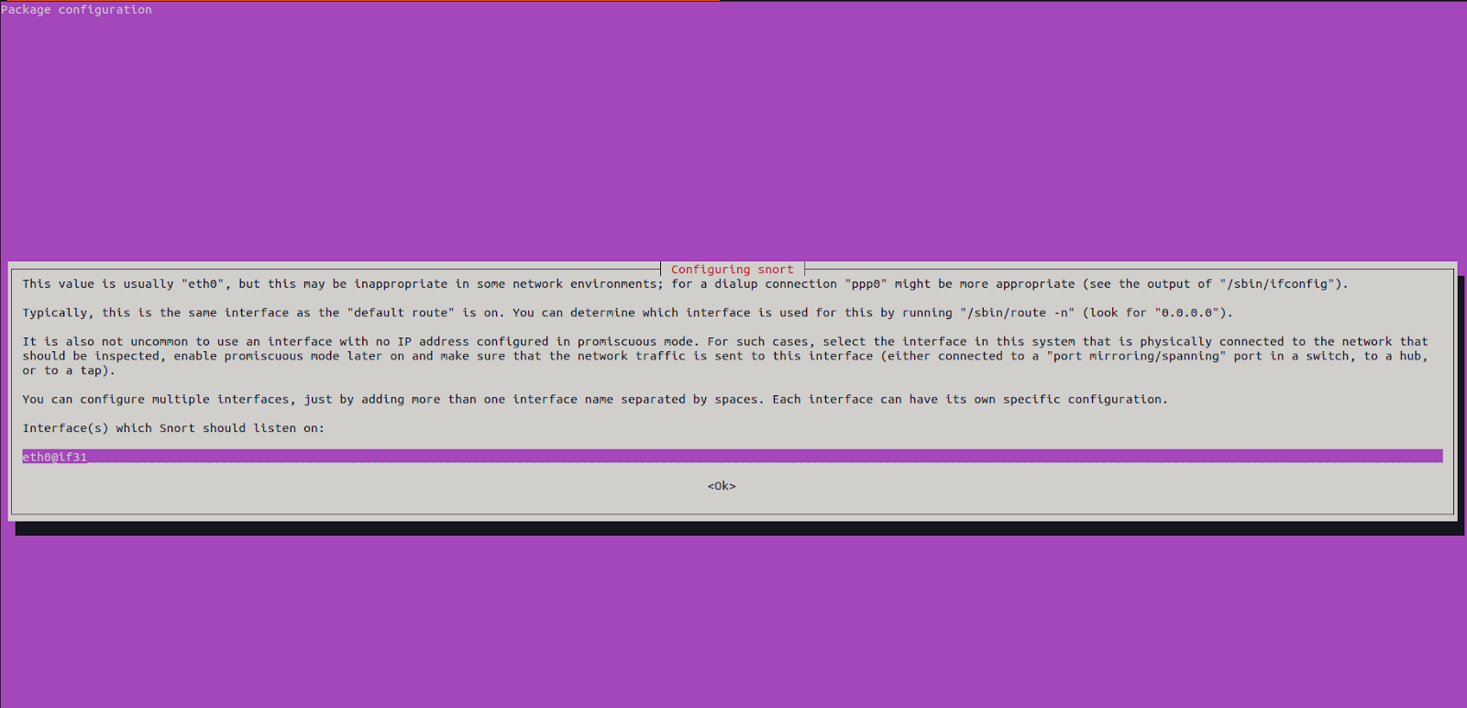

### Give eth0 as interface

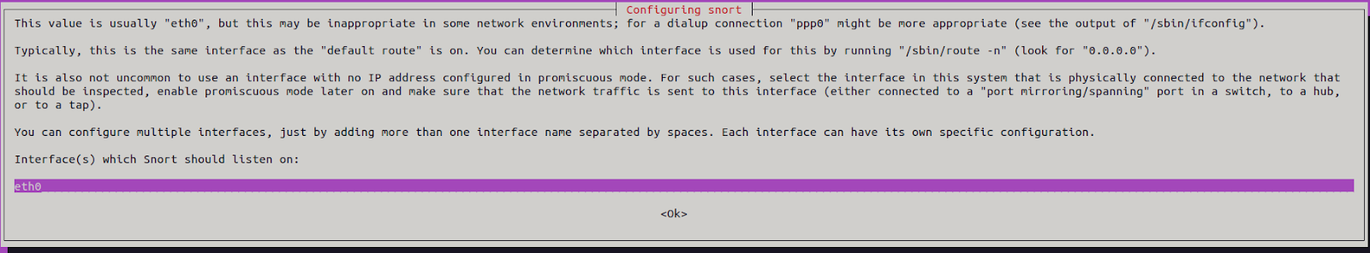

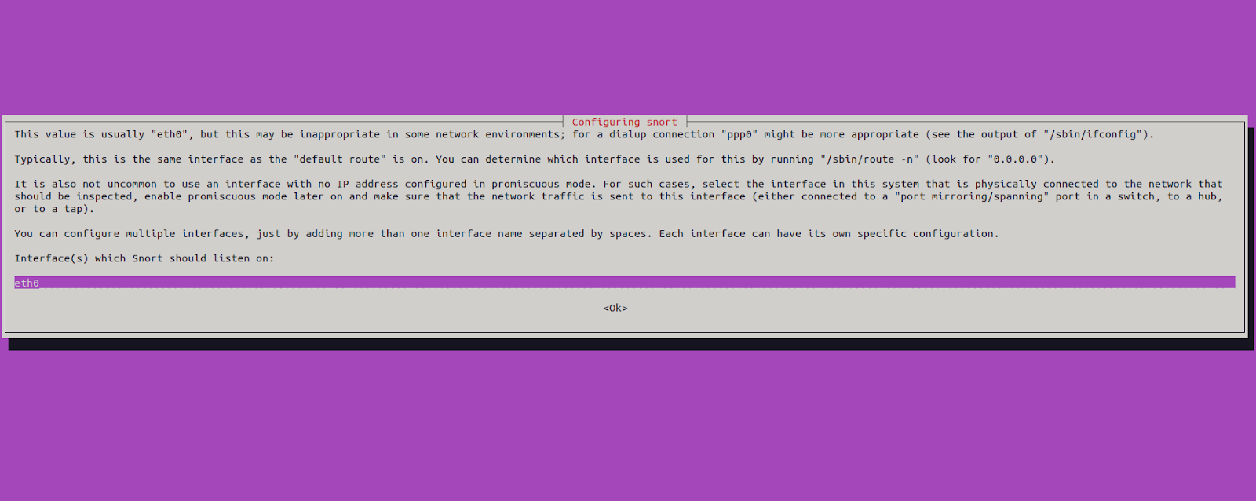

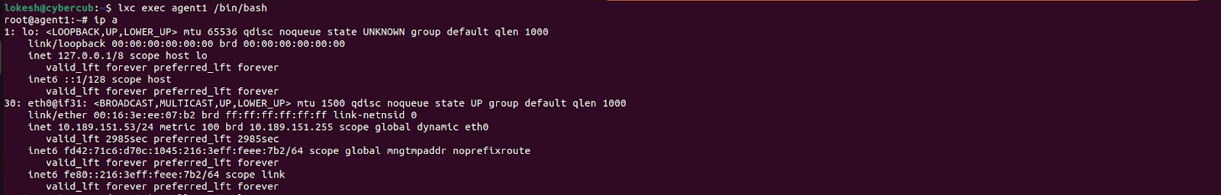

### To determine which version of the Snort is installed, type the following command:

lokesh@agent1:~$ snort -V

,,_ -*> Snort! <*-

o" )~ Version 2.9.15.1 GRE (Build 15125)

'''' By Martin Roesch & The Snort Team: http://www.snort.org/contact#team

Copyright (C) 2014-2019 Cisco and/or its affiliates. All rights reserved.

Copyright (C) 1998-2013 Sourcefire, Inc., et al.

Using libpcap version 1.10.1 (with TPACKET_V3)

Using PCRE version: 8.39 2016-06-14

Using ZLIB version: 1.2.11

### List /etc/snort

lokesh@agent1:~$ ls -la /etc/snort/

total 368

drwxr-xr-x 3 root root 4096 Nov 15 19:36 .

drwxr-xr-x 90 root root 4096 Nov 15 06:48 ..

-rw-r--r-- 1 root root 1281 Dec 3 2019 attribute_table.dtd

-rw-r--r-- 1 root root 3757 Dec 3 2019 classification.config

-rw-r--r-- 1 root root 82469 Dec 3 2021 community-sid-msg.map

-rw-r--r-- 1 root root 23657 Dec 3 2019 file_magic.conf

-rw-r--r-- 1 root root 32789 Dec 3 2019 gen-msg.map

-rw-r--r-- 1 root root 687 Dec 3 2019 reference.config

drwxr-xr-x 2 root root 4096 Nov 15 06:46 rules

-rw-r----- 1 root snort 29775 Dec 3 2021 snort.conf

-rw------- 1 root root 806 Nov 15 19:36 snort.debian.conf

-rw-r--r-- 1 root root 2335 Dec 3 2019 threshold.conf

-rw-r--r-- 1 root root 160606 Dec 3 2019 unicode.map

### Edit /etc/snort/snort.conf

lokesh@agent1:~$ sudo nano /etc/snort/snort.conf

ipvar HOME_NET 192.168.122.141/32

//ipvar HOME_NET [10.189.151.13,10.189.151.97,10.189.151.161]

var RULE_PATH /etc/snort/rules

include $RULE_PATH/local.rules

#pcap

output log_tcpdump: /var/log/snort/tcpdump.log

#csv

output alert_csv: /var/log/snort/alert.csv default

# The include files commented below have been disabled

# because they are not available in the stock Debian

# rules. If you install the Sourcefire VRT please make

# sure you re-enable them again:

#include $RULE_PATH/app-detect.rules

include $RULE_PATH/attack-responses.rules

include $RULE_PATH/backdoor.rules

include $RULE_PATH/bad-traffic.rules

#include $RULE_PATH/blacklist.rules

#include $RULE_PATH/botnet-cnc.rules

#include $RULE_PATH/browser-chrome.rules

#include $RULE_PATH/browser-firefox.rules

#include $RULE_PATH/browser-ie.rules

#include $RULE_PATH/browser-other.rules

#include $RULE_PATH/browser-plugins.rules

#include $RULE_PATH/browser-webkit.rules

#include $RULE_PATH/chat.rules

#include $RULE_PATH/content-replace.rules

#include $RULE_PATH/ddos.rules

#include $RULE_PATH/dns.rules

#include $RULE_PATH/dos.rules

#include $RULE_PATH/experimental.rules

### Test all the configuration changes right or wrong

lokesh@agent1:~$ sudo snort -T -i eth0 -c /etc/snort/snort.conf

Running in Test mode

--== Initializing Snort ==--

Initializing Output Plugins!

Initializing Preprocessors!

Initializing Plug-ins!

.

.

Preprocessor Object: SF_SSH Version 1.1 <Build 3>

Preprocessor Object: SF_DCERPC2 Version 1.0 <Build 3>

Preprocessor Object: SF_MODBUS Version 1.1 <Build 1>

Snort successfully validated the configuration!

Snort exiting

### Create custome rules for snort

lokesh@agent1:~$ sudo nano /etc/snort/rules/local.rules

alert icmp any any -> $HOME_NET any (msg:”ICMP Detection Rule”; sid:100001;)

alert tcp any any -> $HOME_NET 22 (msg: “SSH Connection Attempts”; sid:100002; )

alert tcp any any -> $HOME_NET 80 (msg:”Command Execution Attempt”; content:”GET”; content:”/etc/passwd”; sid:100003; )

### Testing Snort Rules

Firstly; we will send ICMP Ping packets from the Attacker Machine which has IP address 192.168.189.128 to the Ubuntu Machine.

Secondly; we will make an SSH connection attempt from the Attacker Machine to the Ubuntu Machine.

Thirdly; we will send a command execution request with the curl from the Attacker Machine to the Ubuntu Machine.

Snort will also write alerts to the CSV file and PCAP file because we configured We can use these files to investigate attacks later. We can reach this file in the /var/log/snort directory.

### 

lokesh@cybercub:~$ ping 10.189.151.53

PING 10.189.151.53 (10.189.151.53) 56(84) bytes of data.

64 bytes from 10.189.151.53: icmp_seq=1 ttl=64 time=0.044 ms

64 bytes from 10.189.151.53: icmp_seq=2 ttl=64 time=0.038 ms

64 bytes from 10.189.151.53: icmp_seq=3 ttl=64 time=0.050 ms

64 bytes from 10.189.151.53: icmp_seq=4 ttl=64 time=0.072 ms

### Check logs in Agent1

root@agent1:~# sudo snort -q -l /var/log/snort -i eth0 -A console -c /etc/snort/snort.conf

11/18-19:10:58.251654 [**] [1:100001:0] ”ICMP Detection Rule” [**] [Priority: 0] {ICMP} 10.189.151.1 -> 10.189.151.53

11/18-19:10:59.276037 [**] [1:100001:0] ”ICMP Detection Rule” [**] [Priority: 0] {ICMP} 10.189.151.1 -> 10.189.151.53

11/18-19:11:00.300047 [**] [1:100001:0] ”ICMP Detection Rule” [**] [Priority: 0] {ICMP}

# 2. Configure **fail2ban to block repeated SSH & web attacks automatically**.

WHAT IS FAIL2BAN?

01 Helps prevent brute-force attacks

02 Watches logs for authentication failure

03 Creates firewall rules to block IP addresses

04 Able to protect multiple services

05 Completely customizable

root@fail2ban:~# apt update

Get:1 http://security.ubuntu.com/ubuntu focal-security InRelease [128 kB]

Hit:2 http://archive.ubuntu.com/ubuntu focal InRelease

Get:3 http://archive.ubuntu.com/ubuntu focal-updates InRelease [128 kB]

Get:4 http://security.ubuntu.com/ubuntu focal-security/main amd64 Packages [3433 kB]

Get:5 http://archive.ubuntu.com/ubuntu focal-backports InRelease [128 kB]

.

.

.

root@fail2ban:~# apt install fail2ban -y

Reading package lists... Done

Building dependency tree

Reading state information... Done

The following additional packages will be installed:

python3-pyinotify whois

Suggested packages:

mailx monit sqlite3 python-pyinotify-doc

The following NEW packages will be installed:

fail2ban python3-pyinotify whois

0 upgraded, 3 newly installed, 0 to remove and 52 not upgraded.

Need to get 444 kB of archives.

After this operation, 2400 kB of additional disk space will be used.

Get:1 http://archive.ubuntu.com/ubuntu focal/universe amd64 fail2ban all 0.11.1-1 [375 kB]

Get:2 http://archive.ubuntu.com/ubuntu focal/main amd64 python3-pyinotify all 0.9.6-1.2ubuntu1 [24.8 kB]

Get:3 http://archive.ubuntu.com/ubuntu focal/main amd64 whois amd64 5.5.6 [44.7 kB]

.

.

.

root@fail2ban:~# systemctl enable fail2ban

Synchronizing state of fail2ban.service with SysV service script with /lib/systemd/systemd-sysv-install.

Executing: /lib/systemd/systemd-sysv-install enable fail2ban

root@fail2ban:~# ls -al /etc/fail2ban/

total 72

drwxr-xr-x 6 root root 4096 Mar 14 22:53 .

drwxr-xr-x 96 root root 4096 Mar 14 22:53 ..

drwxr-xr-x 2 root root 4096 Mar 14 22:53 action.d

-rw-r--r-- 1 root root 2817 Jan 11 2020 fail2ban.conf

drwxr-xr-x 2 root root 4096 Mar 2 2020 fail2ban.d

drwxr-xr-x 3 root root 4096 Mar 14 22:53 filter.d

-rw-r--r-- 1 root root 25740 Jan 11 2020 jail.conf

drwxr-xr-x 2 root root 4096 Mar 14 22:53 jail.d

-rw-r--r-- 1 root root 645 Jan 11 2020 paths-arch.conf

-rw-r--r-- 1 root root 2827 Jan 11 2020 paths-common.conf

-rw-r--r-- 1 root root 573 Jan 11 2020 paths-debian.conf

-rw-r--r-- 1 root root 738 Jan 11 2020 paths-opensuse.conf

Jail is a configuration file that contains filters and arguments that protect system or a particular service

root@fail2ban:~# less /etc/fail2ban/jail.conf

.

.

root@fail2ban:~# nano /etc/fail2ban/jail.local

[sshd]

enabled = true

port = ssh

filter = sshd

logpath = /var/log/auth.log

maxretry = 3

bantime = 3600

ignoreip = 127.0.0.1 //this is for whitelisting ip

root@fail2ban:~# systemctl restart fail2ban

root@fail2ban:~# systemctl status fail2ban

● fail2ban.service - Fail2Ban Service

Loaded: loaded (/lib/systemd/system/fail2ban.service; enabled; vendor pres>

Active: active (running) since Sat 2025-03-15 00:10:01 UTC; 8s ago

Docs: man:fail2ban(1)

Process: 1455 ExecStartPre=/bin/mkdir -p /run/fail2ban (code=exited, status>

Main PID: 1456 (f2b/server)

Tasks: 5 (limit: 18795)

Memory: 11.0M

CPU: 97ms

CGroup: /system.slice/fail2ban.service

└─1456 /usr/bin/python3 /usr/bin/fail2ban-server -xf start

Mar 15 00:10:01 fail2ban systemd[1]: Starting Fail2Ban Service...

Mar 15 00:10:01 fail2ban systemd[1]: Started Fail2Ban Service.

Mar 15 00:10:01 fail2ban fail2ban-server[1456]: Server ready

SSH jail got activated

root@fail2ban:~# fail2ban-client status

Status

|- Number of jail: 1

`- Jail list: sshd

From another machine trying brute ssh

root@sensor1:~# hydra -l root -P /wordlists/rockyou.txt ssh://10.189.151.97 -I -v

Hydra v9.0 (c) 2019 by van Hauser/THC - Please do not use in military or secret service organizations, or for illegal purposes.

Hydra (https://github.com/vanhauser-thc/thc-hydra) starting at 2025-03-15 02:48:13

[WARNING] Many SSH configurations limit the number of parallel tasks, it is recommended to reduce the tasks: use -t 4

[ERROR] File for passwords not found: /wordlists/rockyou.txt

On the machine where fail2ban hosted it worked as ssh login failed over brute force

root@fail2ban:~# cat /var/log/auth.log

Mar 14 22:47:38 sensor4 sshd[219]: Server listening on 0.0.0.0 port 22.

Mar 14 22:47:38 sensor4 sshd[219]: Server listening on :: port 22.

Mar 14 22:47:38 sensor4 systemd-logind[173]: New seat seat0.

Mar 14 22:49:53 fail2ban sshd[218]: Server listening on 0.0.0.0 port 22.

Mar 14 22:49:53 fail2ban sshd[218]: Server listening on :: port 22.

Mar 14 22:49:53 fail2ban systemd-logind[201]: New seat seat0.

Mar 14 22:50:26 fail2ban sshd[221]: Server listening on 0.0.0.0 port 22.

Mar 14 22:50:26 fail2ban sshd[221]: Server listening on :: port 22.

Mar 14 22:50:26 fail2ban systemd-logind[202]: New seat seat0.

Mar 14 23:06:01 fail2ban CRON[1315]: pam_unix(cron:session): session opened for user root by (uid=0)

Mar 14 23:06:01 fail2ban CRON[1315]: pam_unix(cron:session): session closed for user root

Mar 14 23:17:01 fail2ban CRON[1320]: pam_unix(cron:session): session opened for user root by (uid=0)

Mar 14 23:17:01 fail2ban CRON[1320]: pam_unix(cron:session): session closed for user root

Mar 15 00:12:33 fail2ban sshd[1468]: Connection closed by authenticating user root 10.189.151.79 port 54714 [preauth]

Mar 15 00:12:59 fail2ban sshd[1470]: Connection closed by authenticating user root 10.189.151.79 port 36770 [preauth]

Mar 15 00:13:29 fail2ban sshd[1472]: Connection closed by authenticating user root 10.189.151.79 port 50430 [preauth]

Mar 15 00:16:42 fail2ban sshd[1478]: Connection closed by authenticating user root 10.189.151.1 port 55416 [preauth]

Mar 15 00:17:01 fail2ban CRON[1480]: pam_unix(cron:session): session opened for user root by (uid=0)

Mar 15 00:17:01 fail2ban CRON[1480]: pam_unix(cron:session): session closed for user root

Mar 15 02:30:41 fail2ban sshd[221]: Received signal 15; terminating.

Mar 15 02:30:41 fail2ban sshd[1535]: Server listening on 0.0.0.0 port 22.

Mar 15 02:30:41 fail2ban sshd[1535]: Server listening on :: port 22.

Mar 15 02:30:48 fail2ban sshd[1535]: Received signal 15; terminating.

Mar 15 02:30:48 fail2ban sshd[1539]: Server listening on 0.0.0.0 port 22.

Mar 15 02:30:48 fail2ban sshd[1539]: Server listening on :: port 22.

Mar 15 02:31:06 fail2ban sshd[1540]: Connection closed by authenticating user root 10.189.151.79 port 44738 [preauth]

Mar 15 02:31:14 fail2ban sshd[1542]: Connection closed by authenticating user root 10.189.151.79 port 32808 [preauth]

Mar 15 02:32:13 fail2ban sshd[1546]: Connection closed by authenticating user root 10.189.151.79 port 46542 [preauth]

Mar 15 02:56:51 fail2ban sshd[1568]: Connection closed by authenticating user root 10.189.151.1 port 38304 [preauth]

Mar 15 02:56:55 fail2ban sshd[1570]: Connection closed by authenticating user root 10.189.151.1 port 38308 [preauth]

SIEM & Log Aggregation

# 1. Centralize logs with **ELK Stack (Elasticsearch, Logstash, Kibana)**

Before installation of ELK do set up for dependencies required :

Check ubuntu version you are using

root@elk:~# lsb_release -a

No LSB modules are available.

Distributor ID: Ubuntu

Description: Ubuntu 20.04.6 LTS

Release: 20.04

Codename: focal

Install java dependencies

root@elk:~# apt install default-jdk default-jre -y

Reading package lists... Done

Building dependency tree

Reading state information... Done

The following additional packages will be installed:

at-spi2-core ca-certificates-java default-jdk-headless default-jre-headless

.

.

.

Check java version

root@elk:~# javac -version

javac 11.0.26

Make sure that curl installed if not then install curl

root@elk:~# sudo apt-get install curl

Reading package lists... Done

Building dependency tree

Reading state information... Done

curl is already the newest version (7.68.0-1ubuntu2.25).

curl set to manually installed.

0 upgraded, 0 newly installed, 0 to remove and 29 not upgraded.

Add the elasticsearch APT repository key by using the below command (run these commands

Root

root@elk:~# curl -fsSL https://artifacts.elastic.co/GPG-KEY-elasticsearch | apt-key add -

OK

Add the Elastic Search to the APT source List by using the below command

root@elk:~# echo "deb https://artifacts.elastic.co/packages/7.x/apt stable main" >

/etc/apt/sources.list.d/elastic-7.x.list

Installation of Elastic search:

root@elk:~# apt update

Get:1 https://artifacts.elastic.co/packages/7.x/apt stable InRelease [13.7 kB]

Get:2 https://artifacts.elastic.co/packages/7.x/apt stable/main amd64 Packages [143 kB]

Get:3 http://security.ubuntu.com/ubuntu focal-security InRelease [128 kB]

Hit:4 http://archive.ubuntu.com/ubuntu focal InRelease

Get:5 http://archive.ubuntu.com/ubuntu focal-updates InRelease [128 kB]

Get:6 http://archive.ubuntu.com/ubuntu focal-backports InRelease [128 kB]

Fetched 540 kB in 2s (320 kB/s)

Reading package lists... Done

Building dependency tree

Reading state information... Done

29 packages can be upgraded. Run 'apt list --upgradable' to see them.

Install elastic search

root@elk:~# apt install elasticsearch -y

Reading package lists... Done

Building dependency tree

Reading state information... Done

The following NEW packages will be installed:

elasticsearch

0 upgraded, 1 newly installed, 0 to remove and 29 not upgraded.

Need to get 325 MB of archives.

After this operation, 542 MB of additional disk space will be used.

Get:1 https://artifacts.elastic.co/packages/7.x/apt stable/main amd64 elasticsearch amd64 7.17

Configuration of elasticsearch

root@elk:~# nano /etc/elasticsearch/elasticsearch.yml

network.host: '10.189.151.79'

#

# By default Elasticsearch listens for HTTP traffic on the first free port it

# finds starting at 9200. Set a specific HTTP port here:

#

http.port: 9200

discovery.type: single-node

root@elk:~# nano /etc/elasticsearch/jvm.options

-Xms512m

-Xmx512m

Enable Elasticsearch

root@elk:~# systemctl enable elasticsearch

Synchronizing state of elasticsearch.service with SysV service script with /lib/systemd/systemd-sysv-install.

Executing: /lib/systemd/systemd-sysv-install enable elasticsearch

Created symlink /etc/systemd/system/multi-user.target.wants/elasticsearch.service →

/lib/systemd/system/elasticsearch.service.

Start Elasticsearch

root@elk:~# systemctl start elasticsearch

root@elk:~# curl -X GET "10.189.151.79:9200"

{

"name" : "elk",

"cluster_name" : "elasticsearch",

"cluster_uuid" : "y34ksPnVTziER2z1cq-ycw",

"version" : {

"number" : "7.17.28",

"build_flavor" : "default",

"build_type" : "deb",

"build_hash" : "139cb5a961d8de68b8e02c45cc47f5289a3623af",

"build_date" : "2025-02-20T09:05:31.349013687Z",

"build_snapshot" : false,

"lucene_version" : "8.11.3",

"minimum_wire_compatibility_version" : "6.8.0",

"minimum_index_compatibility_version" : "6.0.0-beta1"

},

"tagline" : "You Know, for Search"

}

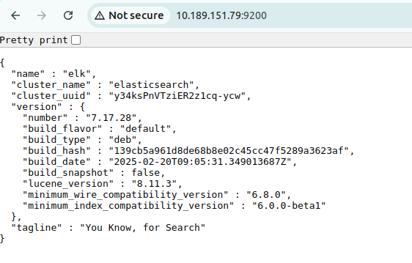

Logstash setup

Install logstash

root@elk:~# apt install logstash -y

Reading package lists... Done

Building dependency tree

Reading state information... Done

The following NEW packages will be installed:

logstash

0 upgraded, 1 newly installed, 0 to remove and 29 not upgraded.

Need to get 375 MB of archives.

After this operation, 632 MB of additional disk space will be used.

Get:1 https://artifacts.elastic.co/packages/7.x/apt stable/main amd64 logstash amd64 1:7.17.28-1 [375 MB]

Fetched 375 MB in 1min 40s (3738 kB/s)

Selecting previously unselected package logstash.

.

.

.

OpenJDK 64-Bit Server VM warning: Option UseConcMarkSweepGC was deprecated in versio

n 9.0 and will likely be removed in a future release.

/usr/share/logstash/vendor/bundle/jruby/2.5.0/gems/pleaserun-0.0.32/lib/pleaserun/pl

atform/base.rb:112: warning: constant ::Fixnum is deprecated

Successfully created system startup script for Logstash

root@elk:~# systemctl enable logstash

Created symlink /etc/systemd/system/multi-user.target.wants/logstash.service →

/etc/systemd/system/logstash.service.

root@elk:~# systemctl start logstash

root@elk:~# systemctl status logstash

● logstash.service - logstash

Loaded: loaded (/etc/systemd/system/logstash.service; enabled; vendor preset: enabled)

Active: active (running) since Sat 2025-03-15 04:44:44 UTC; 7s ago

Main PID: 5130 (java)

Tasks: 25 (limit: 18795)

Memory: 535.3M

CPU: 31.473s

CGroup: /system.slice/logstash.service

└─5130 /usr/share/logstash/jdk/bin/java -Xms1g -Xmx1g -XX:+UseConcMarkSweepGC -XX:CMSIn

.

.

Kibana Set up

root@elk:~# apt update

Hit:1 http://security.ubuntu.com/ubuntu focal-security InRelease

Hit:2 http://archive.ubuntu.com/ubuntu focal InRelease

Hit:3 http://archive.ubuntu.com/ubuntu focal-updates InRelease

Hit:4 https://artifacts.elastic.co/packages/7.x/apt stable InRelease

Hit:5 http://archive.ubuntu.com/ubuntu focal-backports InRelease

Reading package lists... Done

Building dependency tree

Reading state information... Done

29 packages can be upgraded. Run 'apt list --upgradable' to see them.

root@elk:~# apt install kibana -y

Reading package lists... Done

Building dependency tree

Reading state information... Done

The following NEW packages will be installed:

kibana

0 upgraded, 1 newly installed, 0 to remove and 29 not upgraded.

Need to get 293 MB of archives.

After this operation, 744 MB of additional disk space will be used.

Get:1 https://artifacts.elastic.co/packages/7.x/apt stable/main amd64 kibana amd64 7.17.28 [293 MB]

.

.

Creating kibana group... OK

root@elk:~# systemctl enable kibana

Synchronizing state of kibana.service with SysV service script with /lib/systemd/systemd-sysv-install.

Executing: /lib/systemd/systemd-sysv-install enable kibana

Created symlink /etc/systemd/system/multi-user.target.wants/kibana.service →

/etc/systemd/system/kibana.service.

root@elk:~# systemctl start kibana

root@elk:~# systemctl status kibana

● kibana.service - Kibana

Loaded: loaded (/etc/systemd/system/kibana.service; enabled; vendor preset: enabled)

Active: active (running) since Sat 2025-03-15 04:53:07 UTC; 8s ago

Docs: https://www.elastic.co

Main PID: 7519 (node)

Tasks: 11 (limit: 18795)

Memory: 246.8M

CPU: 8.224s

CGroup: /system.slice/kibana.service

.

.

Before Configuration set up make sure that you stop all services

Stop Kibana service

root@elk:~# sudo systemctl stop kibana

Stop Elasticsearch service

root@elk:~# sudo systemctl stop elasticsearch

root@elk:~# sudo nano /etc/elasticsearch/elasticsearch.yml

.

.

xpack.security.enabled: true

xpack.security.authc.api_key.enabled:true

root@elk:~# sudo systemctl restart elasticsearch

Generate Passwords

Go to /usr/share/elasticsearch/bin/

root@elk:~# cd /usr/share/elasticsearch/bin/

root@elk:/usr/share/elasticsearch/bin# sudo ./elasticsearch-setup-passwords auto

Initiating the setup of passwords for reserved users elastic_system,beats_system,remote_monitoring_user.

The passwords will be randomly generated and printed to the console.

Please confirm that you would like to continue [y/N]y

Changed password for user apm_system

PASSWORD apm_system = 5JYIfFJZ7LE71X6sLMTh

Changed password for user kibana_system

PASSWORD kibana_system = sMIBnZ4xK9Od1yLbvyRH

Changed password for user kibana

PASSWORD kibana = sMIBnZ4xK9Od1yLbvyRH

Changed password for user logstash_system

PASSWORD logstash_system = 5XRU2T99usCKWFs0VQO3

Changed password for user beats_system

PASSWORD beats_system = uSUOq3YDzKYkVvYuiTmh

Changed password for user remote_monitoring_user

PASSWORD remote_monitoring_user = wK8wB4NsTmuZFy5PBhRF

Changed password for user elastic

PASSWORD elastic = 50X1xcn80az1w5HrJjK9

Open kibana.yml

root@elk:/usr/share/elasticsearch/bin# nano /etc/kibana/kibana.yml

server.port: 5601

server.host: "10.189.151.79"

elasticsearch.hosts: ["http://10.189.151.79:9200"]

elasticsearch.username: "elastic"

elasticsearch.password: "50X1xcn80az1w5HrJjK9"

Restart kibana

root@elk:~# systemctl restart kibana



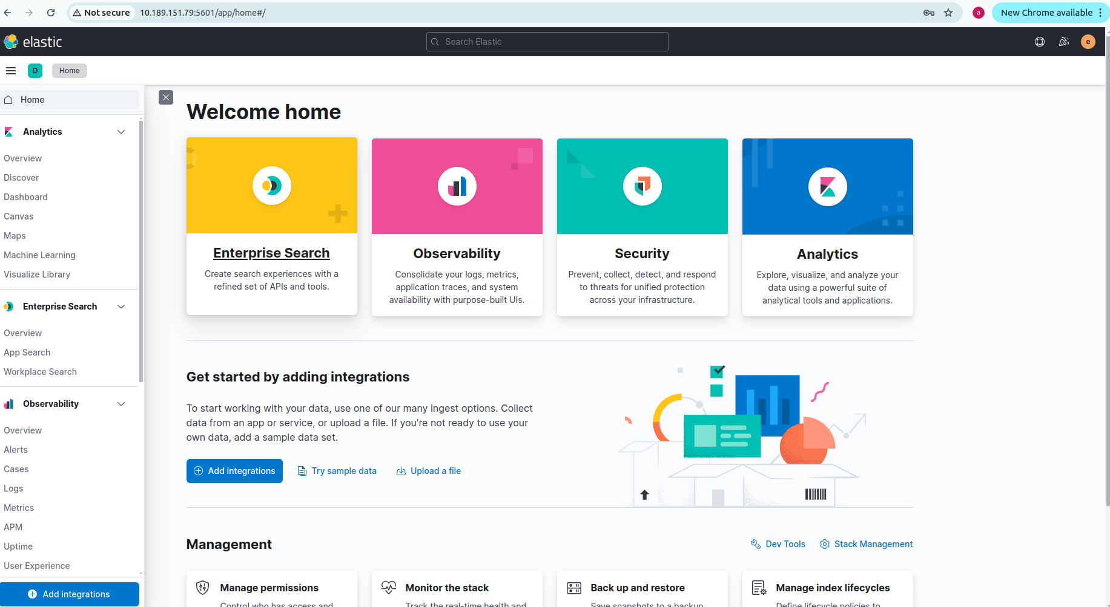

# 

# Implement real-time threat detection & alerting for anomalies.

Note : I have already worked on this to save time I am attaching entire procedure of my previous project !

Download filebeat in windows machine

<https://www.elastic.co/downloads/past-releases/filebeat-7-17-12>

Go to filebeat.yml

In filebeat inputs à type enabed ,path ,tags are configured

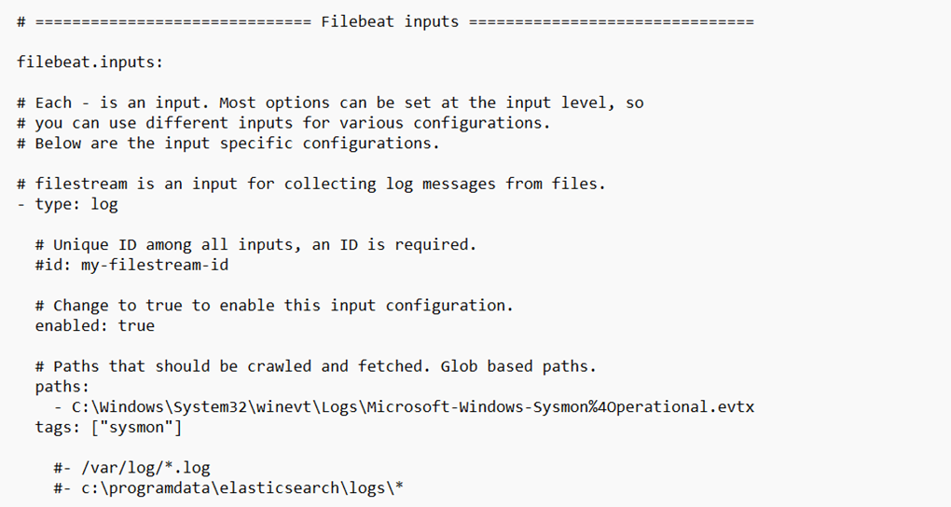

In logstash output ip and port of .conf file con.d folder of logstash

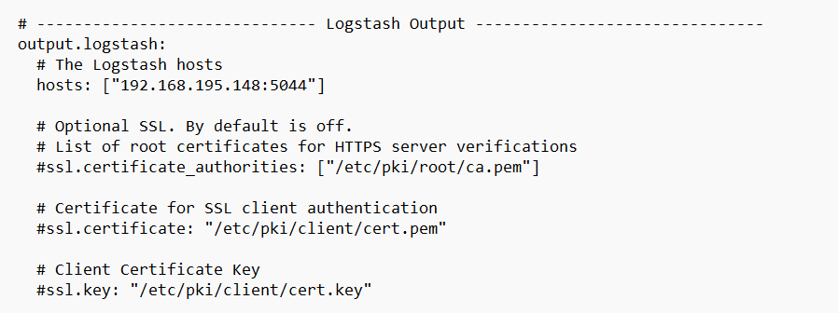

Navigate to filbeat path :



Apply changes

Check configuration of filebeat

.\filebeat.exe -e test config

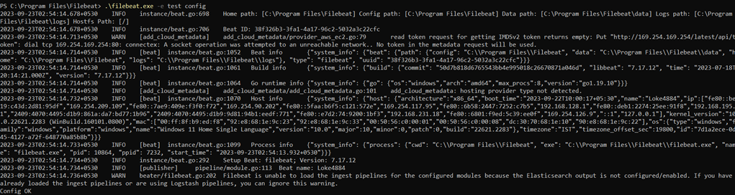

Install filebeat

PowerShell.exe -ExecutionPolicy UnRestricted -File .\install-service-filebeat.ps1

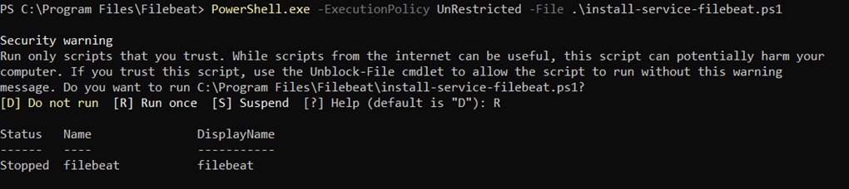

Start the service of filebeat



To check configuration of filebeat



Search services in windows

There you can see status of filebeat

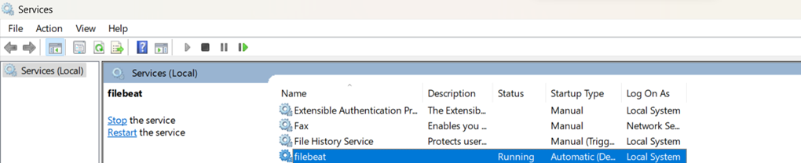

Get-Process -Name "filebeat"

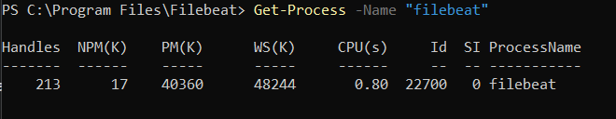

To check Filebeat logs

.\filebeat.exe -e

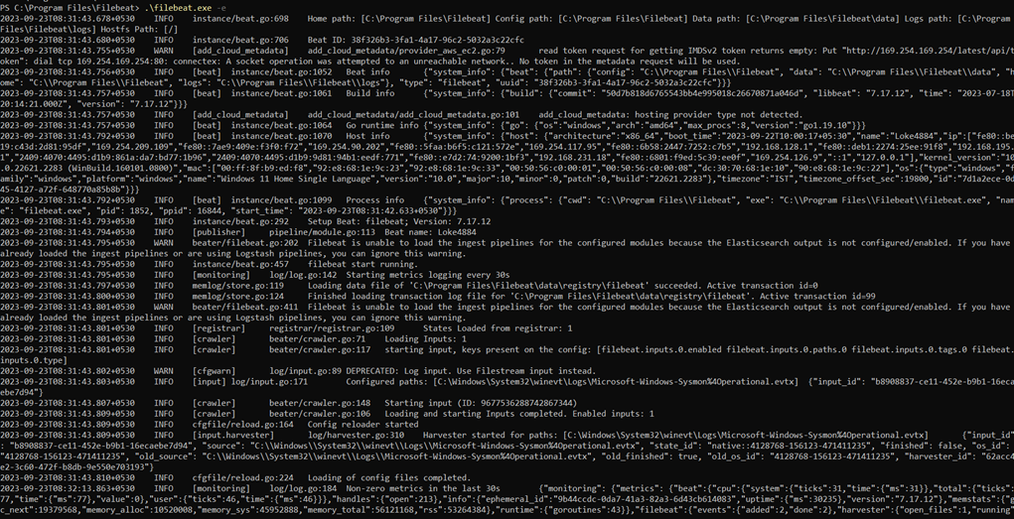

Go to conf.d folder

In this folder you write configuration code for logstash to port to elk



Create a file with extention .conf



To known any other conf file



Write a code inside sysmon.conf



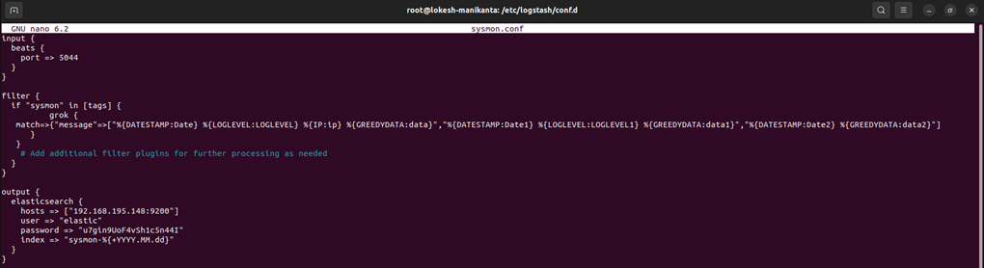

Save and close Sysmon.conf

Sysmon.conf code :

input {

beats {

port => 5044

}

}

filter {

if "sysmon" in [tags] {

grok {

match=>{"message"=>["%{DATESTAMP:Date} %{LOGLEVEL:LOGLEVEL} %{IP:ip}

%{GREEDYDATA:data}","%{DATESTAMP:Date1} %{LOGLEVEL:LOGLEVEL1} %{GREEDYDATA:data1}"

,"%{DATESTAMP:Date2} %{GREEDYDATA:data2}"]

}

}

# Add additional filter plugins for further processing as needed

}

}

output {

elasticsearch {

hosts => ["192.168.195.148:9200"]

user => "elastic"

password => "u7gin9UoF4vSh1c5n44I"

index => "sysmon-%{+YYYY.MM.dd}"

}

}

Restart logstash



Start the services of the logstash



To see logs of logstash (logs will be stored in logstash-plain.log)

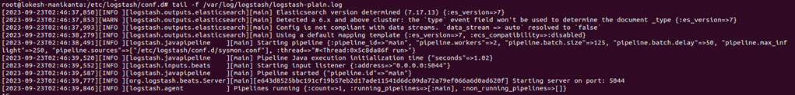

Go to Date à Index Mangement

You will get index you created in logstash configuration file( ex : sysmon.conf)

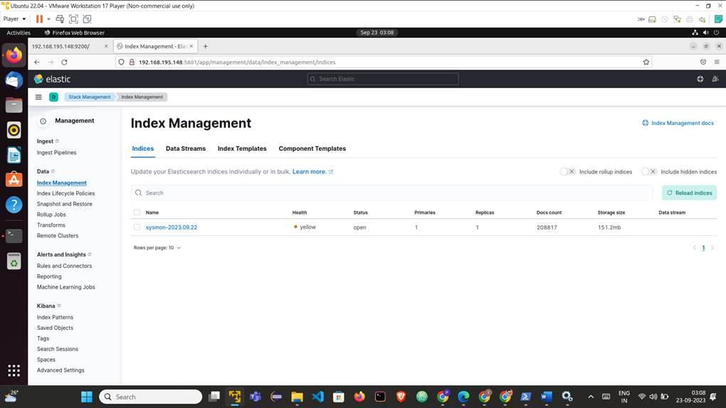

Go to kibana à Index Pattern à Create Index Pattern

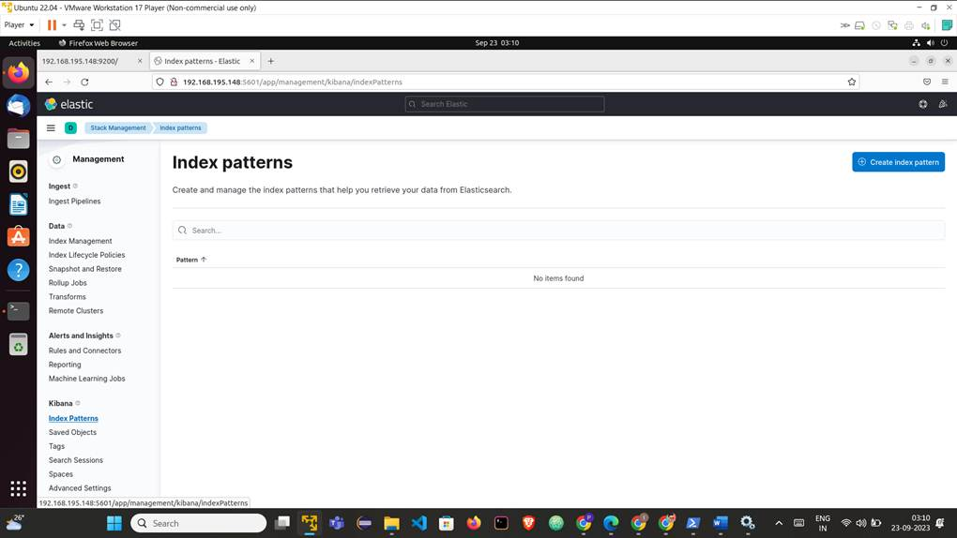

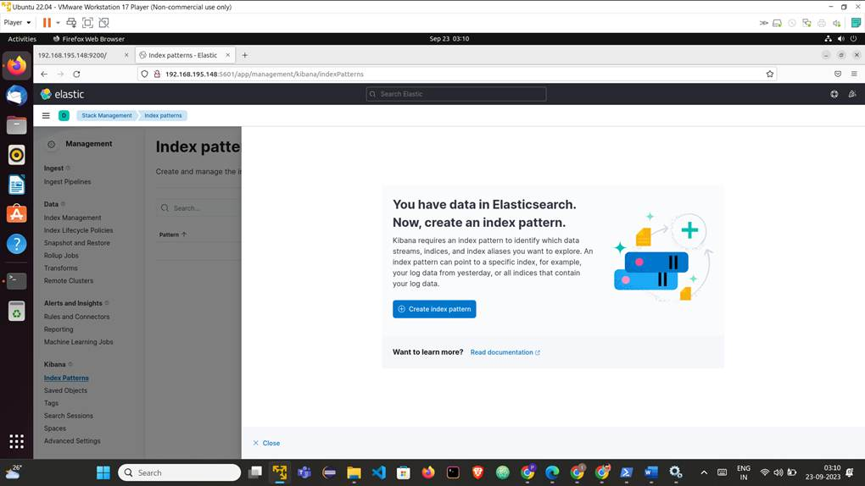

Give name and time stamp and click on create index pattern

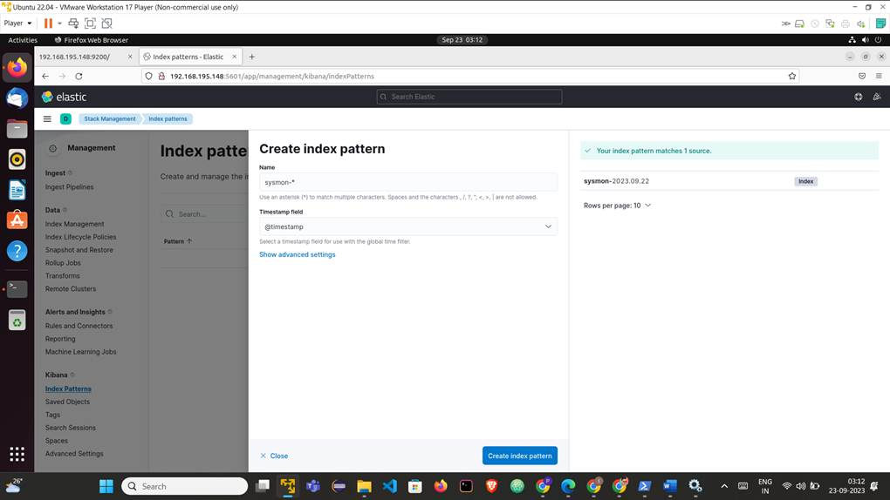

Go to discover choose what Index you created

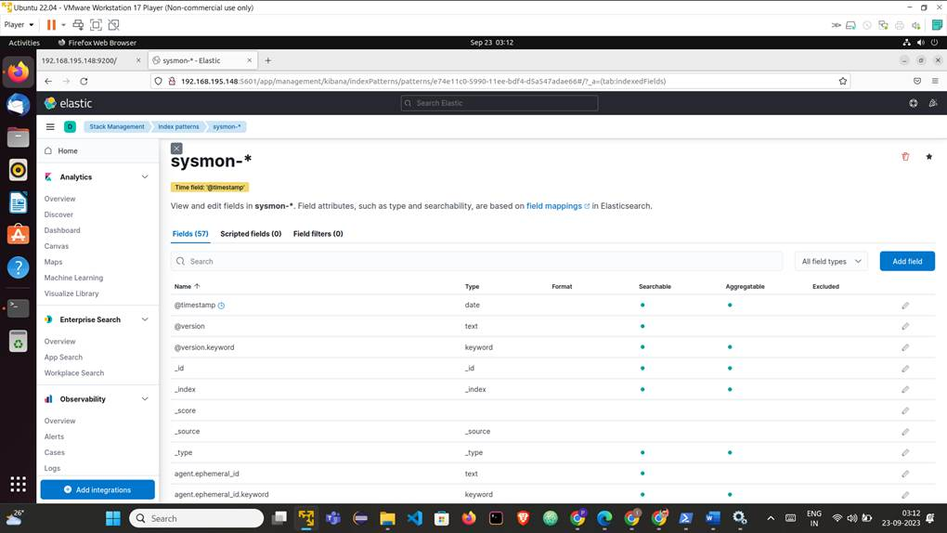

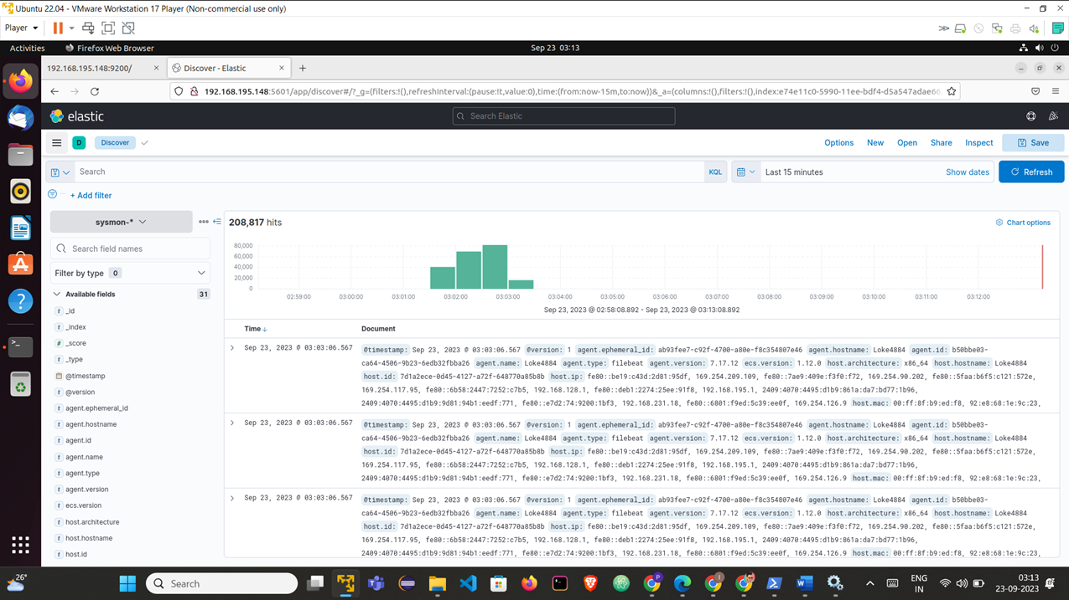

PART 4: NETWORK AUTOMATION & CI/CD FOR INFRASTRUCTURE

# **Continuous Compliance & Auditing**:

## Implement OpenSCAP or CIS Benchmark scans for security compliance.

### Download the compressed XML

lokesh@cybercub:~$ wget https://security-metadata.canonical.com/oval/com.ubuntu.$(lsb_release -cs).usn.oval.xml.bz2

--2025-03-15 15:55:54-- https://security-metadata.canonical.com/oval/com.ubuntu.jammy.usn.oval.xml.bz2

Resolving security-metadata.canonical.com (security-metadata.canonical.com)... 2620:2d:4000:1::28, 2620:2d:4000:1::27, 2620:2d:4000:1::26, ...

Connecting to security-metadata.canonical.com (security-metadata.canonical.com)|2620:2d:4000:1::28|:443... connected.

HTTP request sent, awaiting response... 200 OK

Length: 653195 (638K) [application/x-bzip2]

Saving to: ‘com.ubuntu.jammy.usn.oval.xml.bz2’

com.ubuntu.jammy.us 100%[===================>] 637.89K 435KB/s in 1.5s

2025-03-15 15:56:33 (435 KB/s) - ‘com.ubuntu.jammy.usn.oval.xml.bz2’ saved [653195/653195]

### Uncompress the data

lokesh@cybercub:~$ bunzip2 com.ubuntu.$(lsb_release -cs).usn.oval.xml.bz2

### To evaluate the OVAL , Install Dependencies

lokesh@cybercub:~$ sudo apt install libopenscap8

[sudo] password for lokesh:

Reading package lists... Done

Building dependency tree... Done

Reading state information... Done

The following NEW packages will be installed:

libopenscap8

0 upgraded, 1 newly installed, 0 to remove and 54 not upgraded.

Need to get 2,189 kB of archives.

After this operation, 66.0 MB of additional disk space will be used.

Get:1 http://in.archive.ubuntu.com/ubuntu jammy-updates/universe amd64 libopenscap8 amd64 1.2.17-0.1ubuntu7.22.04.2 [2,189 kB]

Fetched 2,189 kB in 6s (379 kB/s)

Selecting previously unselected package libopenscap8.

(Reading database ... 245543 files and directories currently installed.)

Preparing to unpack .../libopenscap8_1.2.17-0.1ubuntu7.22.04.2_amd64.deb ...

Unpacking libopenscap8 (1.2.17-0.1ubuntu7.22.04.2) ...

Setting up libopenscap8 (1.2.17-0.1ubuntu7.22.04.2) ...

Processing triggers for man-db (2.10.2-1) ...

Processing triggers for libc-bin (2.35-0ubuntu3.9) ...

### Use OpenSCAP to evaluate the OVAL and generate an html report:

lokesh@cybercub:~$ oscap oval eval --report report.html com.ubuntu.$(lsb_release -cs).usn.oval.xml

Definition oval:com.ubuntu.jammy:def:991000000: false

Definition oval:com.ubuntu.jammy:def:981000000: false

Definition oval:com.ubuntu.jammy:def:971000000: false

Definition oval:com.ubuntu.jammy:def:961000000: false

Definition oval:com.ubuntu.jammy:def:951000000: false

Definition oval:com.ubuntu.jammy:def:941000000: false

Definition oval:com.ubuntu.jammy:def:931000000: false

Definition oval:com.ubuntu.jammy:def:921000000: false

Definition oval:com.ubuntu.jammy:def:911000000: false

Definition oval:com.ubuntu.jammy:def:901000000: false

Definition oval:com.ubuntu.jammy:def:891000000: false

.

.

.

.

Definition oval:com.ubuntu.jammy:def:100: true

Evaluation done.

lokesh@cybercub:~$ ll

total 18856

drwxr-x---+ 23 lokesh lokesh 4096 Mar 15 16:00 ./

drwxr-xr-x. 3 root root 4096 Jul 27 2024 ../

-rw------- 1 lokesh lokesh 34550 Mar 15 15:02 .bash_history

-rw-r--r--. 1 lokesh lokesh 220 Jul 27 2024 .bash_logout

-rw-r--r--. 1 lokesh lokesh 3881 Nov 11 00:39 .bashrc

drwx------. 21 lokesh lokesh 4096 Feb 12 01:51 .cache/

.

.

.

-rw-rw-r-- 1 lokesh lokesh 2480339 Mar 15 16:00 report.html

.

### OpenScap result of scans for security compliance for my local machine

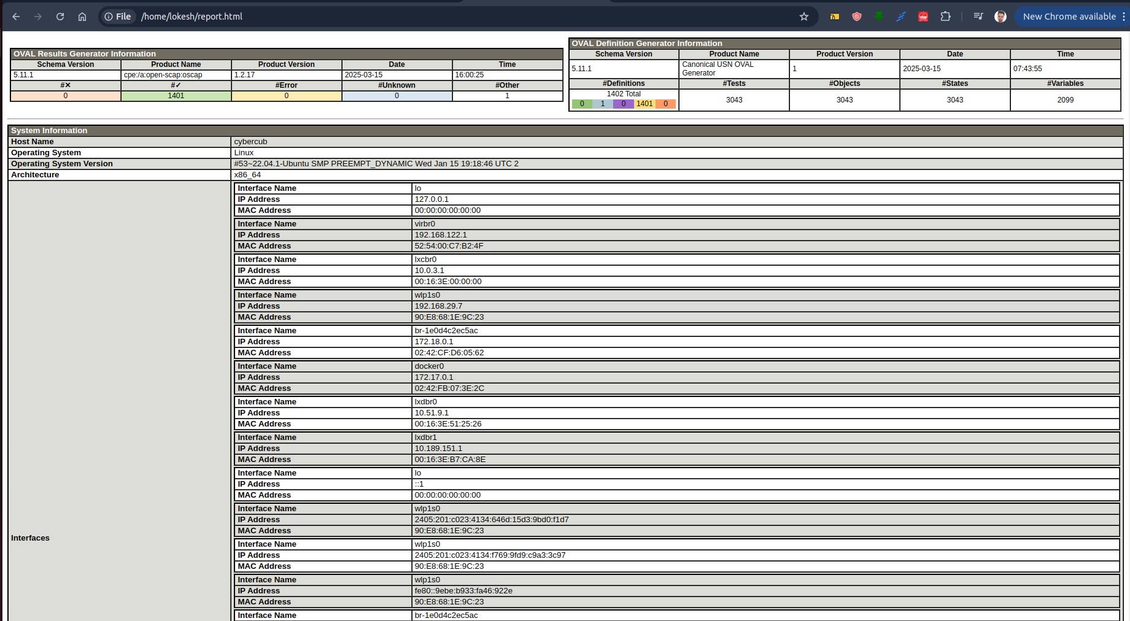

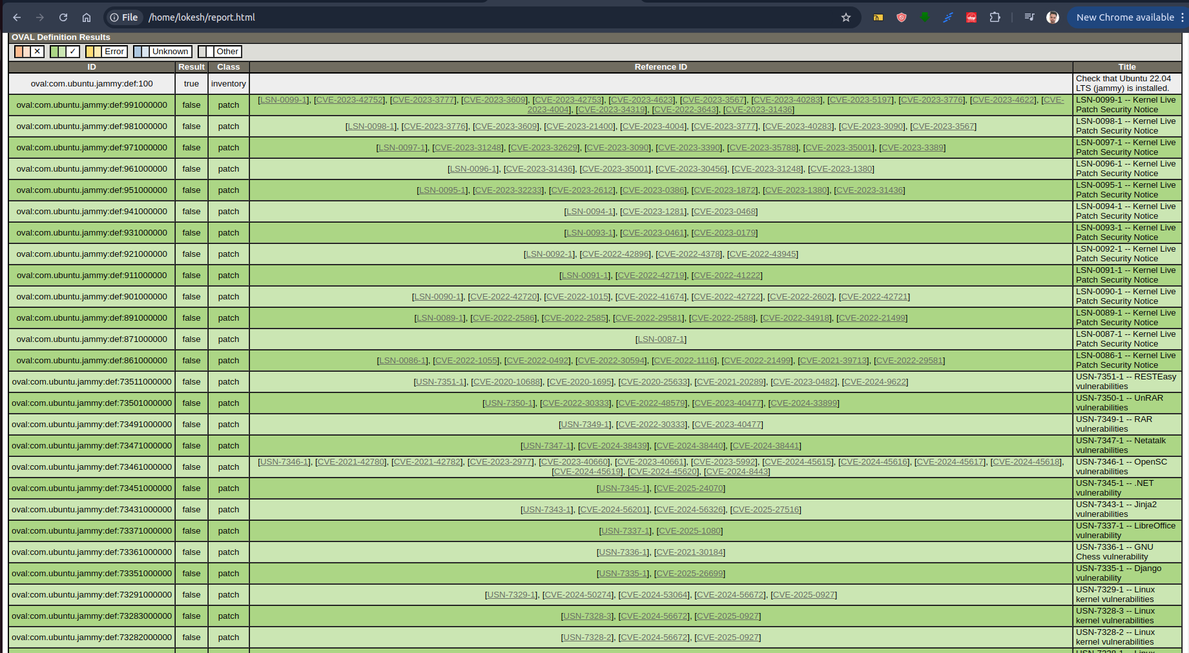

**PART 5: ENTERPRISE-GRADE BACKUP & DATA PROTECTION**

Data Encryption & Access Control:

Implement **Zero Trust Security Model (ZTNA) for remote access**.

Implemented a **Zero Trust Security Model (ZTNA)** for remote access using **OpenVPN** deployed on an **Amazon EC2 instance**. The setup enforces a "**Never Trust, Always Verify**" policy, ensuring strict authentication and authorization for every access request. Additionally, for enhanced security, **key pairs** are enabled to establish secure and verified remote connections.

Click on EC2

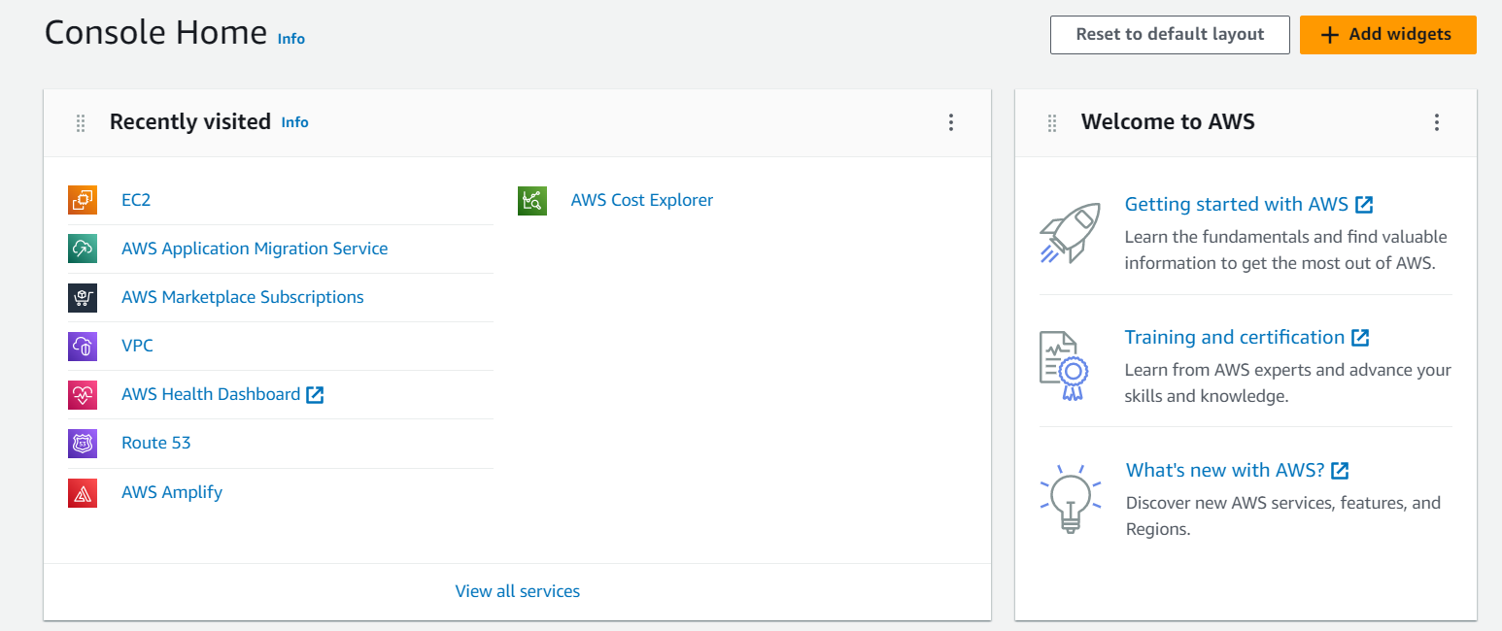

Go to EC2 -> Lauch Instance

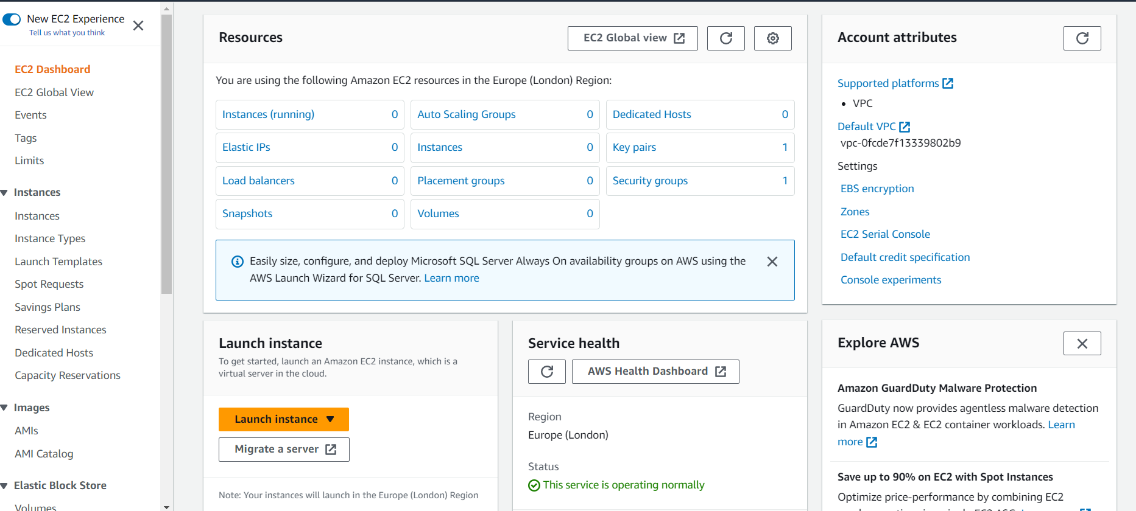

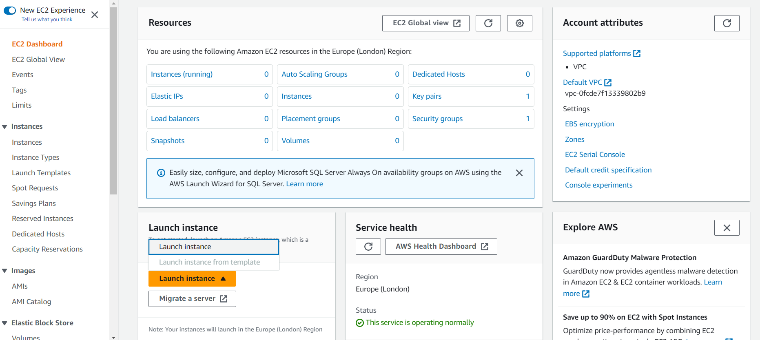

Launch the instance

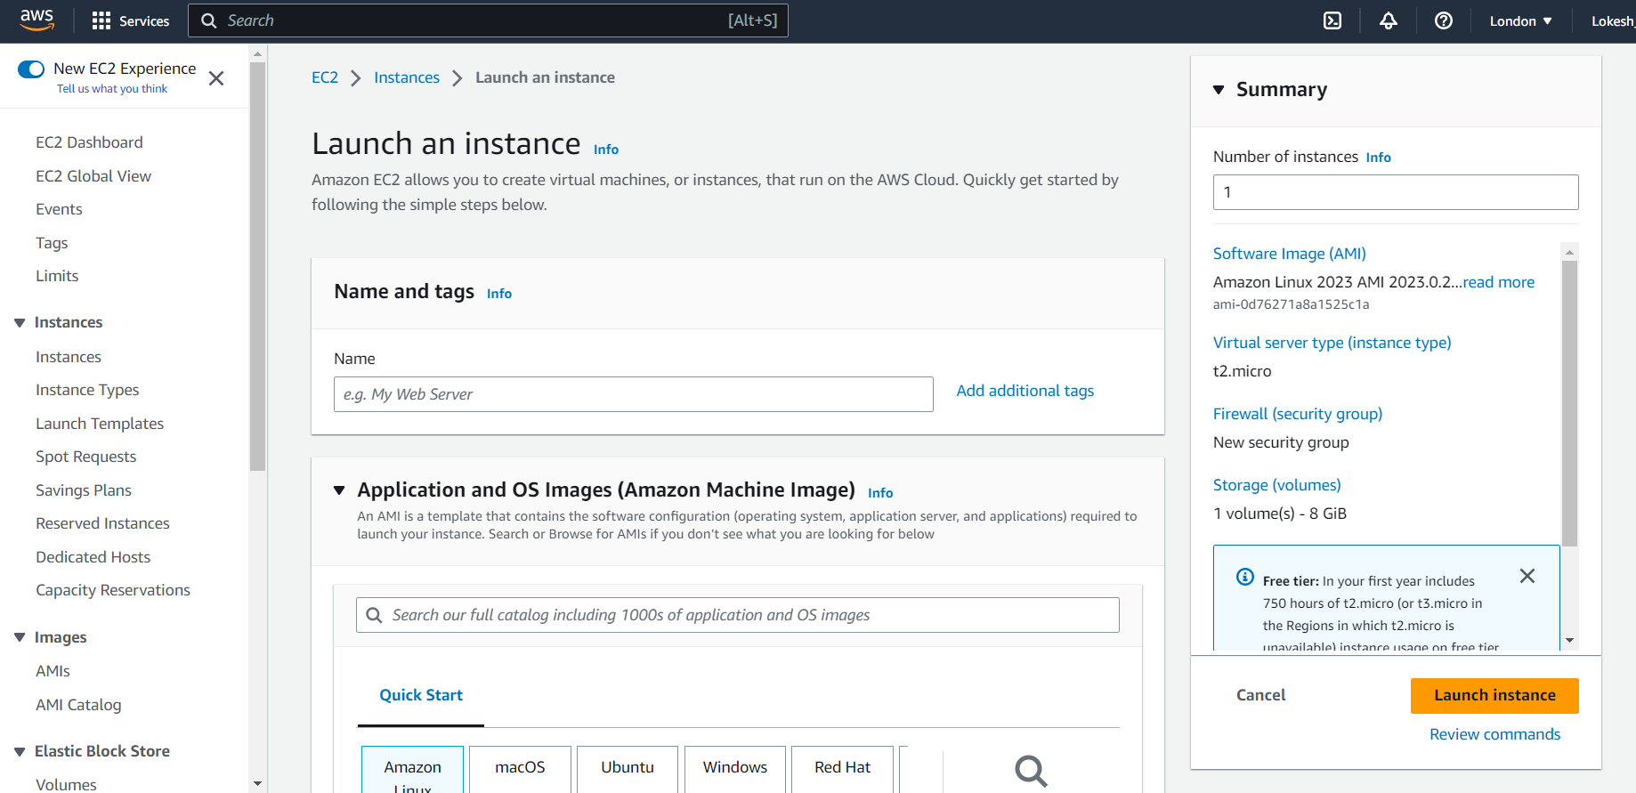

Set name for launch instance :

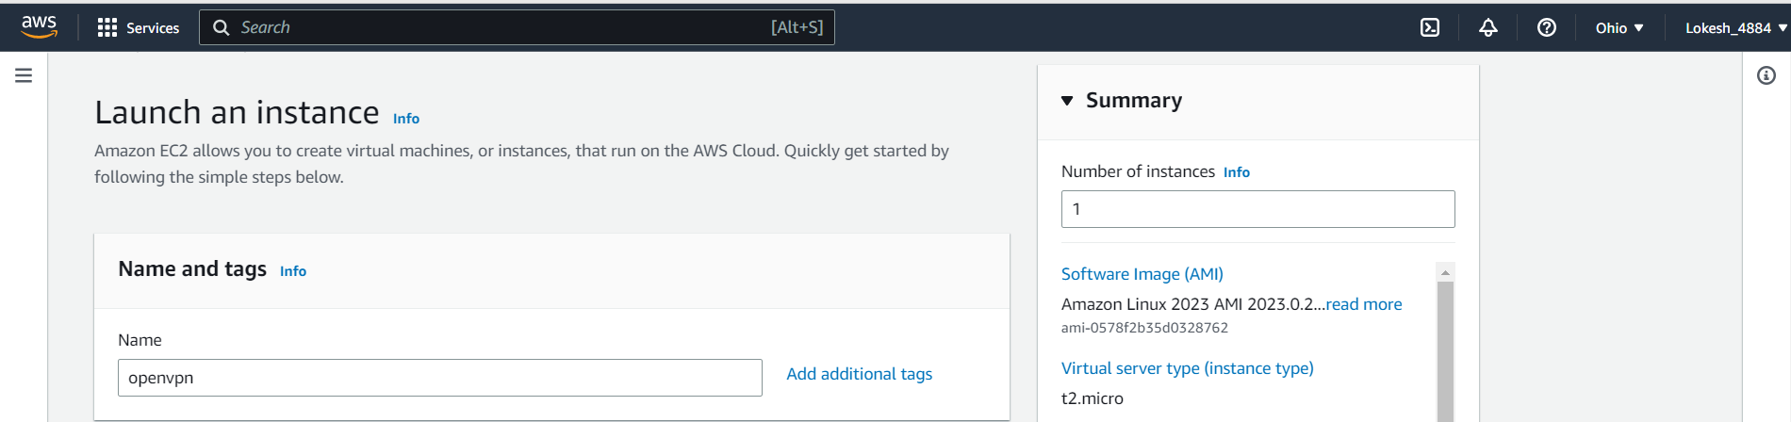

Click on Browse more AMIs

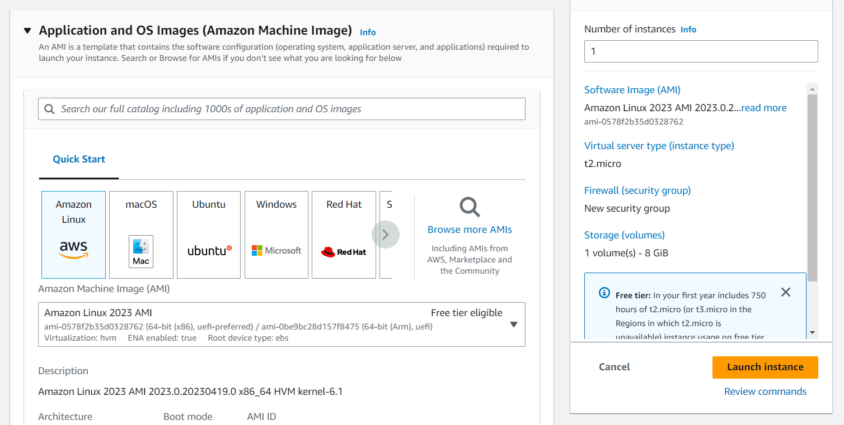

After clicking AMIs

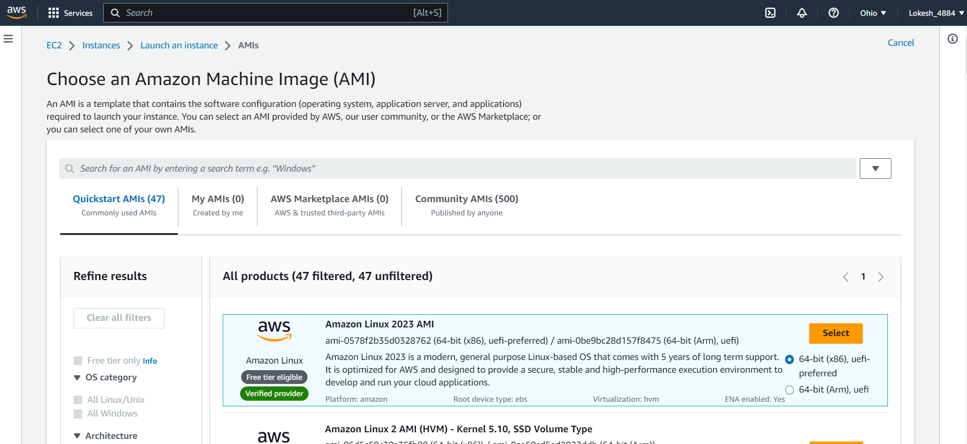

Go to AMIS Marketplace and search for openvpn

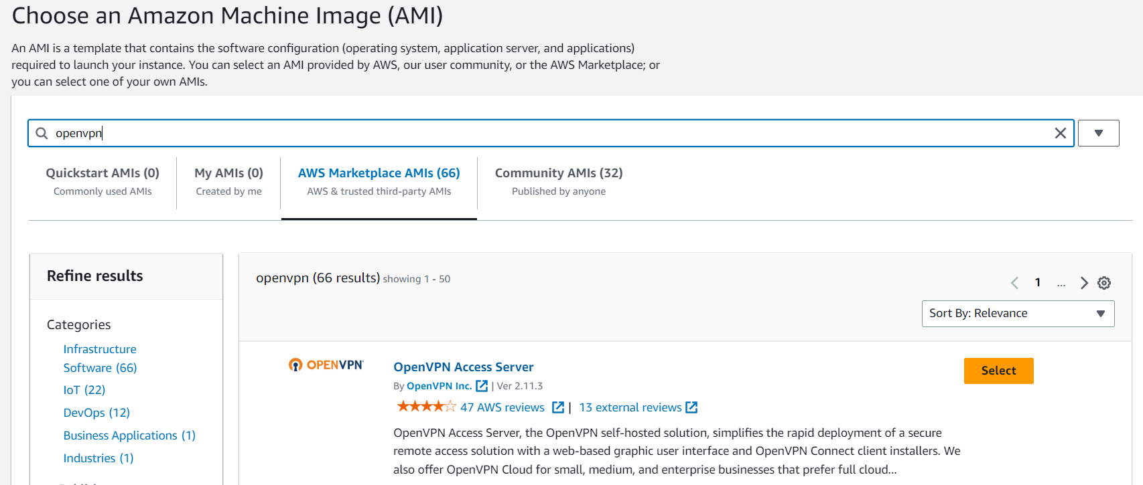

Click on continue

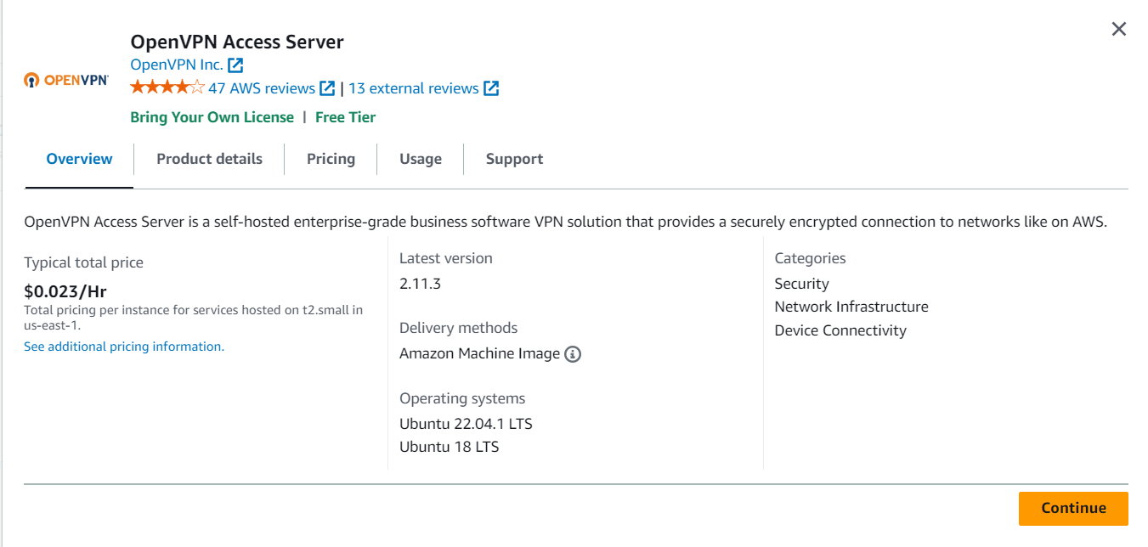

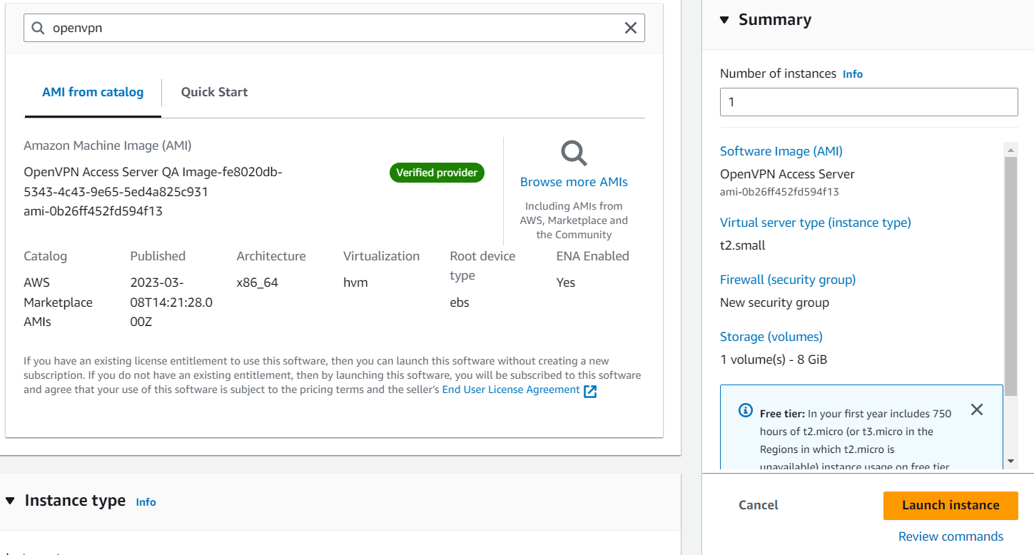

Select free tier Instance type as t2.micro

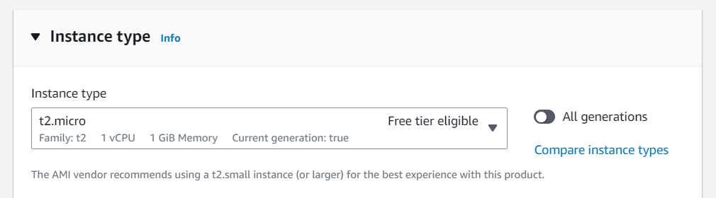

Create a new Key pair using RSA for OpenSSH then choose .pem file and click on create key pair

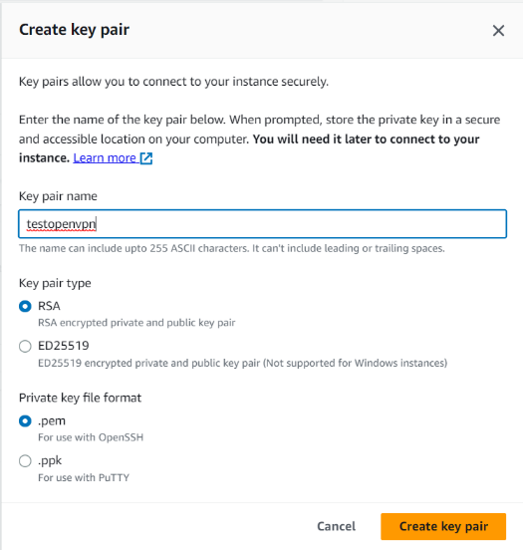

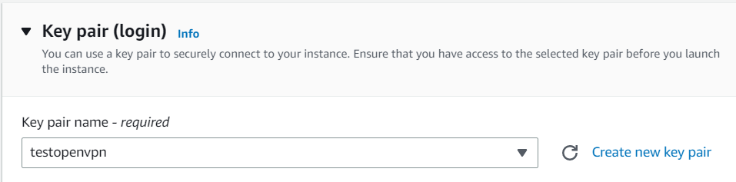

Allow SSH traffic , CUSTOMTCP traffic, CUSTOMUDP, HTTPS traffic from the internet

0.0.0.0/0 **means "anywhere on the internet."**

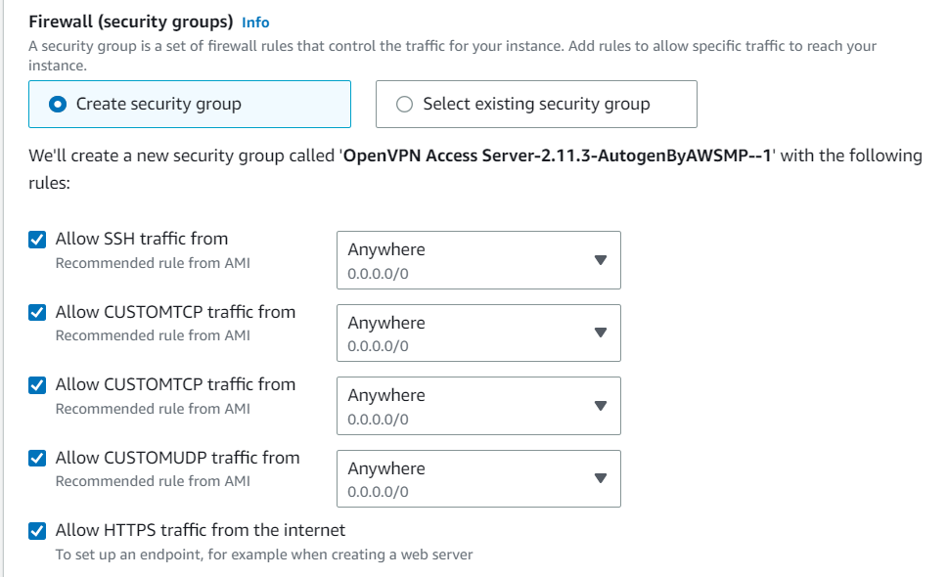

Click on Launch Instance :

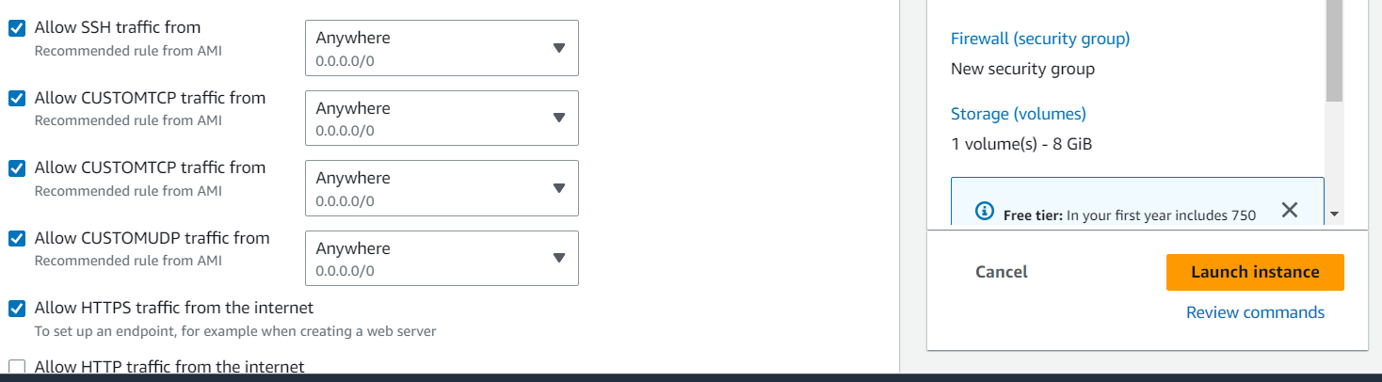

It takes some time

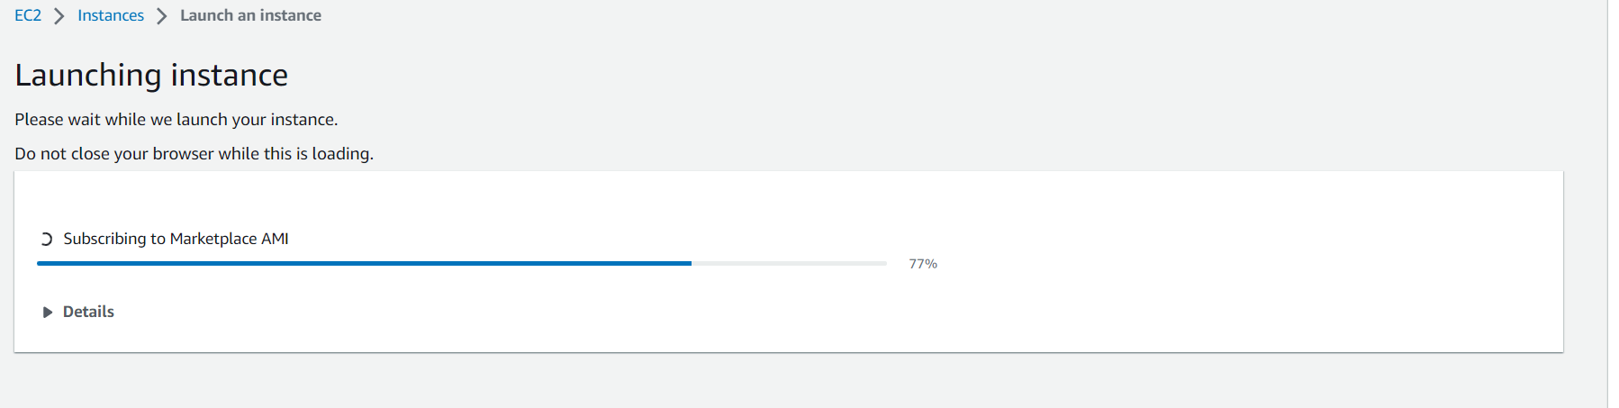

Go to Instances -> Instances

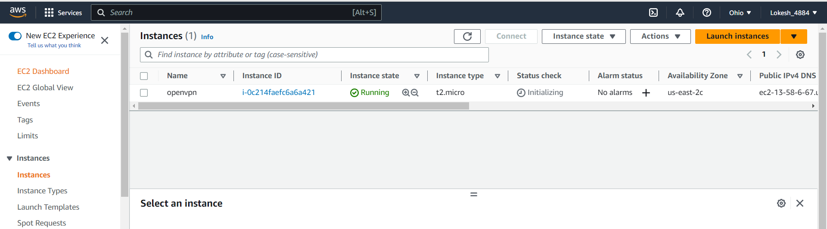

Right Click on Instance ID

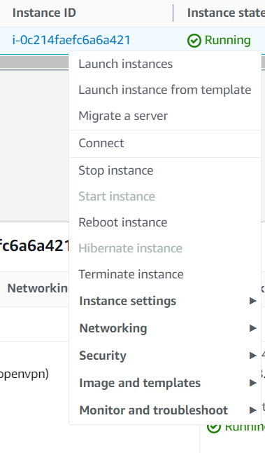

Click on Connect

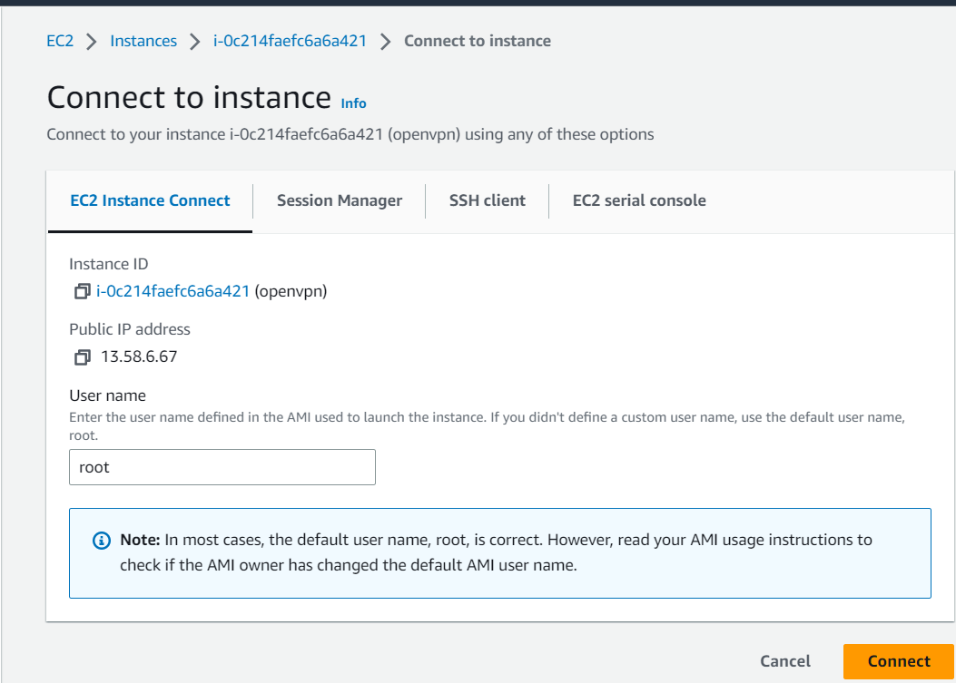

Go to SSH client

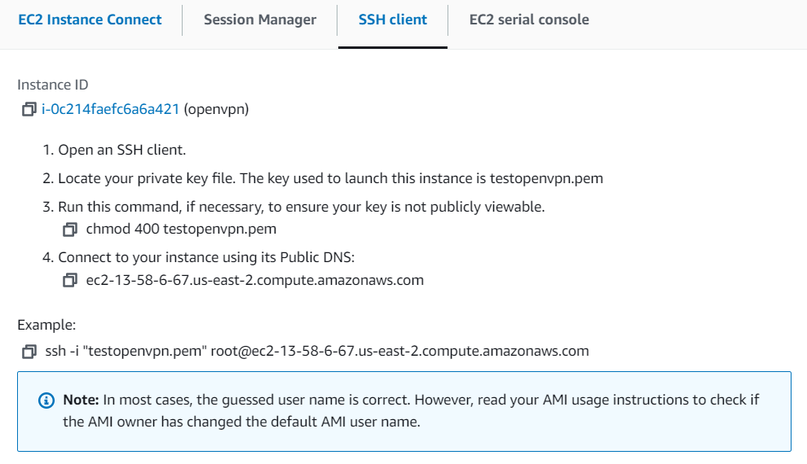

Copy example



Copy that Command and paste it on Command Prompt (only where testopenvpn file is existed) :

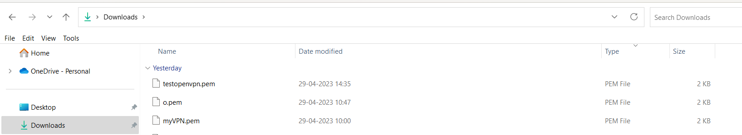

Open Command prompt in download location and Execute that command :

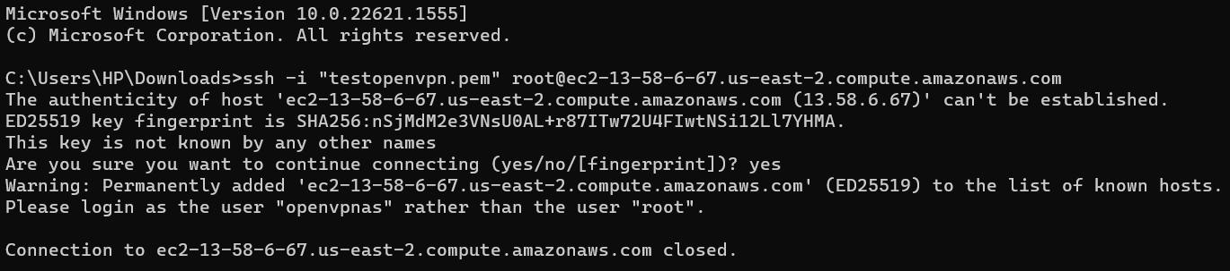

It asks to use as openvpnas as User than root so it refuses

Use Same Command replace root as openvpnas :



Instead root we use openvpnas(from the command)

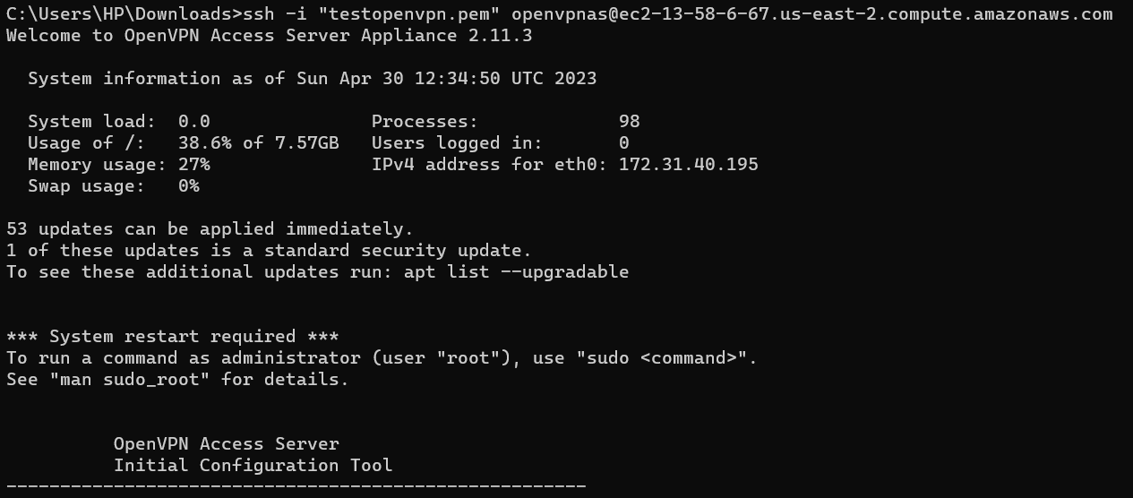

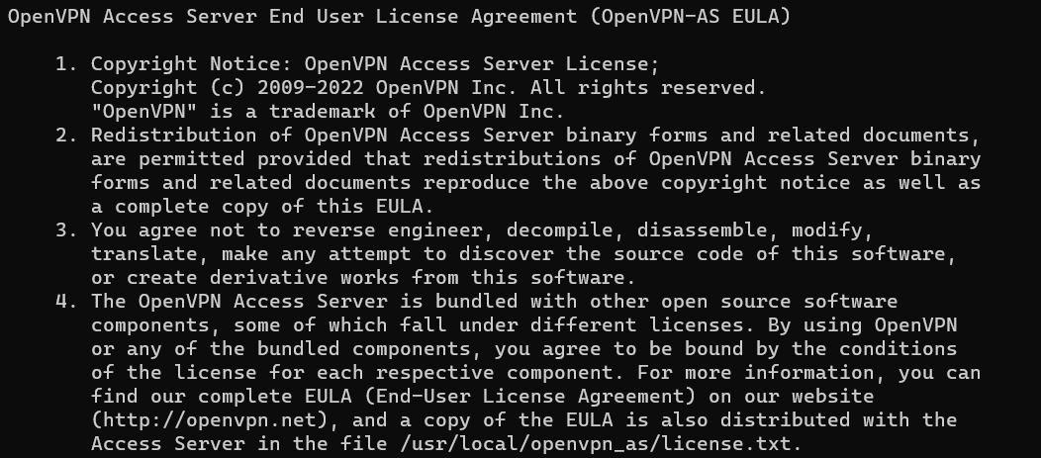

Like that it shows all User License Agreement

Just go with all default option

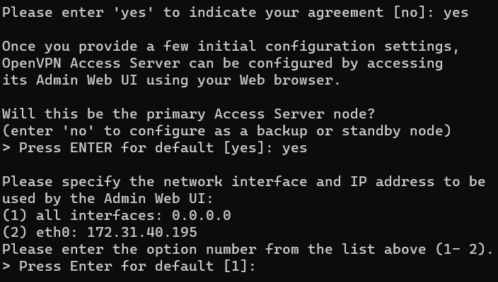

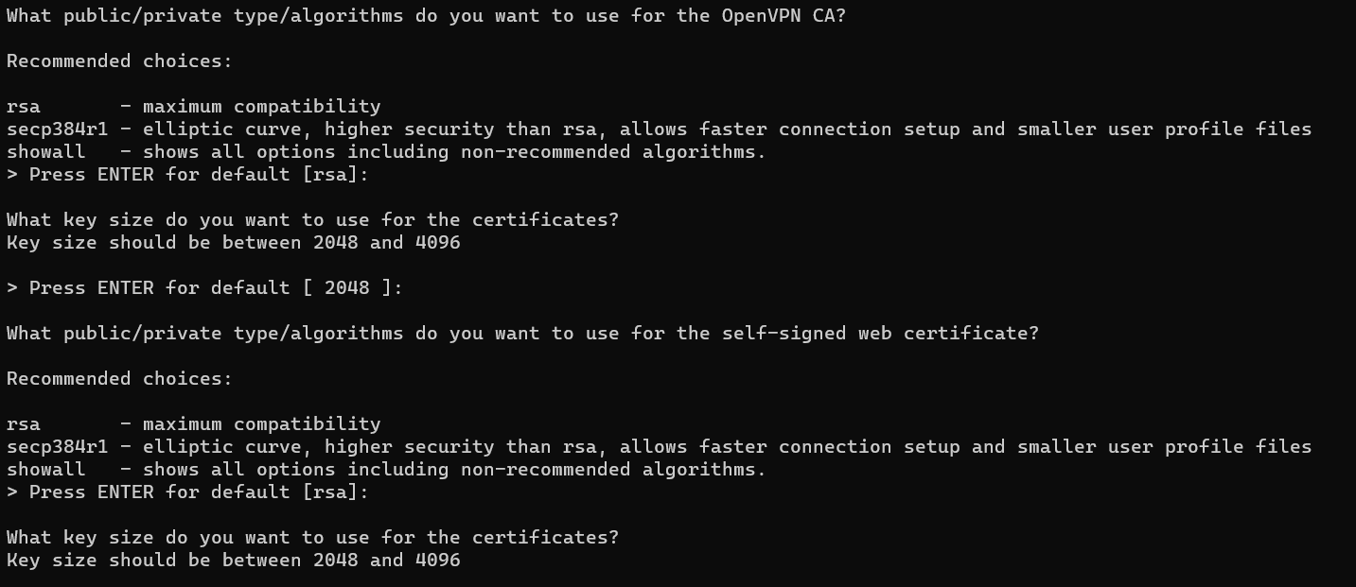

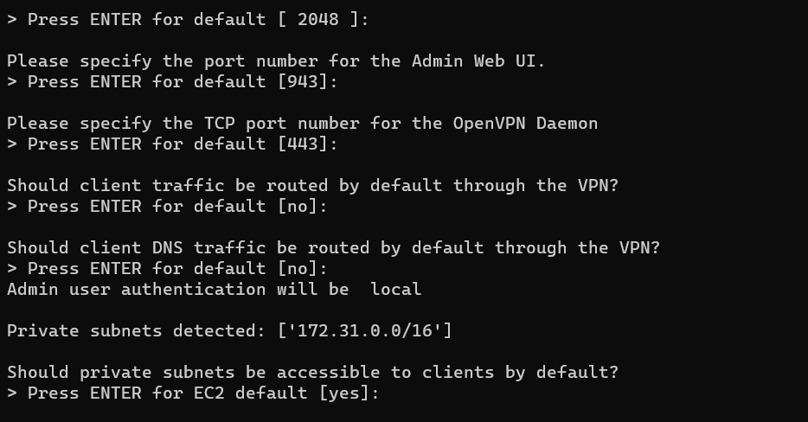

You can give password manually or otherwise just give enter it assigns a default password

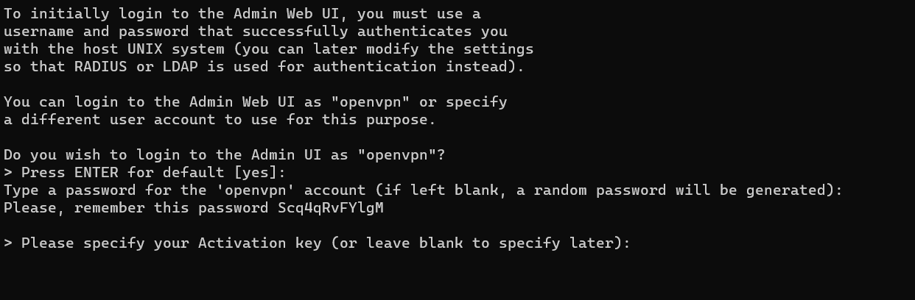

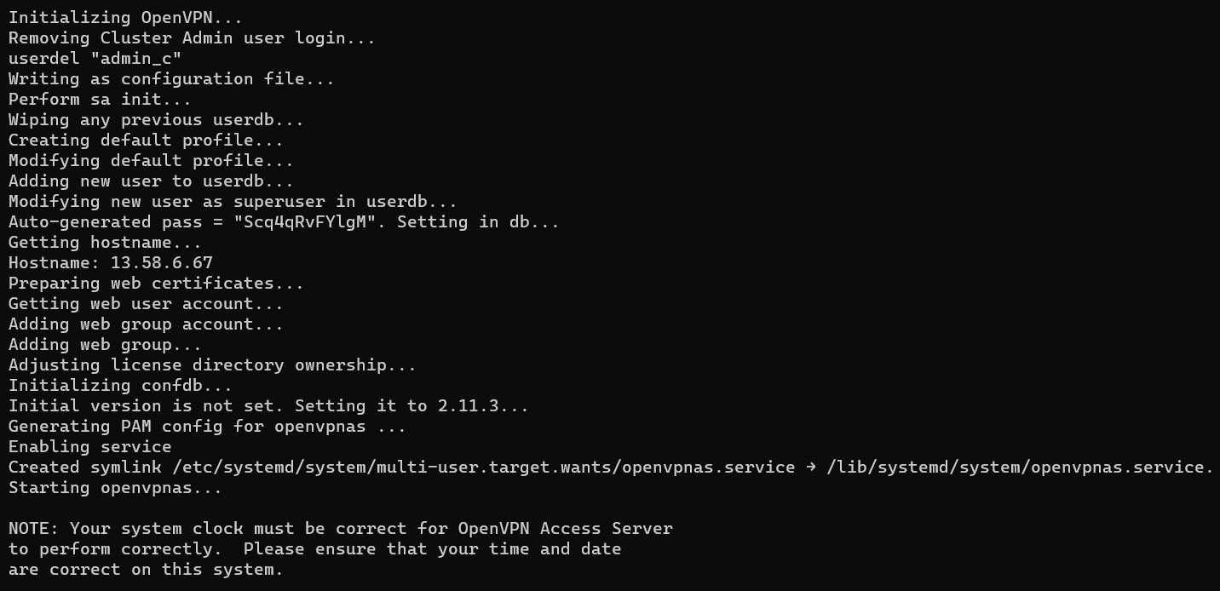

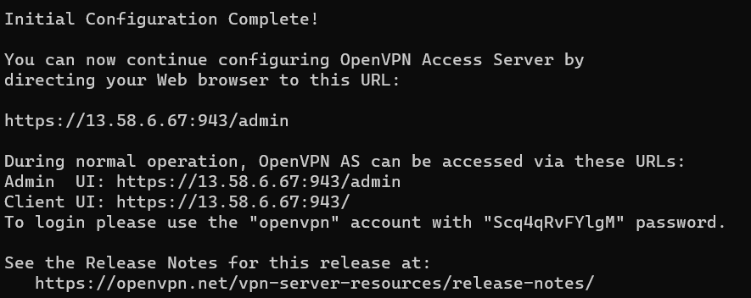

Go to EC2 Instance Connect Copy Public IP address :

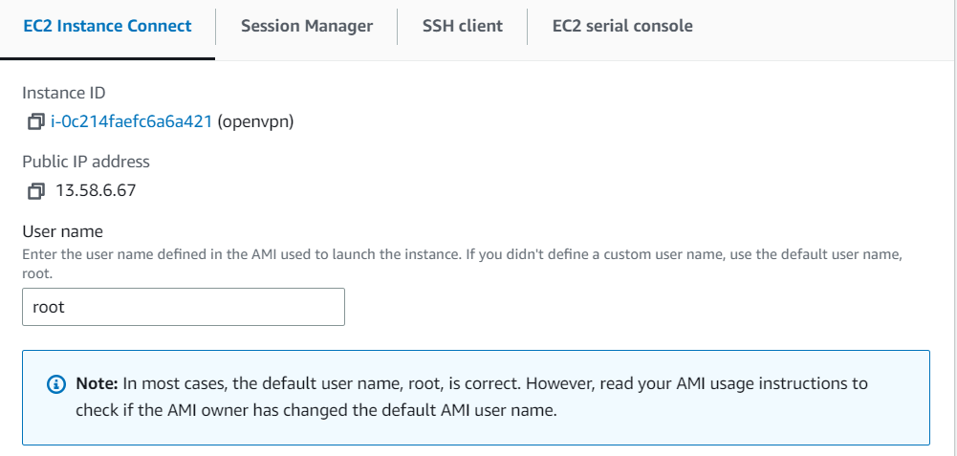

Search : <https://13.58.6.67:943/admin/>

Just proceed for action and you will get a login page :

Enter user name as openvpn which you have given in making a instance in AWS and next give password which was created in command prompt

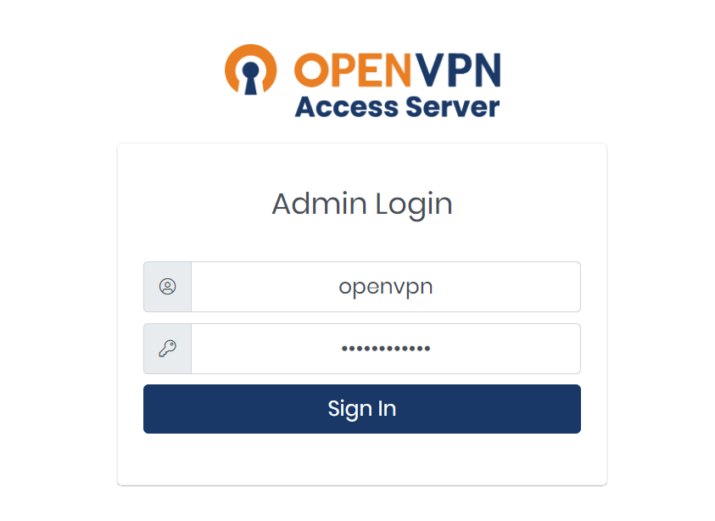

Next you will get this page press on Agree



You will get this page

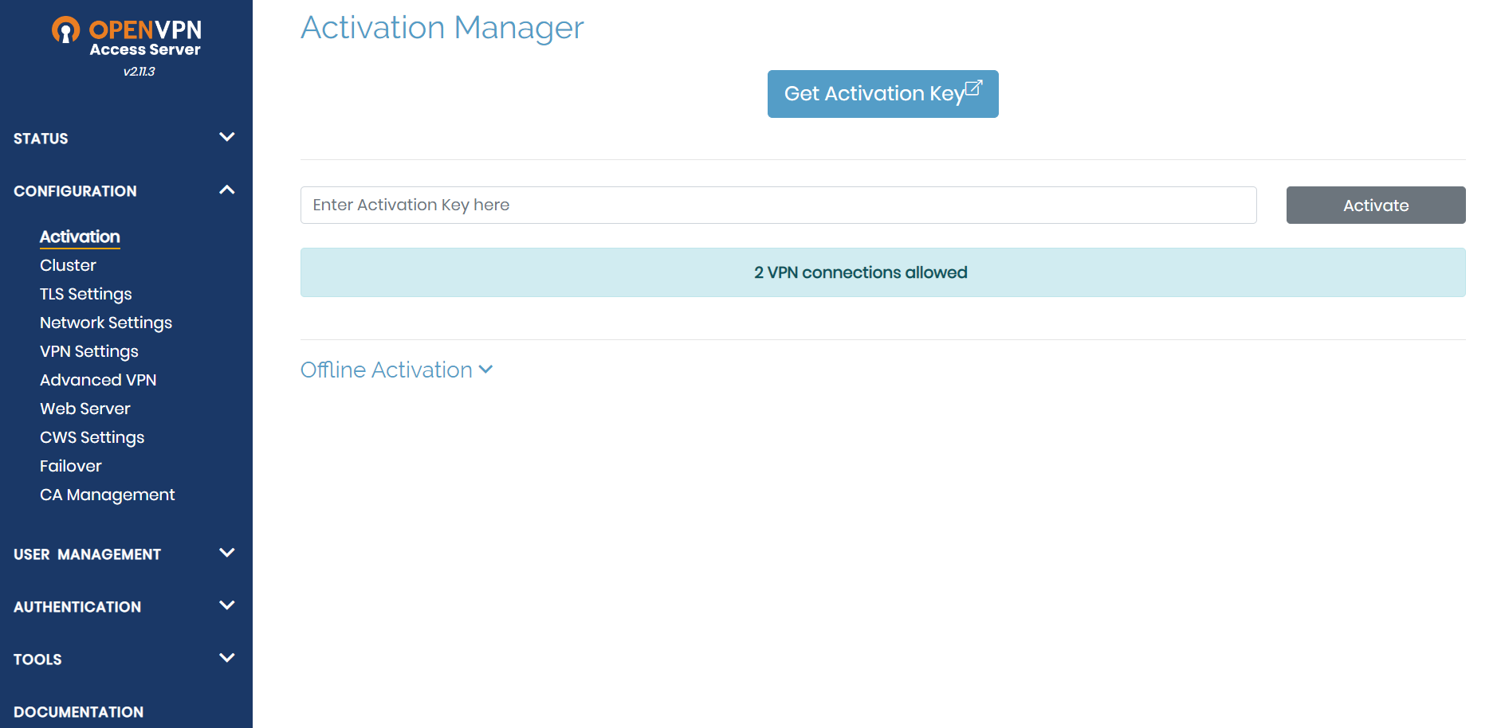

Go to VPN settings

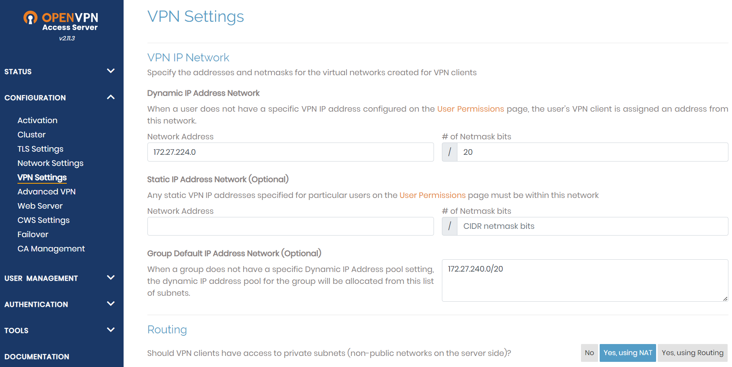

By default in VPN settings



Enable client Internet traffic be routed through VPN?



Click on Save Settings

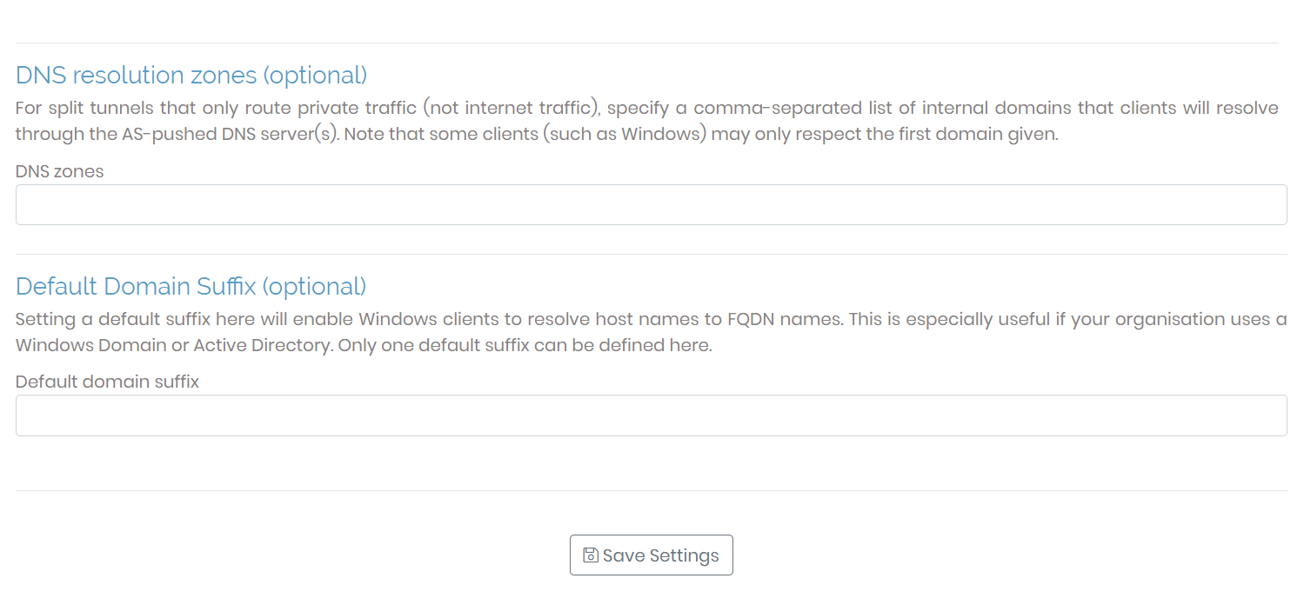

Search in chrome: <https://13.58.6.67/>

Implement **Zero Trust Security Model (ZTNA) for remote access**, credentials which you gave in creating Instance in AWS as openvpn and enter password (which you gave in command prompt ) this OpenVPN always follow ZTNA – Never Trust Always Verify poilicy

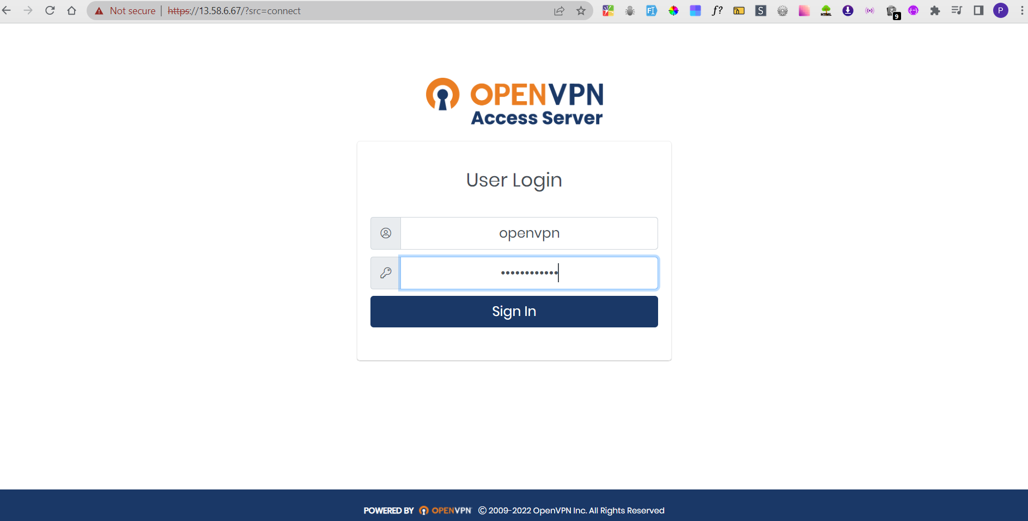

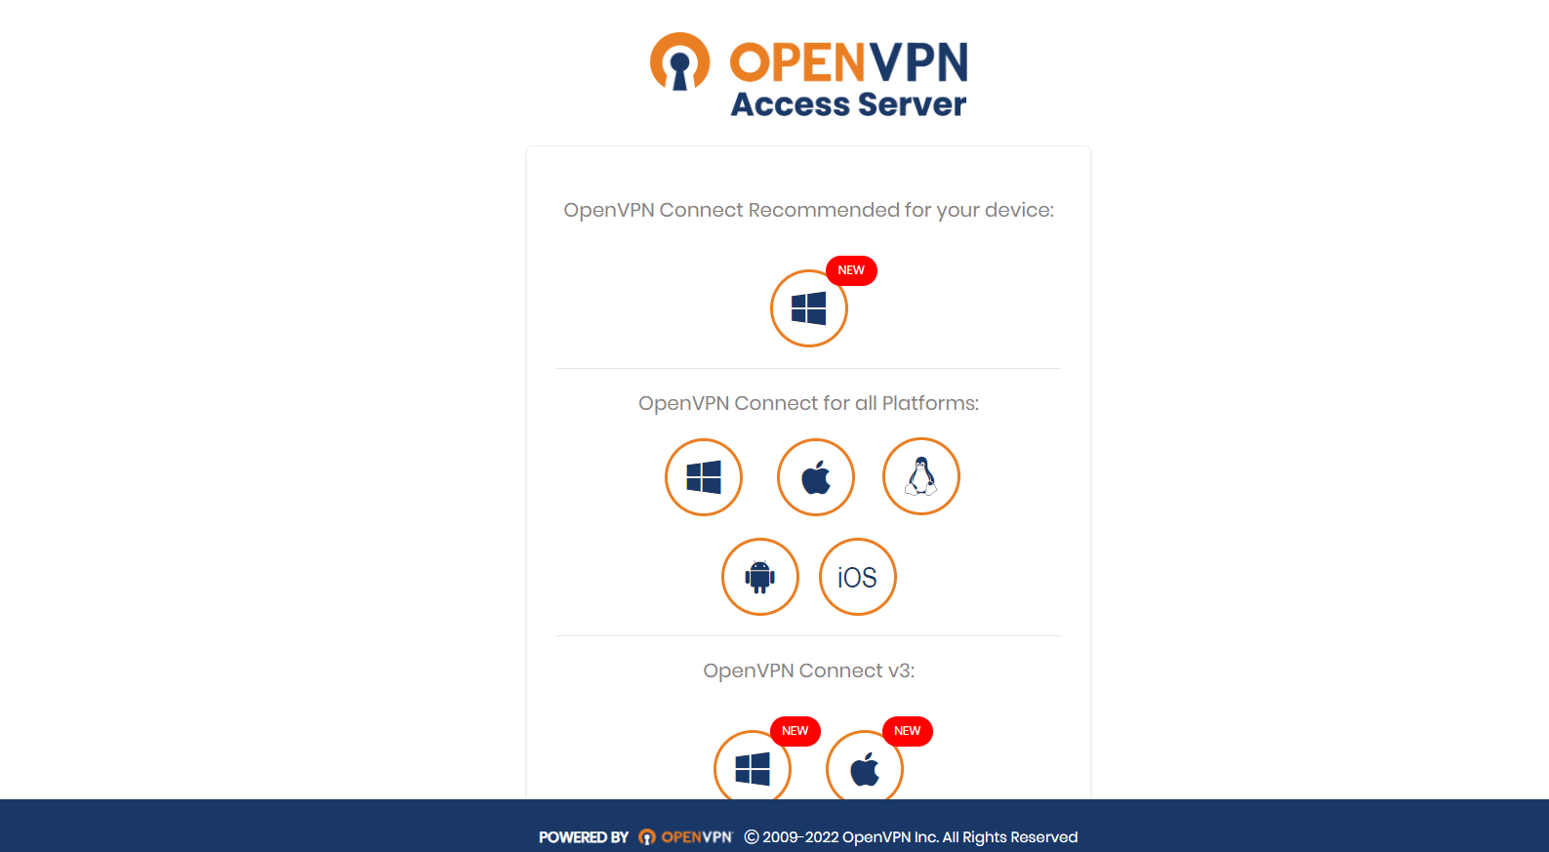

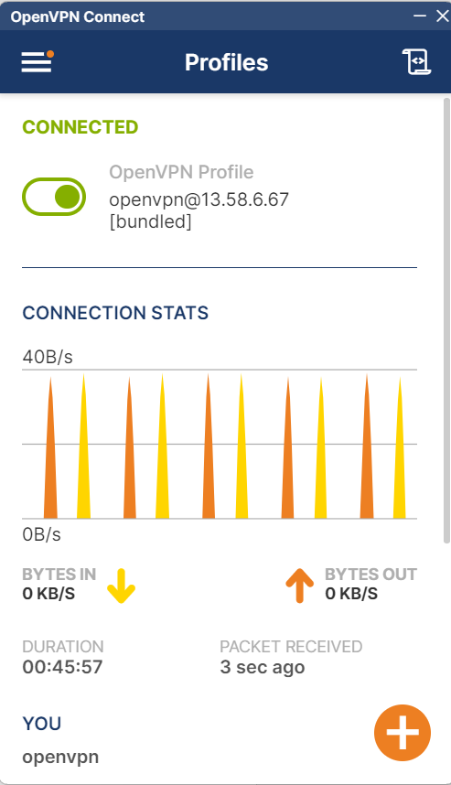

PART 6

### 

### **Zeek (formerly Bro) - Network Security Monitoring Tool**

* **Network Traffic Analysis** – Zeek monitors and logs network activity for security analysis.
* **Deep Packet Inspection** – Extracts detailed metadata from network packets.
* **Flexible Scripting** – Uses Zeek scripting language for custom security policies.
* **Protocol Detection** – Supports HTTP, DNS, SSL/TLS, and many more.
* **Security Event Detection** – Identifies anomalies, intrusions, and threats.
* **Log Generation** – Creates structured logs for further analysis in SIEMs.
* **Open Source & Scalable** – Used in large-scale network monitoring setups.

### The apt-get update command updates the local package index by fetching the latest package lists from the repositories. This ensures the system is aware of available updates but does not install them.

root@agent:/home/lokesh# apt-get update

Get:1 http://security.ubuntu.com/ubuntu jammy-security InRelease [129 kB]

Hit:2 http://archive.ubuntu.com/ubuntu jammy InRelease

Get:3 http://archive.ubuntu.com/ubuntu jammy-updates InRelease [128 kB]

.

.

### The apt-get upgrade command installs the latest versions of all installed packages without removing any existing ones. It updates only those packages that do not require dependency changes.

root@agent:/home/lokesh# apt-get upgrade

Reading package lists... Done

Building dependency tree... Done

Reading state information... Done

Calculating upgrade... Done

.

.

### Downloading zeek-7.0.5.tar.gz zip file from zeek official website

root@agent:/home/lokesh# wget https://download.zeek.org/zeek-7.0.5.tar.gz

--2025-02-28 07:44:33-- https://download.zeek.org/zeek-7.0.5.tar.gz

Resolving download.zeek.org (download.zeek.org)... 52.84.45.124, 52.84.45.34, 52.84.45.68, ...

Connecting to download.zeek.org (download.zeek.org)|52.84.45.124|:443... connected.

HTTP request sent, awaiting response... 200 OK

Length: 95847393 (91M) [application/x-gzip]

Saving to: ‘zeek-7.0.5.tar.gz’

zeek-7.0.5.tar.gz 100%[================================================================================================================>] 91.41M 3.79MB/s in 25s

root@agent:/home/lokesh# ls

wazuh-agent_4.9.2-1_amd64.deb zeek-7.0.5.tar.gz

### use the following commands to add zeek repository into binary packages.

root@agent:/home/lokesh# apt-get install cmake make gcc g++ flex bison libpcap-dev libssl-dev python3-dev swig zlib1g-dev -y

Reading package lists... Done

Building dependency tree... Done

Reading state information... Done

Extract zeek-7.0.5.tar.gz

root@agent:/home/lokesh# tar -xzf zeek-7.0.5.tar.gz

root@agent:/home/lokesh# ls

wazuh-agent_4.9.2-1_amd64.deb zeek-7.0.5 zeek-7.0.5.tar.gz

Go to zeek-7.0.5

root@agent:/home/lokesh# cd zeek-7.0.5

root@agent:/home/lokesh/zeek-7.0.5# ls

CHANGES Makefile auxil doc src

CMakeLists.txt NEWS ci docker testing

COPYING README cmake man vcpkg.json

COPYING-3rdparty README.md cmake_templates repo-info.json zeek-path-dev.in

INSTALL VERSION configure scripts

### The ./configure command checks system dependencies and prepares the build environment for compiling Zeek 7.0.5.

root@agent:/home/lokesh/zeek-7.0.5# ./configure

.

.

-- Configuring done

-- Generating done

-- Build files have been written to: /home/lokesh/zeek-7.0.5/build

### The command make install compiles and installs Zeek 7.0.5 from source in the /home/lokesh/zeek-7.0.5 directory on the agent system.

root@agent:/home/lokesh/zeek-7.0.5# make install

.

.

-- Installing: /usr/local/zeek/share/zeek/cmake/ZeekConfigVersion.cmake

-- Installing: /usr/local/zeek/share/zeek/cmake/ZeekTargets.cmake

make[1]: Leaving directory '/home/lokesh/zeek-7.0.5/build'

### The command `make` compiles the Zeek 7.0.5 source code in the `/home/lokesh/zeek-7.0.5` directory on the `agent` system.

root@agent:/home/lokesh/zeek-7.0.5# make

.

.

[100%] Built target rst

make[2]: Leaving directory '/home/lokesh/zeek-7.0.5/build'

make[1]: Leaving directory '/home/lokesh/zeek-7.0.5/build'

root@agent:/home/lokesh/zeek-7.0.5#

### 

### 

### 

### Go to /usr/local/zeek/

root@agent:/home/lokesh/zeek-7.0.5# cd /usr/local/zeek/

root@agent:/usr/local/zeek# ls

bin etc include lib logs share spool var

root@agent:/usr/local/zeek# cd bin

root@agent:/usr/local/zeek/bin#

### Edit the Bash configuration file for the current user.

root@agent:/usr/local/zeek/bin# nano ~/.bashrc

.

.

export PATH=/usr/local/zeek/bin:$PATH #Add this line at last

### The command source ~/.bashrc reloads the .bashrc file without needing to restart the shell. This applies any changes made, such as new aliases, environment variables, or custom configurations, immediately.

root@agent:/usr/local/zeek/bin# source ~/.bashrc

### Check whether zeek is deployed

root@agent:/usr/local/zeek/bin# zeek --version

zeek version 7.0.5

### Check where zeek installed

root@agent:/usr/local/zeek/bin# which zeek

/usr/local/zeek/bin/zeek

root@agent:/usr/local/zeek/bin# cd ..

root@agent:/usr/local/zeek# cd etc

root@agent:/usr/local/zeek/etc#

root@agent:/usr/local/zeek/etc# ls

networks.cfg node.cfg zeekctl.cfg zkg

### Edit node.cfg make sure to use standalone , localhost , ethernet of local machine where zeek is hosting

root@agent:/usr/local/zeek/etc# nano node.cfg

[zeek]

type=standalone

host=localhost

interface=eth0

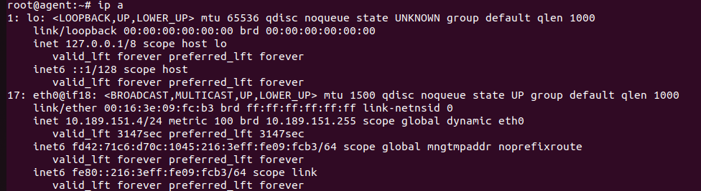

root@agent:/usr/local/zeek/etc# zeekctl check

Hint: Run the zeekctl "deploy" command to get started.

zeek scripts are ok.

root@agent:/usr/local/zeek/spool# apt-get install mailutils -y

Reading package lists... Done

Building dependency tree... Done

Reading state information... Done

### Deploy zeek

root@agent:/usr/local/zeek/etc# zeekctl deploy

checking configurations ...

installing ...

removing old policies in /usr/local/zeek/spool/installed-scripts-do-not-touch/site ...

removing old policies in /usr/local/zeek/spool/installed-scripts-do-not-touch/auto ...

creating policy directories ...

installing site policies ...

generating standalone-layout.zeek ...

generating local-networks.zeek ...

generating zeekctl-config.zeek ...

generating zeekctl-config.sh ...

stopping ...

stopping zeek ...

starting ...

starting zeek ...

root@agent:/usr/local/zeek/etc# zeekctl status

Name Type Host Status Pid Started

zeek standalone localhost running 29477 28 Feb 11:17:04

### Go to logs that captured by zeek

root@agent:/usr/local/zeek/etc# cd ..

root@agent:/usr/local/zeek# ls

bin etc include lib logs share spool var

root@agent:/usr/local/zeek# cd logs/

root@agent:/usr/local/zeek/logs# ls

2025-02-28 current

root@agent:/usr/local/zeek/logs# cd current

### These all are different logs that generated by zeek

root@agent:/usr/local/zeek/logs/current# ls

capture_loss.log conn.log loaded_scripts.log notice.log packet_filter.log reporter.log stats.log stderr.log stdout.log telemetry.log weird.log

### Printing to the screen conn.log

In Zeek, conn.log is a foundational log file that tracks network connections, providing information about the source and destination hosts, ports, protocols, and connection state, allowing for analysis of network traffic and detection of unusual activity.

root@agent:/usr/local/zeek/logs/current# tail -f conn.log

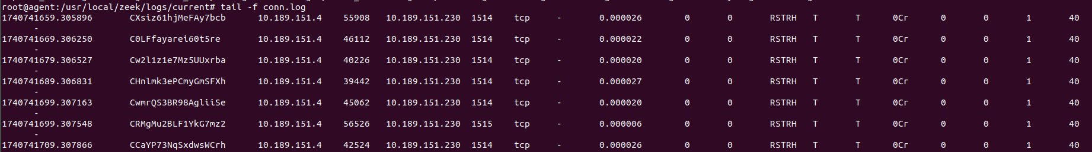

### I have changed logs format to json

root@agent:/usr/local/zeek/logs/current# tail -f conn.log

{"ts":1740954863.250134,"uid":"CyCGXM2n791ANkwBSl","id_orig_h":"fd42:71c6:d70c:1045::1","id_orig_p":5353,"id_resp_h":"ff02::fb","id_resp_p":5353,"proto":"udp","conn_state":"OTH","local_orig":true,"local_resp":false,"missed_bytes":0,"history":"C","orig_pkts":0,"orig_ip_bytes":0,"resp_pkts":0,"resp_ip_bytes":0,"ids_malicious":"zeek_conn"}

{"ts":1740954863.250256,"uid":"CUMjeL2eDwRrHbKBa","id_orig_h":"10.189.151.1","id_orig_p":5353,"id_resp_h":"224.0.0.251","id_resp_p":5353,"proto":"udp","conn_state":"OTH","local_orig":true,"local_resp":false,"missed_bytes":0,"history":"C","orig_pkts":0,"orig_ip_bytes":0,"resp_pkts":0,"resp_ip_bytes":0,"ids_malicious":"zeek_conn"}

{"ts":1740954872.461894,"uid":"CdVgF23kGRzguGp0v8","id_orig_h":"10.189.151.4","id_orig_p":68,"id_resp_h":"10.189.151.1","id_resp_p":67,"proto":"udp","conn_state":"OTH","local_orig":true,"local_resp":true,"missed_bytes":0,"history":"C","orig_pkts":0,"orig_ip_bytes":0,"resp_pkts":0,"resp_ip_bytes":0,"ids_malicious":"zeek_conn"}

{"ts":1740954863.254029,"uid":"CskYGd2bMnUrvMrQ4l","id_orig_h":"fe80::216:3eff:feb7:ca8e","id_orig_p":143,"id_resp_h":"ff02::16","id_resp_p":0,"proto":"icmp","duration":0.27585291862487793,"orig_bytes":40,"resp_bytes":0,"conn_state":"OTH","local_orig":true,"local_resp":false,"missed_bytes":0,"orig_pkts":2,"orig_ip_bytes":152,"resp_pkts":0,"resp_ip_bytes":0,"ids_malicious":"zeek_conn"}